

Computing Project

Project Title: QR Code Generator

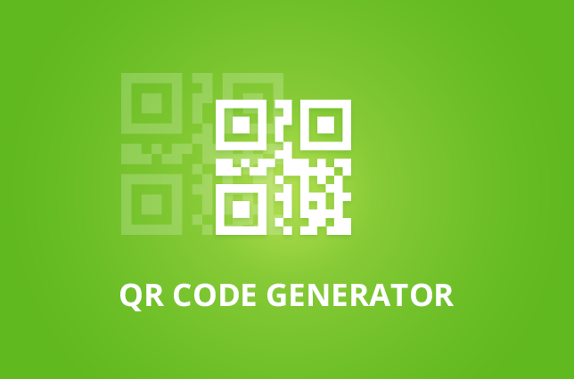

Name: Bhupendra Sharma

NCC ID: 00176178

Level 5 Diploma in Computing

Softwarica College of IT & E-Commerce

Kathmandu, Nepal

31/1/2020

# Acknowledgement

It is great pleasure for me to undertake this project I feel highly doing the project entitled – “QR Code Generator”.

I am grateful to my project guide MR. SUDEEP BAJIMAYA faculty member of Softwarica college of IT and E-Commerce and all the respective teachers who helped me in this project.

This project would not have completed without their enormous help and worthy experience. Whenever I was in need, they were behind me.

Last but not the least I would like to thank my classmates who have helped me a lot.

Date: 2020-02-03 Bhupendra Sharma

Batch: 23 A

# Abstract

The system developing by me is a QR code generator and I am taking the MYSQL database advantages comes embed with XAMPP software and Laravel framework with the benefits of MVC design pattern. The purpose of developing system is to give platform to design free QR code and use it for the personal work or scan and decode the information on it. While user can have overview on the blog post too. And the system would have admin features to manages all the blog post, profiles and overall process of the system.

The main concept of the system project is to build website to eradicate the peoples time, cost for designing the QR code and searching them. This project is going to benefit the people and advanced the business such as while having payment or to provide details regrading and can be used in visiting card and many such.

Build website is simple and easy to understand by any age group people and safe to use and the system is fast that it can create and scan code in minimum time. User can create an account and manages the profile and code created by them while the blog content and database system manipulation process authority will be only for the admin no the other which makes it safer. And the user sitting in any corner can have accessed to this system benefits.

For the project, I must use waterfall model for the development methodology and implement all the process of the waterfall model for making website efficient.

Table of Contents

Acknowledgement 2

Abstract 3

Chapter 1- Introduction 5

Chapter 2: analysis 9

2.1 introduction 10

Swot analysis: 10

2.2 feasibility study 11

2.3 Information Gathering Methodology 13

2.3.1 Interview 13

2.3.2 Questionnaires 15

2.4 system architecture and database architecture 17

2.4.2 Database architecture (client server architecture) 18

2.5 SRS document: 20

Functional requirement 20

Non-functional requirement 22

2.6 MoSCoW prioritization: 24

2.7 Use case 27

2.8 Class diagram: 28

Chapter 3: Design 31

3. Design: 31

3.1 Structural Modeling 31

3.1.1 class diagram 31

3.2 Behavioral Modeling 34

Behavioral Diagrams represent the components of a structure that are time-dependent and express the system's complex principles and how they contribute to one another. The components in these representations mimic the verbs in a natural language, and the linking associations usually reflect the rate of change. 34

3.2.1 Activity Diagram 34

3.2.2 Sequence Diagram 42

3.3 Database Modeling 46

3.3.1 Data dictionary 46

3.3.2 ER diagram 48

3.4 UI Modeling 49

Chapter 4- Implementation 57

programming language 57

Design pattern (MVC) 57

Chapter 5- Testing 58

Black Box Testing 58

White Box Testing 85

Unit Testing 85

Chapter 6- Other project issues 86

6.3 Risk management 88

Chapter9 – Appendix 102

# 

# Chapter 1- Introduction

* 1. **Project introduction**

Everything is connected with technology internet and the technology has been essential part of the people in this era without technology life could not be imagined today. People wants an fastest and the easiest way to communicate and share the information as quickly as possible. Business is being more productivity implementing automation technology over it.

Many are using the QR code system for promoting businesses marketing, building online community and such as for payment of electricity bills internet bills. While the QR code can be included in a book and encode a phone number, videos or web page for renewing the book.

I will be developing system as a web application to make people easier to create and scan code form where they are and provide a security to decoded code by user which might be sensible. The website is simple and easy to understands and the user can register over site and manage their profile and store the created code by them. Some of the features of the websites such as maintaining site blog posts, users and database system will only have accessed to the administration ensuring and preventing the chance of failure of the system.

* 1. **Background of Project**

QR code generator is a web application in which user can easily choose the type and generate code for its uses and its free it does not require any additional charges for doing it. As well as the user would able to scan code by sitting where they are.

Our system would have an authorized admin who manages all the blog post and content of the website and database system where user credentials are stored. Except the authorized admin no one is able to up down websites.

Developed system would also have some of the extra features such as rules and regulations with the user manual page to help the peoples and instruct them how the system works and how they should perform.

Our designed system is a fully responsive and support well on mobile phone and many devices. And that was the reason for choosing the Laravel framework for the development of the project.

* 1. **Overview of project**

QR code generator is the web-based application and not patents so its free and has best performance, efficient, reliable, better security than that of the Bar code system. In the system user are able to create account and have a own personal identity over the website and manages the account. Website will have a striking landing page and image slider in main page with the responsive navigation bar. The website has newsletter and the user can have contact info of administration in curse of any issues. And there is an admin panel from where all the websites process could be managed.

Finally, the system has a responsive site which provides the easiest method to create and scan code QR code and the many more features are added to the site.

* 1. **Problem statement**

Our QR code generator system is web application with the most advanced features. The system grants the user to create account, create code and scan code many more features and all the overall background process are handled by the administration.

While creating a QR code user might face problems such as not reading the user provided information by the system and created the false code and the user account might be compromised faced security issues. And the user might catch error bugs in site and might take merits of it and compressed the site so the security is the main problems.

To eradicate issue, I must prepare the best planning to overcome the arises issues in the system. I must setup the backup plan for the system.

* 1. **Aim and objectives**

Aim:

Aim of the system is to provide the best and easiest way to design their QR code for free and scan the code. Using the QR code system is faster than compared to the traditional Bar code system.

Objectives:

* Having an efficient system
* making it easier for people of all ages to navigate
* improving performance-increasing access-providing accurate knowledge
* saving time
  1. **Features**
* Login functionality
* Registration functionality
* User would be able to manages the profile
* Generate QR code
* Scan QR code
* User can download the create code in high quality print format
* Image slider with responsive
* Newsletter form and contact form
  1. **Justification of project**

It provides the easiest way to create code and use it where the user will not be charged for doing it. And this project saves the time of people. This raises technical dependency. Since it has simpler configuration, flexibility will be given.

# Chapter 2: analysis

QR code generator analysis section is divided into subsections and them are:

# 2.1 introduction

A well-ordered description of the stages of a process used during each stage to move on the data sources, returns and activities that arise. A process review can be used to increase awareness of how the procedure operates, and to determine future targets on enhancing the procedure by evacuating waste and developing expertise.

We had to consider all the functional and non-functional criteria of our project that are gathered in the following review stage to provide the better result at first. And for this we had to adopt methodologies and methods that help manage the process of research.

Research is an important development step for gaining a better understanding of complex topics, making policy, measuring performance, gathering requirements, etc. So, and I will use SWOT research in my research.

Swot analysis: SWOT analysis (analysis of strengths, disadvantages, opportunities and threats) is a method for defining and assessing internal and external variables which may influence the feasibility of a project, product, location or individual. Swot's research reflects on:

**Strengths**: what is stronger for your company than your competition?

**Weaknesses**: what needs to be improved by the organization?

**Opportunities**: what market trends could lead to higher sales?

**Threads:** what are the competitive advantages over the organization?

Throughout my research, Swot analysis used to support a company, whether it's an enterprise or a person, gain insight into its current and future market position.

# 2.2 feasibility study

A feasibility study is an experiment that takes into consideration all the relevant factors of a project, including fiscal, technological, legal and planning requirements, in order to determine the probability that the project will be successfully completed. The aim of a feasibility study is to fully understand all facets of a proposal, design, or plan; to become informed of any possible problems that may arise through project implementation; and to assess whether the project is feasible — that is, worthwhile pursuing — after evaluating all of the significant factors.

Studies of feasibility are important for enterprise development. Feasibility studies can also lead to marketing strategies that could help convince investors or banks that it is a wise choice to invest in a particular project or business. I have also completed some feasibility studies for my proposal and they are:

1. **Feasibility:** A research on financial viability programs how much start-up funding, capital flows, investment returns and other financial considerations are required. The research takes into consideration how much cash is required, where it originates, and how it is being spent. Which will lead not to be any financial problem while developing my system.
2. **Technical feasibility:** does the company have the technology resources to undertake the project? I. e, hardware. My final project will be ready in web app which can be accessed using laptop, mobile devices supporting the internet services can easily use it through browser. And I will be using some design of web to make to good interactive of user and interface.

**Programming languages:** In my project I’m going to use PHP, Javascript, HTML and bootstrap because it is being most commonly used in the development of todays web app development and the framework available in this are supportable in all devices and more responsive as compared to other one.

Reasons for project being technically feasible:

1. Using internet, the user wishing to access this website or web app can easily access from anywhere and anytime.
2. Mostly used common devices are computer laptop and mobiles phones and my project is compatible for all of them threes and can easily use this app.
3. Mostly all the companies are trying for their growth with the means of advertisement and for it my project is the best one among.
4. And I found in my analyzing process all most all people uses internet for their day to day work.
5. **Social feasibility:** Social feasibility is one of the feasibility studies where people's acceptance for the product to be launched is considered. And my project is not differentiating any cultural of society nor promoting any political agendas or cultural part.

Thus, as result we are on the right way not insulting any of social cultural.

1. **Schedule feasibility**: Schedule viability is the degree to which a Program, Budget, Task or System timeline is practical and feasible. Our project will not be completed/successful if it is not completed on time. So for my project also I had done some time estimation and it is shown in Gantt chart:
2. **Operational feasibility:** Operational viability relates to the proportion of problems being taken care of with funding from another suggested system. This helps maximize the opportunities and fulfills the preconditions as defined during the undertaking's development. This takes care that the company is sponsored by the board and the customers. I have incorporated SWOT analysis for the QR code generation method, and the study will define all the capabilities, limitations, risks, etc. that will aid in the process.

# 2.3 Information Gathering Methodology

Analyzing the various aspect of the project we have to use some information gathering methodologies and the gathered data or information during this process is also used for feasibility study of the mentioned project and the used methodologies in my project are detailed below with descriptions:

## 2.3.1 Interview

An interview is a conversation where questions are asked and answers are given. In common parlance, the word "interview" refers to a one-on-one conversation between an interviewer and an interviewee. Which makes the very east and fastest way to collect the required data and information for my project. In the course of interview I had made some questions before to ask the individual going to be enrolled in my project in future time.

As my project is not based for any individual company or organization it is for all the one in required field. So, for the interview regarding my project I have choose two person one working on NGO and the other one is college student.

* **Interview with NGO’s employee**

Some of the questions were made for the interviewee for the calculation of success of my project and the details of the interview are as follows:

Interview Details:

Interview taken date: July 18, 2019

NGO’s employee name: Aditya Sharma

Questions asked in interview:

1. How frequently they organize program?
2. What they do to promote any awareness?
3. Are they having any issues while communicating with people?
4. How many people are available during their visit?
5. In what way they takes persons view and store them?
6. What are the features they using in their system?
7. In what way they are connect to the internet?
8. Does, they require any external entities?
9. How frequently they uses social media and any links?

* **Interview with college student**

After interviewing the NGO’s employee I was prepared for the interviewing the college student and the question asked with him are:

Interview taken date: July 19, 2019

Student name: Ashish Sharma

Question asked in interview:

1. How he uses the internet?
2. How he shares the study link to any one?
3. How he pays for the stuffs in the market?
4. Whether he visits the campaign field or access it through the internet?
5. How he stores the information?
6. What does he like to prefer in scanning code in single step or just go through the old process?

The above question with student helps me to clarify that my project is going to useful in coming days.

## 2.3.2 Questionnaires

Questionnaires is the another method that I have choose for the information gathering methodology. Questionnaires is useful for taking the overall view on the system and here the questions are all most the same for the all.

In this section I have distributed set of questions among 100 random peoples involving some on teacher profession some on tech company, some were parents and their children studying in higher level.

**Questions used are listed below:**

1. **What is your name?**

**……………………………………………………………………**

1. **What is your age?**

**……………………………………………………………………**

1. **What is contact number?**

**……………………………………………………………………..**

1. **What is your address?**

**…………………………………………………………………….**

1. **What is your qualification?**

**……………………………………………………………………..**

1. **What you use frequently-**

**Desktop [ ] Mobile [ ] laptop [ ] other[ ]**

1. **How longer you use device choose in no.5?**

**High[ ] Medium[ ] Less[ ]**

1. **Have you heard about QR code before?**

**Yes [ ] No [ ]**

1. **Does you have basic knowledge of computer and internet?**

**Yes [ ] No [ ]**

1. **What do you suffer more over the internet?**

**………………………………………………………**

1. **Do you think that internet is best way to promote business?**

**Yes [ ] No [ ]**

# 2.4 system architecture and database architecture

I will be using MVC software architecture in software development process as I decide to make a web application so my system should be faster and also support asynchronous technique.

Model–View–Controller (usually referred to as MVC) is a design framework widely used to create user interfaces, splitting an application into three interconnected sections. This is required to distinguish internal information interpretations from the manner in which information is presented to and approved by the customer. Such major components are decoupled by the MVC architecture pattern enabling code reuse and concurrent growth.

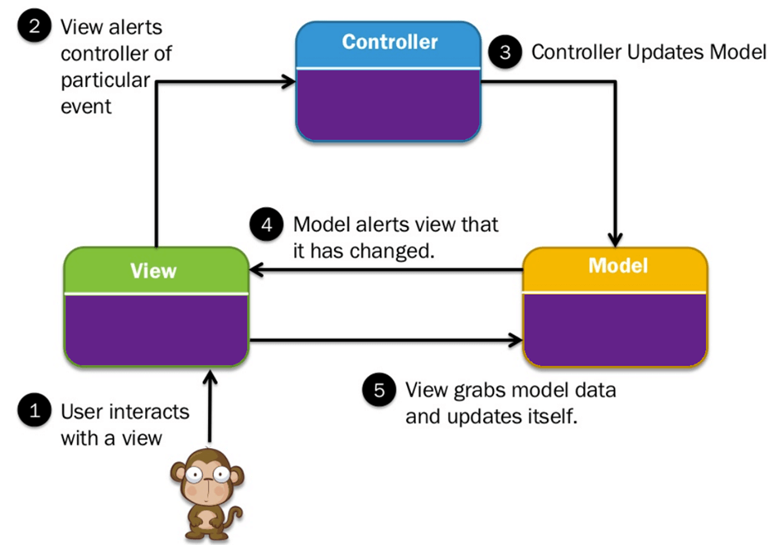

Fig: MVC design pattern

Models for handling data and business logic

Controllers for handling the user interface and application

Views for handling graphical user interface objects and presentation

Thus the results in user request being processed as follows:

1. To address the challenge, the controller retrieves the data it needs from the database.
2. The image is made and forwarded to the device for viewing by the browser.
3. The user (on the client) will forward a link request to the server handler.
4. The controller offers the view of the collected data.

**Benefits of MVC pattern:**

1. The change rarely affects the layout as a whole.

2. Ideal for large size web application development.

3. Production of Web applications quicker.

4. Asynchronous Technique is supported by MVC web application.

5. MVC model returns the data with no scripting required.

6. Provides a variety of opinions

## 2.4.2 Database architecture (client server architecture)

The software I am designing is based on a client-server system, so I use three-tier design for the database system for the implementation of my structure. A three-tier architecture is a client-server architecture that develops and manages functional process logic, data access, computer data storage, and user interface on separate platforms as independent modules. Three layer architecture is a software design standard and well-established architecture for computers.

Benefits of three-tier architecture:

**Performance**: Because the Presentation tier will store queries, the use of the network is limited and the burden on the User and Data third parties is can. You can load-balance every rate, if appropriate.

**Scalability**— Every degree can be scaled horizontally. For e.g., you can load the Presentation tier between three servers without adding servers to the Application and Data Tier to fulfill additional user demands.

**Availability**— If the application tier server is down and caching is open, then the Presentation tier will manage client requests using the cache.

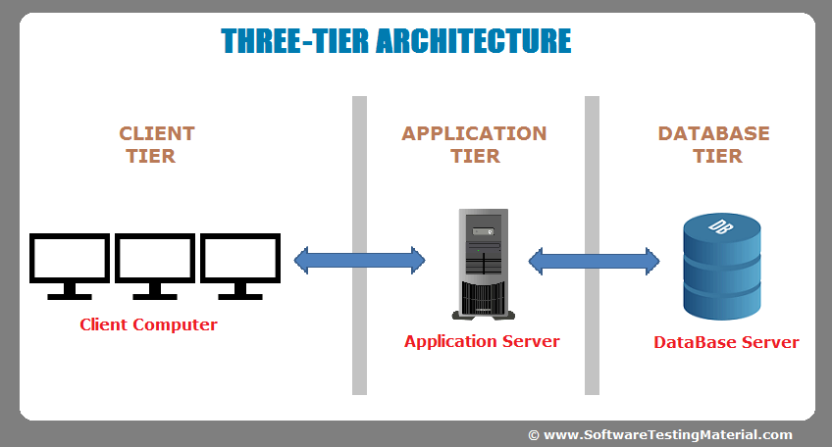

Fig: three-tier architecture

**Presentation Tier:** Involves the top level and shows administration related data open on a site. Each rate interfaces with other outsiders by transmitting criticism through the system to the customer and other outsiders.

**Application Tier:** Similarly named middle point, level of reasoning, market justification or stage of rationale, this level is taken from the level of presentation. This regulates the utility of application by line by line treatment.

**Data Tier:** Houses the data facilities where information is stored and retrieved. In this type, data is kept separate from the software servers or business logic.

# 2.5 SRS document:

A Specification for System Requirements (SRS) is a specification that specifies what the system will do, and how it is expected to perform. And it can also help you make choices about the lifecycle of your product— for example, when to remove a function. Using the SRS helps to make sure that the requirements are met.

There are two types of requirement related to SRS document and they are explained in related term to the project being developed:

## Functional requirement

Defining a device or its part is a practical necessity. This defines the functions which a program is required to perform. A function is simply inputs, behavior, and outcomes. It can be a calculation, data manipulation, business process, user experience, or any other aspects that decide what a system is designed to be doing.

The usable software needs support you catch the system's expected actions. Such activity can be expressed in terms of activities, resources or duties, and which program is allowed to perform.

The benefit of functional requirement is that it allows to test whether the established framework has all the functionalities that were specified in that application's functional specification.

1. **Sign in**

In our system we have developed the function where user can sign in or log in to the system with the registered account and view the details about how and where to create the code and used it. For the login or sign in process user should have the email and password associated or registered in our database.

1. **Sign** up

Where the our system provides login functionality it should also have the sign up function for new user who visited our site and can have access to it. And for this process user should provide a genium email and strong password for their account security.

1. **Update profile**

After the completion of sign up process user can have access to their account or if the user is already registered they can simply login and access it or edit the profile as their need and can see the resulted or create QR code in their account details.

1. **View QR code uses**

QR code can be uses for different purposes such as for marketing or promoting apps or events and in many ways. If the condition such as user are not aware about its uses in todays world then they can simply have information on it through the website and uses according to their needs and required field.

1. **Select QR code type for**

QR code are uses for different purposes and have many advantages on it and knowing the its uses where and where user can choose according to their uses and used it on required place.

1. **Create QR code**

After finalizing the area to uses such as for marketing or promoting user can create the QR code for their uses and applied it to the work.

1. **Track campaign performance**

Tracking test success You will check the scan results after the campaign starts-how many days, where, where and with what apps the codes were scanned. So, you will instantly notice any changes in results. All material is presented in the form of graphs and charts which are easy to understand.

1. **High quality print format**

Users can download the codes in several pixel and vector file formats such as JPEG, PNG, EPS and SVG after creating or generating the QR code. The generated files are high-resolution and the user can choose the best option to print QRR codes in any size, color and on any medium, without any quality compromises.

1. **Sending and viewing messages**

In our system user can encode the message they want to share and shared them among the interested candidate and the user who gets it can decode easily and have it on. For the decoding user can use mobile and scan it through the related app.

1. **Decode generated QR code**

Some of the user also want to decode the already generated code which they have been suggested by some one or been shared or found in some product and they might want to explore it and wants to decode. For this I have developed the feature to decode the already generated code which made they easy to explore the external fields.

1. **Read manual**

All the user directly associated or in directly some of them may not have the knowledge on how to use it then they can simply visit the help sector and read the manual illustrate for the uses.

## Non-functional requirement

The consistency characteristic of a software system is specified by a nonfunctional prerequisite. We describe a set of norms used to determine a system's particular function. Of eg, how quickly does the website load?

To guarantee the reliability and productivity of the entire software program, a non-functional condition is necessary. Failure to meet non-functional requirements may result in systems that fail to meet user requirements.

The advantages of the non-functional requirement are ensuring that the software system follows the rules of law and compliance as well as ensuring the software system's reliability, performance, and availability.

For the better performance and effective functionality, the developer should identify the quality attributes, considering this some of the non-functional requirement are carried out are:

1. **Security:**

Security requirements mean the device is secure from unauthorized access to the system and the data stored inside. Which takes into account various levels of authorization and verification through multiple roles of consumers.

Some of the things needed for the maintaining security are:

Always keeping the software and firmware up-to-date.

Constantly creating new passwords.

Using the multi-factor authentication when need or possible incase.

Examples: Connection permissions can only be modified by data administrator of the network for the specific device details.

1. **Reliability:**

Reliability determines how possible it is for a given period of time for the program to function without interruption. Reliability reduces due to programming errors, device defects or other machine part issues.

Measuring the effectiveness of the program can be measured on the number of correctly performed operations.

Example: the database update process must reign in every related refresh when any update falls flat.

1. **Performance:**

Poor performance results in negative experience for users. It also endangers system security when overloaded. Performance is a numerical function that reflects the system's response to different user interactions.

Things for maintaining performance:

Achieving high web application performance and low page load speeds.

Combining CSS and JavaScript files to reduce HTTP requests.

Example: For users who access the website using an LTE connection, the front-page load time must be no more than 2seconds.

1. **Availability:**

Spinnability is determined by the period the software so resources of the device are accessible for use with all activities. Therefore, planned times of upkeep directly influence this function. And it's important to define how to minimize the impact of repairs.

Things for maintaining availability:

The team has to define the most critical components of the system that must be available at all time.

Well prepared for user notifications in case the system or one of its parts becomes unavailable.

Example: New module delivery should not affect the front page, product pages and test the quality of sites and should not take longer than one hour to complete. The residual pages that may experience problems will have to view a message with a timer indicating when the device will be online again.

1. **Scalability:**

Scalability criteria explain how the device will develop without its output having a negative effect. This involves servicing more people, storing more data and transacting further.

Server scalability allows the database system to be able to perform additional work due to higher physical costs such as external computers, cpus, power and storage.

Things for maintaining scalability:

Compressing data or using optimizing algorithms, etc.

Increase scalability by adding memory, servers, or disk space.

Example: The occupancy cap for websites must be reasonably flexible to accommodate 200,000 visitors at a period.

## 2.6 MoSCoW prioritization:

The MoSCoW method is a prioritization technique used in management, business analysis, project management, and software development to reach a common understanding with stakeholders on the importance they place on the delivery of each requirement.

When managing a project, it is important to develop a clear understanding of the customers' requirements and their priority.

The MoSCoW method can help. MoSCoW stands for must, should, could and would:

M - Must have this requirement to meet the business needs

S - Should have this requirement if possible, but project success does not rely on it

C - Could have this requirement if it does not affect anything else on the project

W - Would liketo have this requirement later, but delivery won't be this time

MoSCoW prioritization for functional requirement.

|  |  |  |  |
| --- | --- | --- | --- |
| No. | Requirement name | Requirement title | Prioritization |
| 1 | FR1 | Sign in | Must have |
| 2 | FR2 | Sign up | Must have |
| 3 | FR3 | Update profile |  |
| 4 | FR4 | View QR code uses | Should have |
| 5 | FR5 | Select QR code for | Must have |
| 6 | FR6 | Create QR code | Must have |
| 7 | FR7 | Track campaign performance | Could have |
| 8 | FR8 | High quality print format | Must have |
| 9 | FR9 | Sending and viewing messages | Would have |
| 10 | FR10 | Decode generated QR code | Must have |
| 11 | FR11 | Read manual | Could have |

MoSCoW prioritization for Non-functional requirement.

|  |  |  |  |  |
| --- | --- | --- | --- | --- |
| No. | Requirement name | Requirement title | Prioritization | Description |
| 1 | NFR1 | Performance | Must have | The more good performance in system, the more useful output can get. |
| 2 | NFR2 | Security | Should have | Data security is one of the any system as important data of code is being used here. |
| 3 | NFR3 | Scalability | Must have | For the scalability with increase of data and new technology, system also have to change. |
| 4 | NFR4 | Maintainability | Must have | To response upcoming errors and bugs maintain is required. |
| 5 | NFR5 | Usability | Must have | In order to archieve business need every system should be useable. |
| 6 | NFR6 | User-friendly | Must have | User friendly system can improve users satisfaction and performance. |
| 7 | NFR7 | Serviceability | Could have | Developed system should be designed in a way to solve errors and problems itself. |
| 8 | NFR8 | Data integrity and GUI consistency | Must have | Work in system should be without confusion and ambiguity. |

# 2.7 Use case

A use case is a tool used in the study of the applications to define, describe and coordinate system requirements. The use case consists of a set of possible sequences of encounters in a specific environment between programs and clients, and is connected to a specific purpose. This consists of a set of modules (e.g., groups and interfaces) that can be used together in a manner that has an effect larger than the parts of the individual entities.

The use case for my project is:

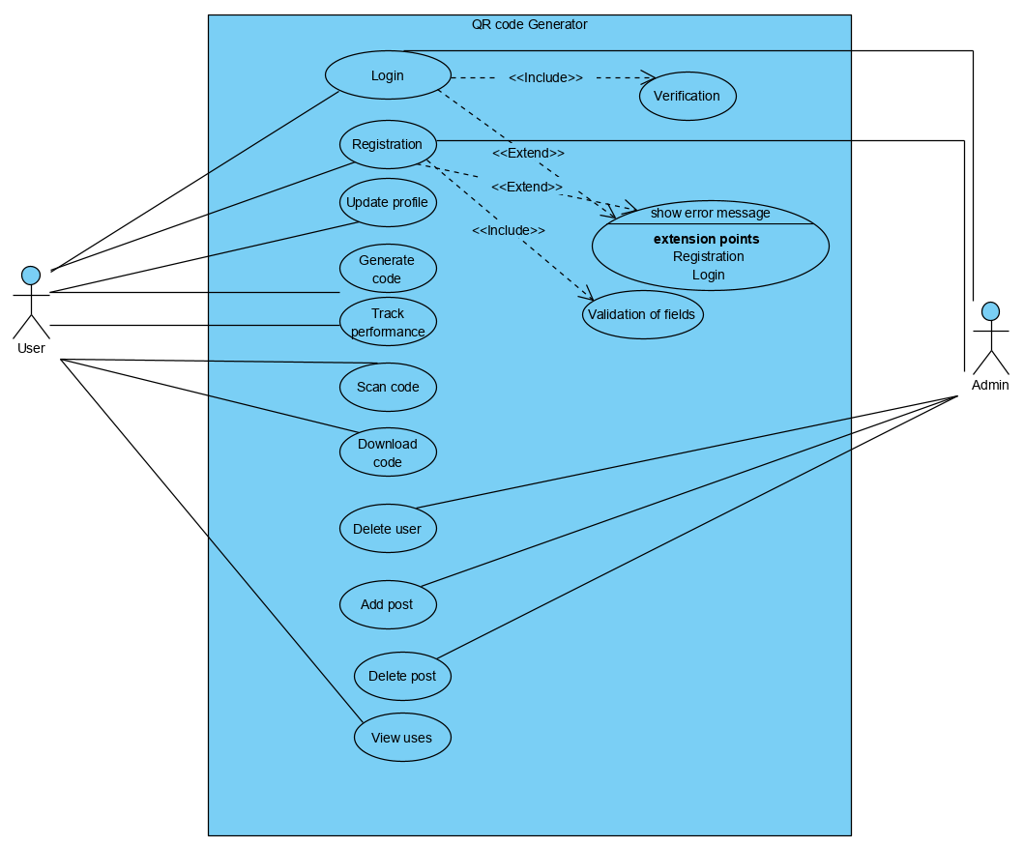

Figure1: use case diagram

# 2.8 Class diagram:

A class diagram is an example of the UML (Unified Modeling Language) relationships and source code dependency among classes. In this case, a class describes the methods and variables within an object which is a particular entity within a system or code unit representing that entity. Unit diagrams are important for object-oriented programming (OOP) of all types.

UML Class Diagram offers a program framework description by displaying groups, characteristics, activities and their relationships. The diagram includes the description, characteristics and function of the class in separately specified storage containers.

**Natural Languages Analysis (NLA):**

Evaluation of natural language is the method of defining verbs, adjectives and nouns in a document of a meaning. Knowing the natural language helps machines to infer sense from the feedback of person or natural language, and others include the creation of natural language.

* Nouns relate to potential classes
* Adjectives relate to potential attributes
* Verbs relate to potential functionality that must be represented.

For the identification of NLA there is a scenario and the scenario for the project is:

**SCENARIO:**

Todays world is of internet and all the things along with the human being are in dependent upon mostly on internet or the technology. As the technology and the internet is growing the day by day the uses of it in different area is growing rapidly. The world is being advanced and advanced.

Now days most of the business are successful through use of internet. They use internet for the advertisement purposes, learning, teaching, and many more. Considering its growth and making the day to day work easy we thought to develop a system where a user can compress a data and use for it work with the help of quick response code generator. Which would facilizes the user to generate the code or scan the code easily from accessing browser and can easily scan from the mobile phones with supportive apps.

A QR code (quick response code) is a type of 2D bar code that is used to provide easy access to information through a smartphone. The system should be Web API show it should be developed in PHP it is widely used and compatible one and many framework are also available. The user being registered in system must provide the details such as: Full name, Address, Mobile number, Email etc.

And the functions needed to be implemented in the system are:

* User can create an account, edit profile, view details.
* User should be provided with manual in the system to create the code.
* User can create the QR code for social media channels
* User can create the code for vCard
* User can create a code for the website links
* User could be able to create code for messages
* User should be able to download the generated code
* Users should be able to share generated code through social media.
* User can also delete generated code from their account.
* Users should also be provided with the uses of QR code.

**NLA identification from the scenario:**

|  |  |
| --- | --- |
| **Nouns** | **Verbs** |
| Users, Admin, QR code | Update profile, view profile, create QR code, Decode generated code, Download code, Add or delete QR code, uses of QR code |

**Candidate class:**

1. Users
2. Admin
3. QR code

**Methods:**

1. Update profile
2. View profile
3. Create QR code
4. Decode generated code
5. Download code
6. Add QR code
7. Delete code
8. View uses of QR code

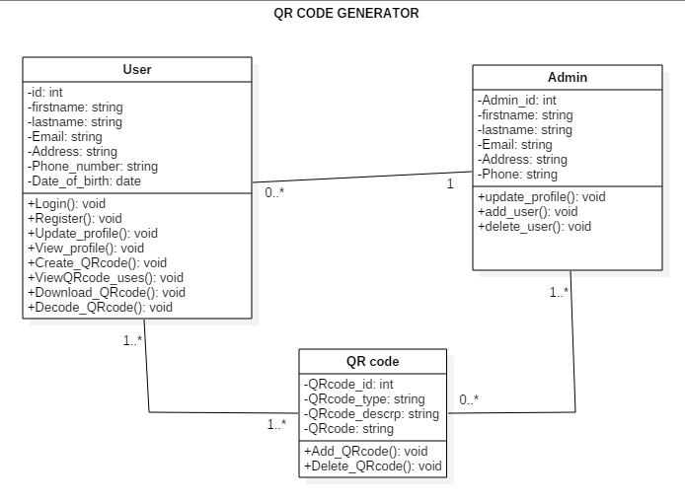

Fig: Class diagram

# Chapter 3: Design

# 3. Design:

Designing is the process or the early phase of the project development where’s the project works/key features, structure as well as the success of the project criteria are well explained and figure out. Some of the criteria are mentioned in the design phase of my project such as structural modelling, behavioral modelling, database modeling and UI modeling which requires certain diagram. All of the phases included in design are well explained how it is applied in the project and they are:

## 3.1 Structural Modeling

It simulation reflects the device structure and this is the frame or location where all other elements reside. Structural modeling captures a system's static characteristics, it consists of class diagram, entity diagram, deployment diagram, part diagram, and so on, but this model never defines the system's fluid actions and looking to the requirement for the design phases I have asked to provide details on class diagram as well as the final class diagram of the project.

### 3.1.1 class diagram

#### It is the simulation language used to represent the framework for general purposes. It is a virtual language required for the software industry to define, simulate, build and log operating device objects as well as market modeling. In all forms of object-oriented programming (OOP), class diagrams are useful.

#### Justification: why class diagram is made

Reasons of including class diagram in my project are explained/described in points below:

* It represents or describes the overall project on a single diagram.
* It can be used for the base for deployment and component diagram.
* As my project is OOP object-oriented program this is the only UML which can appropriately depict various aspects of OOPS concept.
* As the classes are building blocks of an OOP-based program, the class diagram has a fitting framework to reflect the groups, the inheritance and everything that OOPs have in their sense.It illustrates the proper design and analysis of application can be faster and efficient.

In the process of drawing class diagram many notations representing the process are included and it uses or notations explanation used in process of drawing class diagram are:

**Notations used in class diagram:**

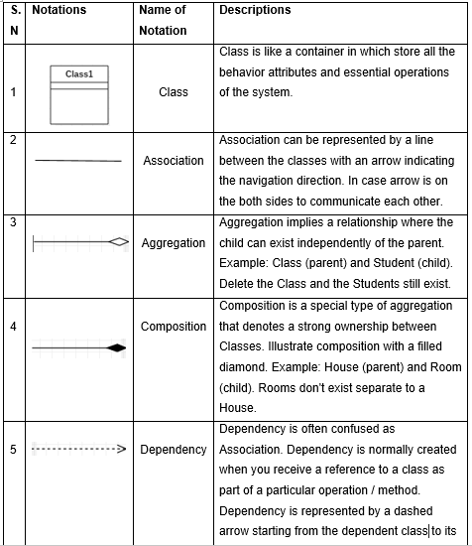

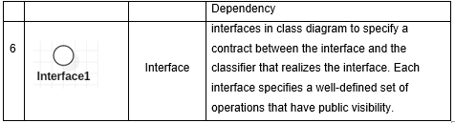

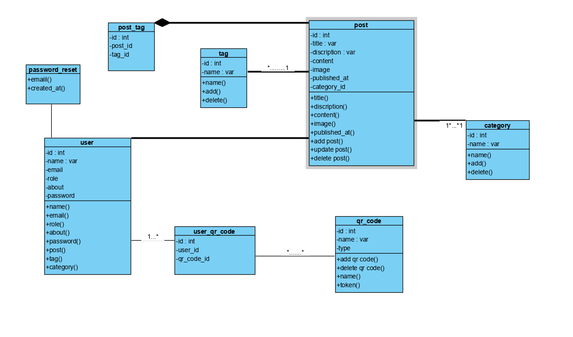

Fig: Class diagram

The above shown class diagram is for the QR code generator system. This class diagram clearly describes the attributes and the methods of the classes which helps in explaining the system in easy way. While developing the class diagram I have identified some classes and their attributes as well as the methods and the relations have been also shown in diagram with multiplicity. Such as user can be one or many and QR code be zero to many as one user may not have QR code created or can have created multiply times in numbers and one QR code can have one description and specify date of creation so they are shown in one to one.

## 3.2 Behavioral Modeling

### Behavioral Diagrams represent the components of a structure that are time-dependent and express the system's complex principles and how they contribute to one another. The components in these representations mimic the verbs in a natural language, and the linking associations usually reflect the rate of change.

### 3.2.1 Activity Diagram

Activity diagram explains the dynamic aspects of the system/project. It is important diagram in UML as the part of Behavioral modeling. The operation diagram is basically a flowchart for describing the flow from one task to another. The behavior could be defined as machine service.

The control flow is drawn from one operation to another. This flow can be sequential, branched, or concurrent. Activity diagrams deal with all type of flow control by using different elements such as fork, join, etc.

#### Justification:

Activity diagram captures the dynamic behavior of the system and other purpose of an activity diagram are:

* It draws the activity flow of a system on high level.
* This diagram describes the parallel, branched and concurrent flow of the system.
* Diagram describes the sequence from one activity to another.
* An activity diagram portrays the control flow from a start point to a finish point showing the various decision paths that exist while the activity is being executed.

**Notations used in Activity diagram:**

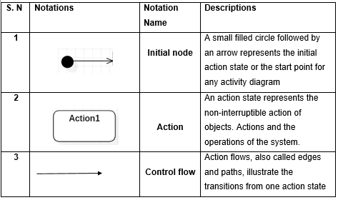

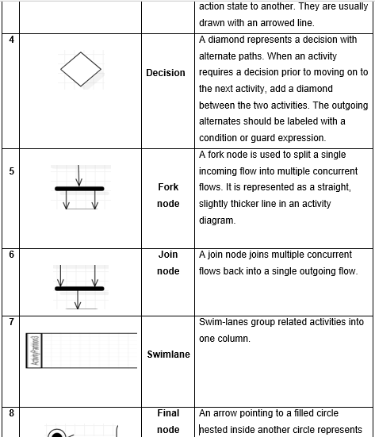

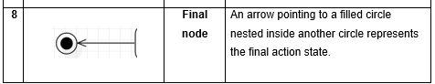

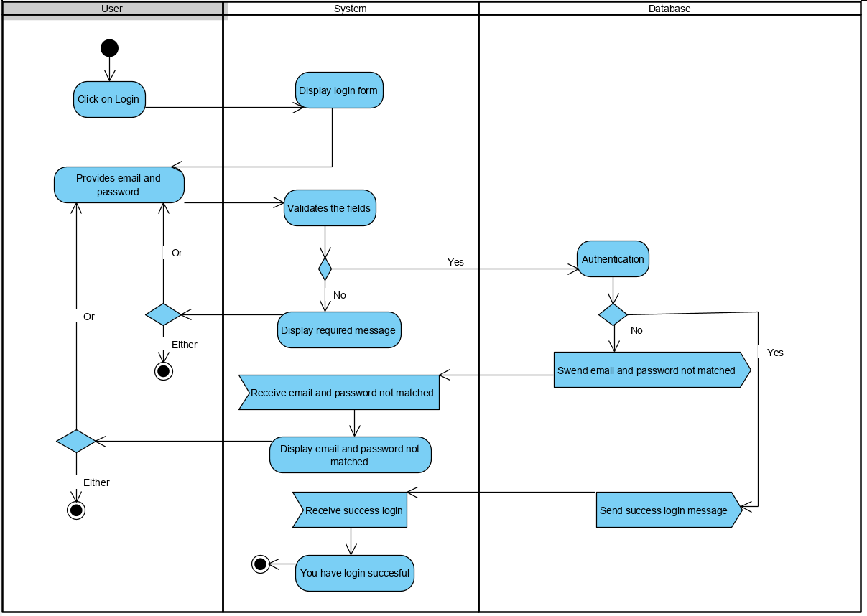

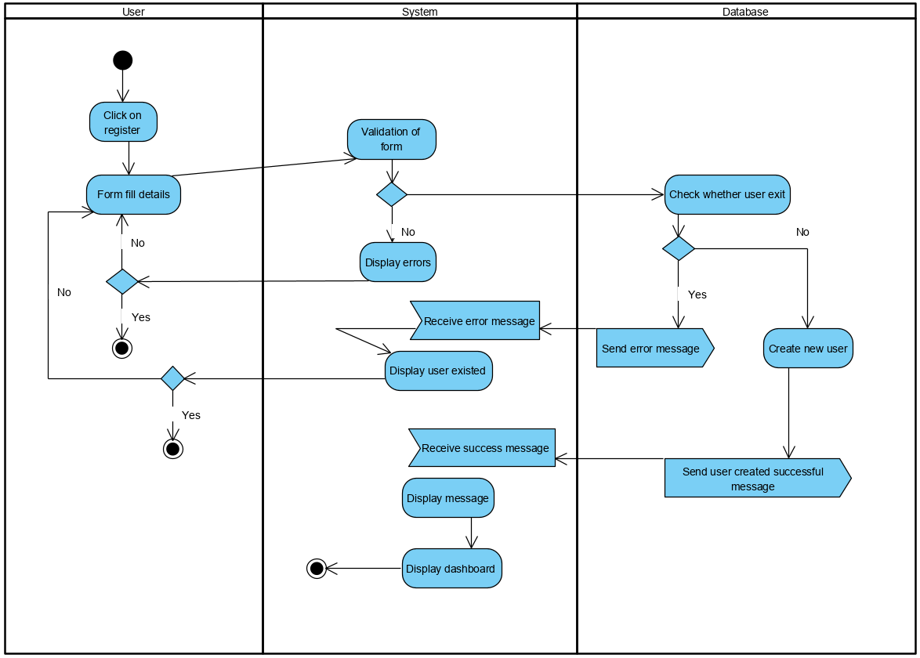

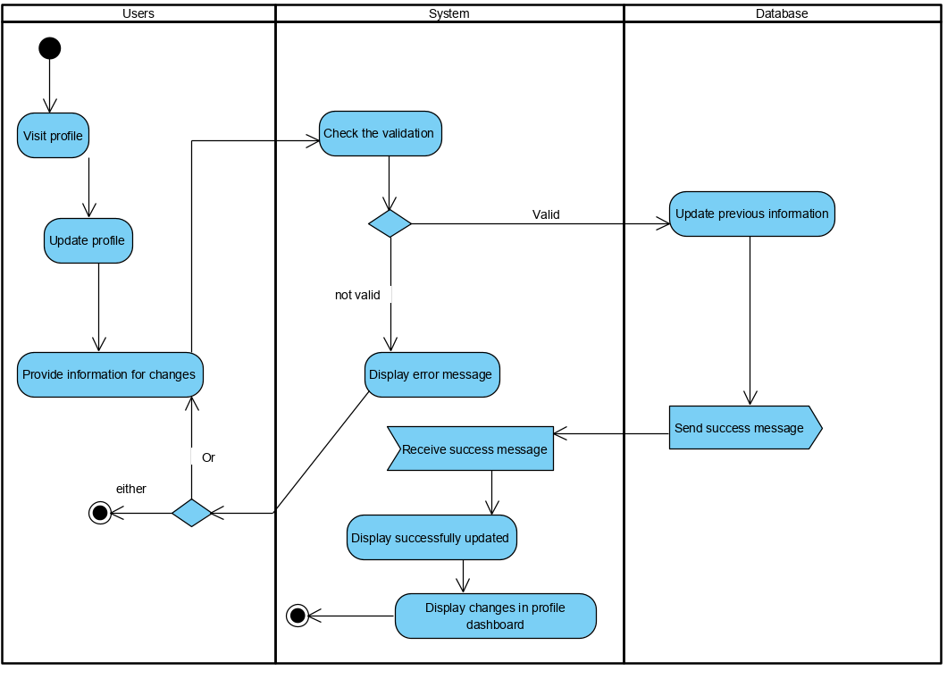

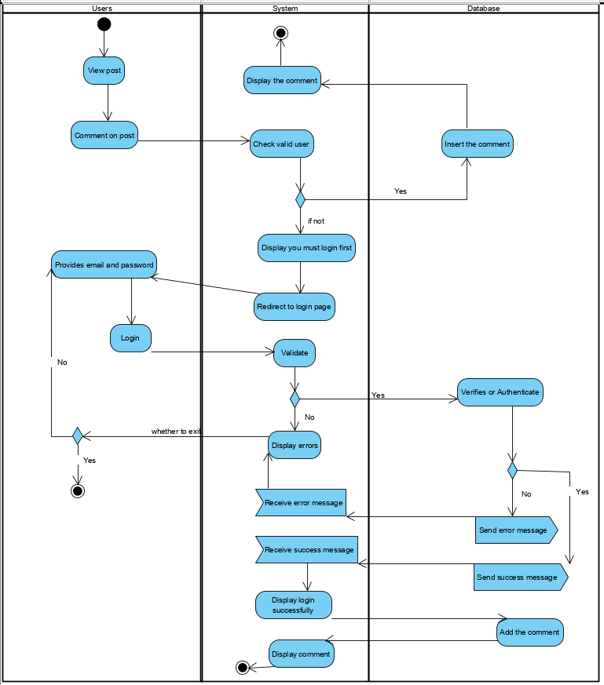

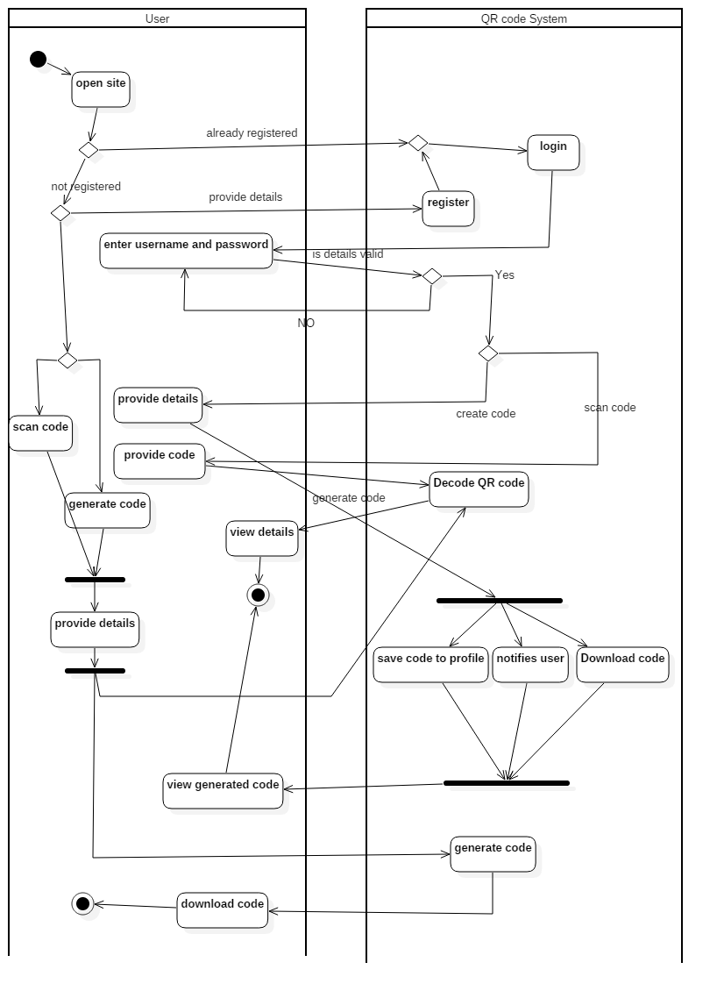

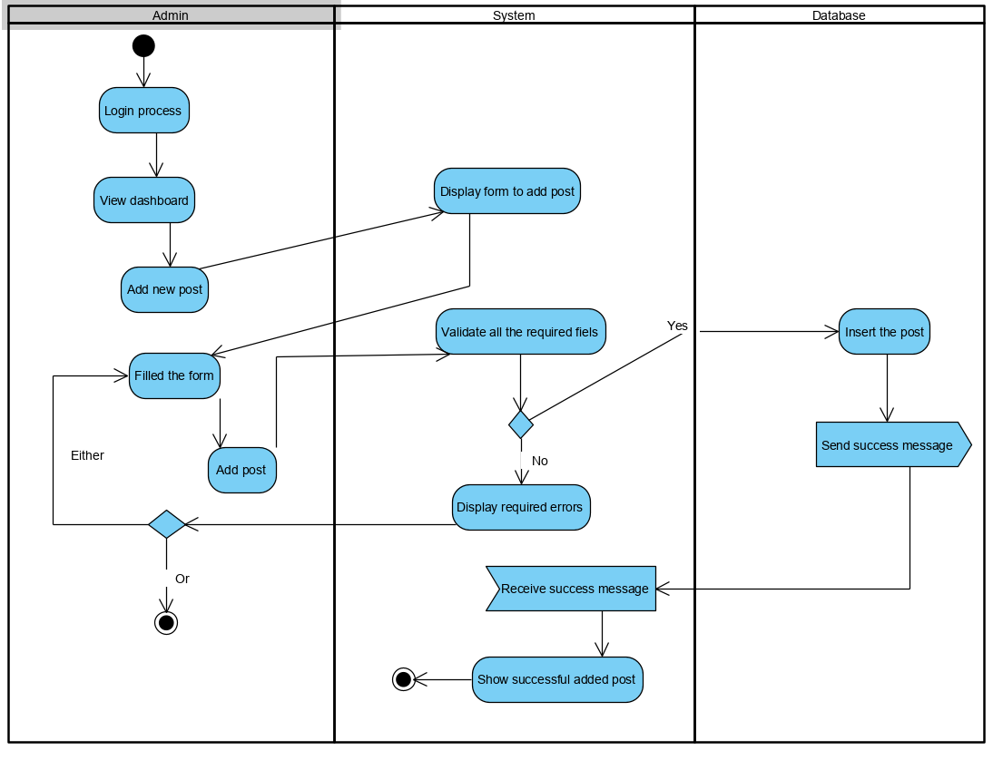

Fig: Activity Diagram

The above activity diagram shows the user interaction to our system how it reacts or acts. And going through the diagram we would know that user who open site can go through the easy process of creating code with registration or login process or can go through without process and create as well as decode code.

The diagram is developed in swim lane using a tool named StarUML. how the user interact with system in every aspect is shown from starting to ending point.

### 3.2.2 Sequence Diagram

#### A timeline diagram shows relationships between items organized in order of time. It describes the individuals and classes that engage in the scenario and the sequence of communications that are exchanged between objects required to execute the features of the scenario. Usually sequence diagrams are correlated with application case realizations in the Logical View of the unit under development.

#### Justification:

In the design phase of my project I have made sequence diagram and the justification of making this diagram is:

* In the design phase, the diagram can be used by architects and engineers to compel relations between the artifacts of the structure, thereby fleshing out the overall system architecture.
* Process diagram shows the linear sequence of the relations between events that exist.
* A business-level sequence diagram may be used as a checklist guide to clarify specifications for potential program introduction, in addition to recording an organization's current affair.

**Notations used in Sequence diagram:**

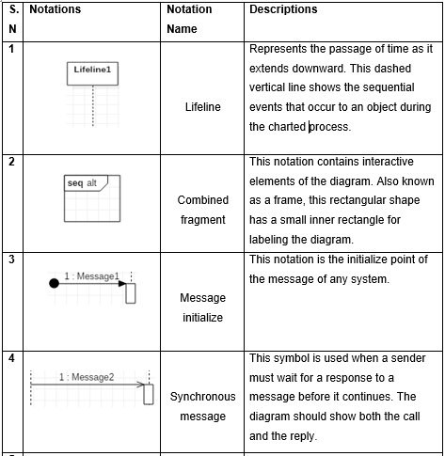

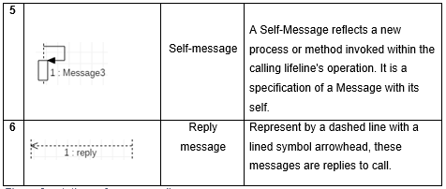

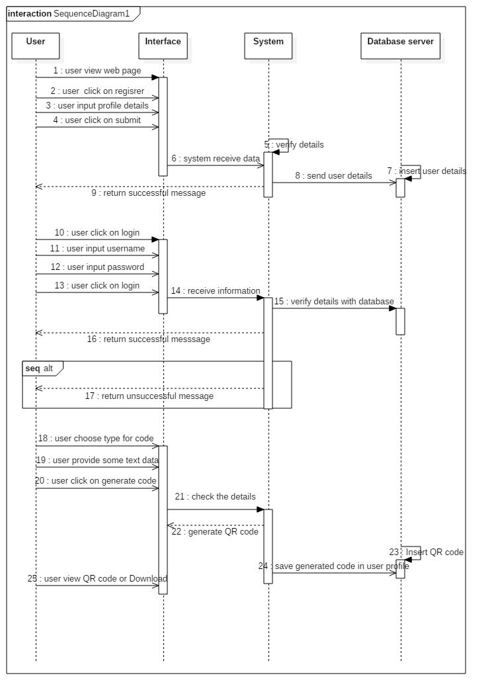

Fig: Sequence Diagram

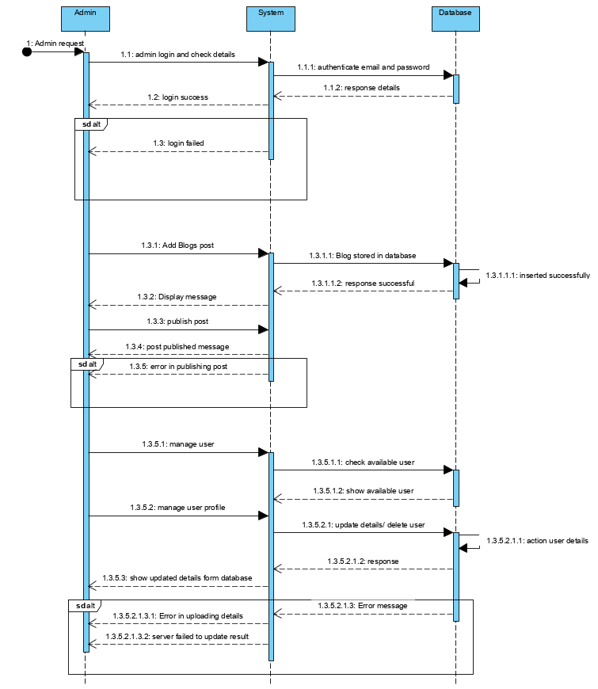

Fig: sequence diagram

The designed sequence diagram explains how the objects interactions occur in sequential order and the functionality. The above diagram says the how user registered in our system, how the exchange of information and message is going on through the system in order. In diagram I have user four lifeline user, interface, system, database server.

User interact with the interface and the system receive info as the user provide it to the interface and provide return message and check the login functionality in case of user login.

## 3.3 Database Modeling

A System architecture describes a database's conceptual nature and layout, which determines how data is stored, retrieved, and modified in a database management framework. A data model helps design the database at the conceptual, physical and logical levels.

### 3.3.1 Data dictionary

We may claim a file or a group of files to a data dictionary containing the information, i.e. records. It is an essential part of any relational database. Unfortunately, owing to its significance, only data base managers communicate with the application vocabulary becomes inaccessible to most database users.

In the code dictionary the metadata includes:

* Table-defined constraints, including primary keys, foreign-key relations to other tables, and non-zero constraints.
* All database tables and their owners ' names.
* Names of all indexes and columns referred to by the sheets in all those tables.

Some of the tables were made for storing information of user, admin and QR code as well as posts and images used they are:

**Table for user:**

|  |  |  |  |  |
| --- | --- | --- | --- | --- |
| Name | Data type | Length | Null | Constraint |
| Id | Integer | 10 | No | Primary key |
| Firstname | Varchar | 200 | Yes | - |
| Last name | Varchar | 200 | Yes | - |
| Email | Varchar | 200 | Yes | - |
| Address | Varchar | 200 | Yes | - |
| Phone_number | Varchar | 200 | Yes | - |
| Date_of_birth | Date | - | Yes | - |
| Registered_date | Date | - | Yes | - |

**Table for QR code:**

|  |  |  |  |  |
| --- | --- | --- | --- | --- |
| Name | Data type | Length | Null | Constraint |
| QRcode_id | Integer | 10 | No | Primary key |
| QRcode_type | Varchar | 100 | Yes | - |
| Descrption | Varchar | 200 | Yes | - |
| QRcode | Varchar | 200 | Yes | - |
| Created_date | date |  | Yes | - |
| User_id | Integer | 10 | No | Foreign key |

**Table for post:**

|  |  |  |  |  |
| --- | --- | --- | --- | --- |
| Name | Data type | Length | Null | Constraint |
| Post_id | Integer | 10 | No | Primary key |
| Title | Varchar | 100 | Yes | - |
| Description | Varchar | 200 | Yes | - |
| Image_name | Varchar | 200 | Yes | - |
| Published_date | date |  | Yes | - |
| Admin_id | Integer | 10 | No | Foreign key |

**Table for slider:**

|  |  |  |  |  |
| --- | --- | --- | --- | --- |
| Name | Data type | Length | Null | Constraint |
| Id | Integer | 10 | No | Primary key |
| Title | Varchar | 100 | Yes | - |
| Descrption | Varchar | 200 | Yes | - |
| Image_name | Varchar | 200 | Yes | - |
| Published_date | date |  | Yes | - |

**Table for category:**

|  |  |  |  |  |
| --- | --- | --- | --- | --- |
| Name | Data type | Length | Null | Constraint |
| Id | Integer | 10 | No | Primary key |
| name | Varchar | 100 | Yes | - |

**Table for tag:**

|  |  |  |  |  |
| --- | --- | --- | --- | --- |
| Name | Data type | Length | Null | Constraint |
| Id | Integer | 10 | No | Primary key |
| name | Varchar | 100 | Yes | - |

### 3.3.2 ER diagram

A Diagram of Organizational Relationships (ERD) is a description of data structures. An Individual Relationship Diagram shows the entities (tables) and tables within that group of tables.

An entity-relationship (ER) diagram is a graphical representation of individuals and their interactions with each other, usually used in data base computation or arrangement of data in the information system. An individual is a piece of data-an item or idea about which the data is stored.

And there are three basic elements in ER-Diagrams:

* Attributes are the data which an entity wants to collect.
* Relationships describe the interinstitutional relationships.
* Entities are the "things" we would like to store information for. An entity is an individual, place, object or event.

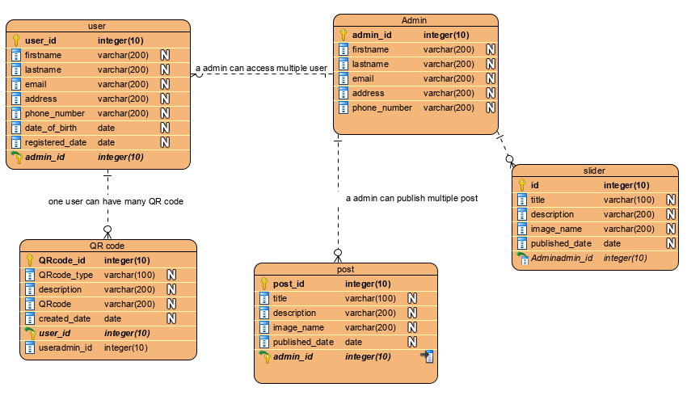

Fig: ER- Diagram

## 3.4 UI Modeling

UI modeling is the process of making interfaces in software which focus on design or looks. It typically refers to graphical user interface but also includes others, such as voice-controlled ones. The design for my web app as a proto-types are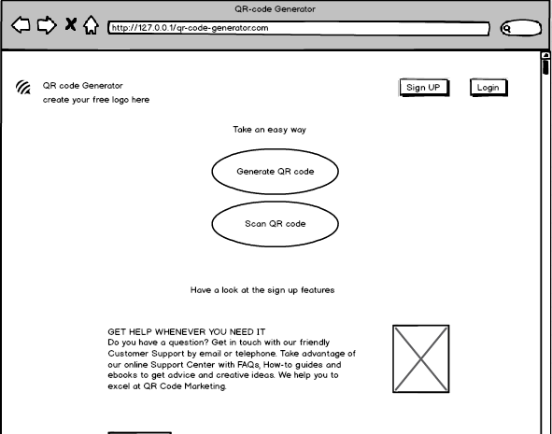

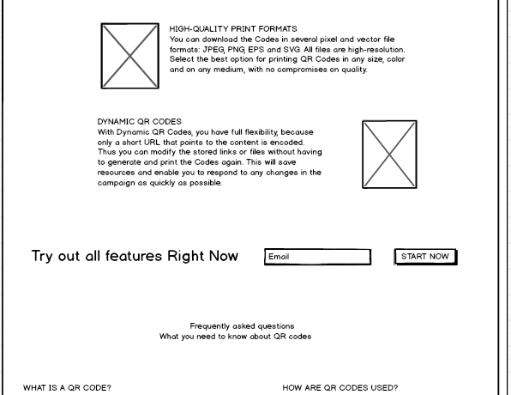

Fig: home page

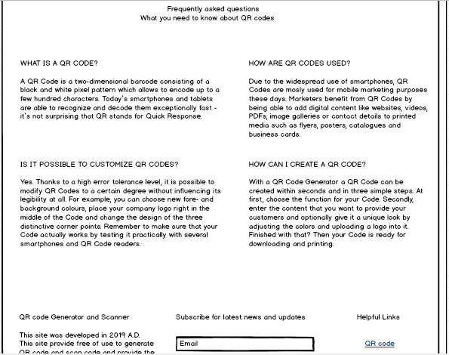

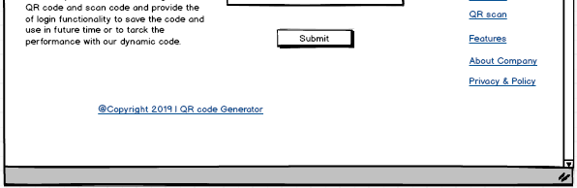

Fig: home page

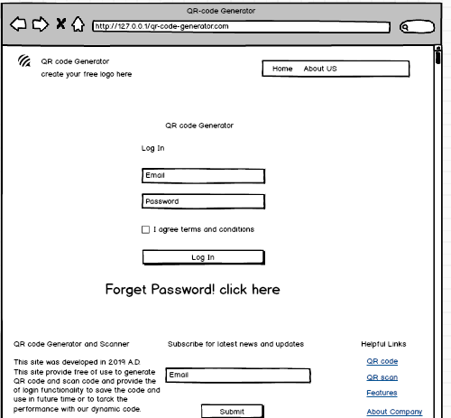

Fig: login page/ form

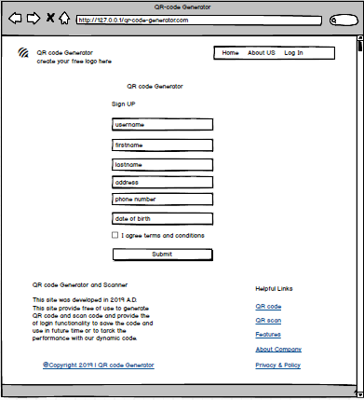

Fig: registration page

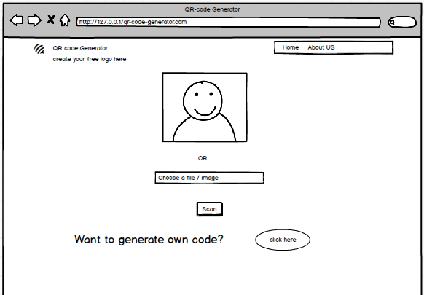

Fig: scan code

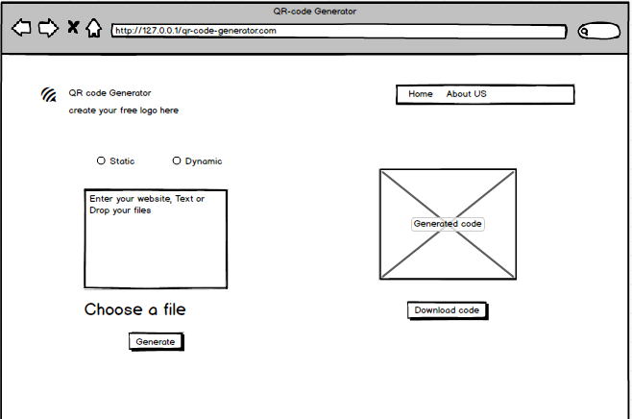

Fig: generate code

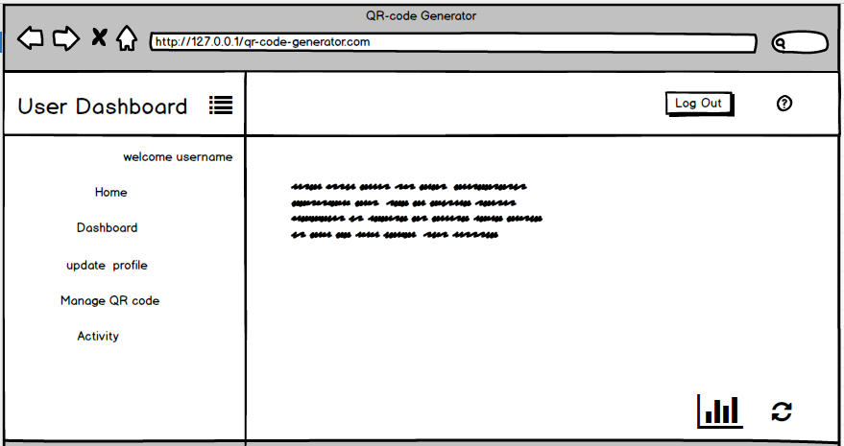

Fig: user dashboard

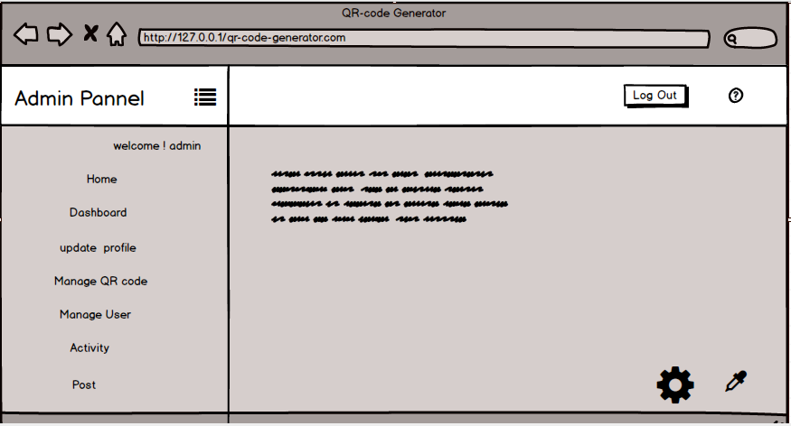

Fig: admin panel

# Chapter 4- Implementation

Implementation is the third phase of methodology for the development of waterfall models. This converts the definition of physical design into the conceptual or operation, into a smaller unit of components or into the working computer code. This process guarantees the functioning of the components of the device. The appendix lays out all the architecture of the UI and its coding element.

## programming language

The programming language is the correct language, which includes a collection of commands, instructions and many other syntaxes which produce different output types. It used to apply the algorithms for computer programming. Word where programmers write code into high-level language, and this is translated into low-level language, using a parser that explicitly understands computer hardware.

For the development of this project I must be using PHP Laravel framework to convert features and functions of the physical design into real implementation. And I must be using JavaScript, bootstrap, CSS for making design user attractive and user friendly.

## Design pattern (MVC)

Project pattern is normally a portable approach, it provides a better answer to a common software design problem, and it allows a reasonable or manageable clean program code. It is essentially a description of how issues occur in the method. Development style makes programming modular, which speeds up the project development cycle. Many different design patterns are available for problem solving.

I must use MVC template pattern for this project, MVC stands for Model View Controller.

# Chapter 5- Testing

Testing is the process used to identify the correctness completeness and quality of the developed computer software. Or we can claim the checking is an exercise to verify if the actual results fit the expected results and to make sure the software system is free of defects. Under controlled conditions, monitoring software runs the program to ensure that it behaves as defined, find anomalies, and check that what has been stated is what the user actually requested.

## Black Box Testing

Black-Box research is a code review technique that analyzes an application's utility without peering into its internal frameworks or functions. For every degree of computer research, this evaluation methodology can be used in all intents and purposes: process, incorporation, method, and approval. It is some of the time referred to as basic, dependent research.

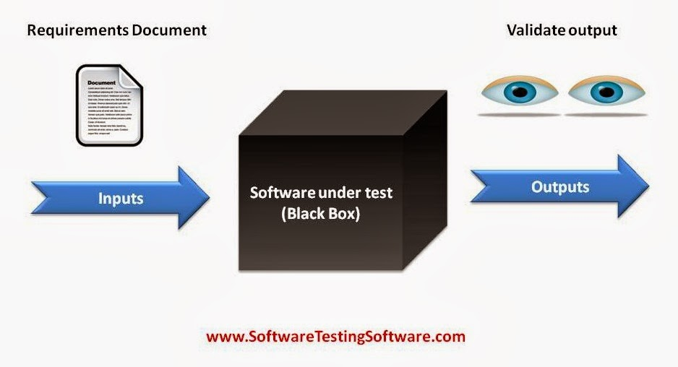

Figure: Black Box Testing

Black box testing was performed for the some of the functionality for our developed system and their tests and test cases are mentioned with detailed:

Login:

|  |  |  |  |  |  |  |
| --- | --- | --- | --- | --- | --- | --- |
| **Test case ID** | **Test Scenario** | **Test Description** | **Test Data** | **Expected Result** | **Actual Result** | **Status** |
| T01login | Login validation | Without email and password | Email=””  Password=”” | Login failed message email required | Message displayed email required | Pass |
| T02login | Login validation | Providing email and leaving password field empty | [Email=bhupendrasharma98123@gmail.com](mailto:Email=bhupendrasharma98123@gmail.com)  Password=”” | Login failed message password require | Message displayed password required | Pass |
| T03login | Login validation | Providing invalid email and password | [Email=bhupendra@gmail.com](mailto:Email=bhupendra@gmail.com)  Password=bhupendra12 | Login failed message credentials do not match our record | Message displayed credentials do not match record | Pass |
| T04login | Verification | Providing valid email and password | Email= [bhupendrasharma98123@gmail.com](mailto:bhupendrasharma98123@gmail.com)  Password=”sharma77” | Login success show dashboard | Login succeed displayed dashboard | Pass |

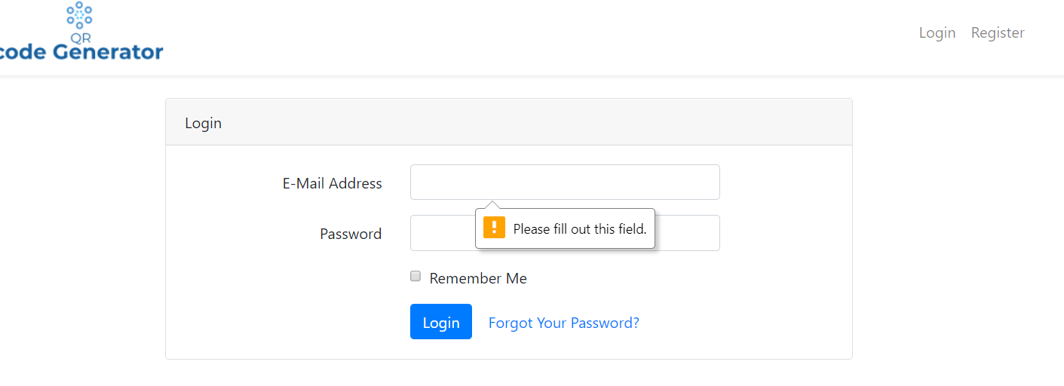

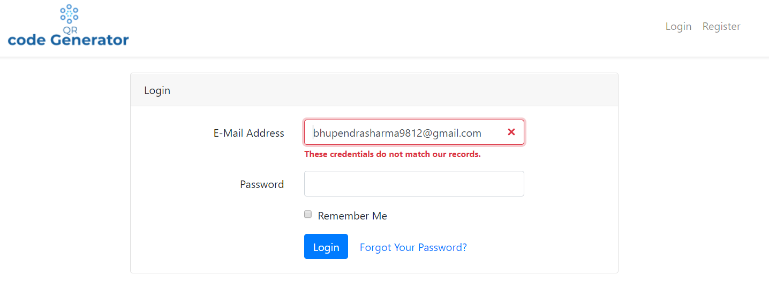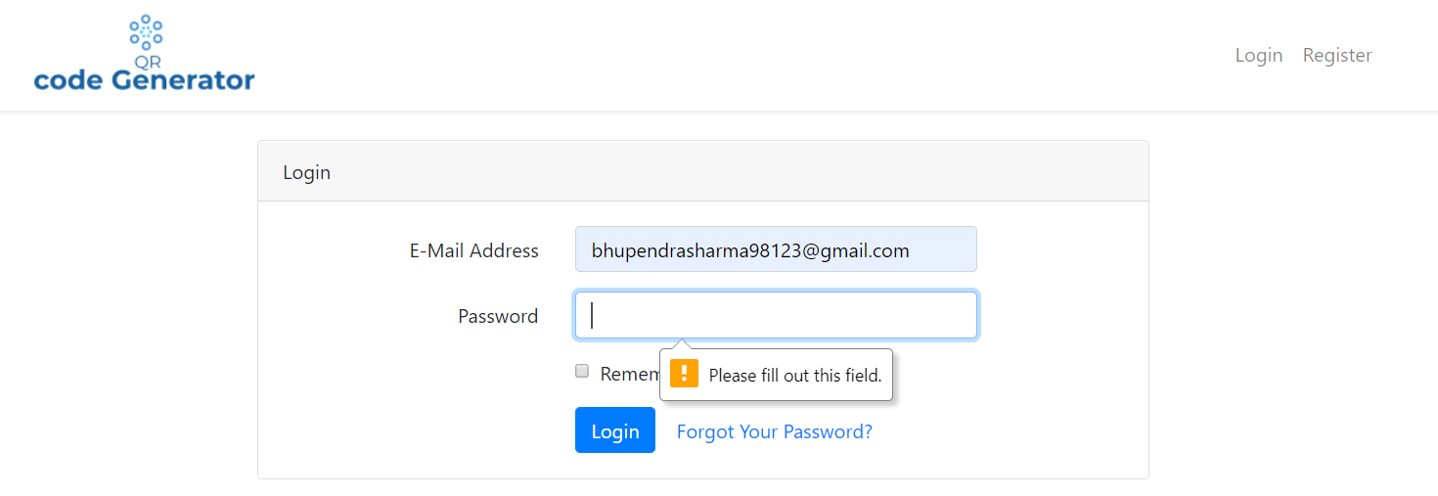

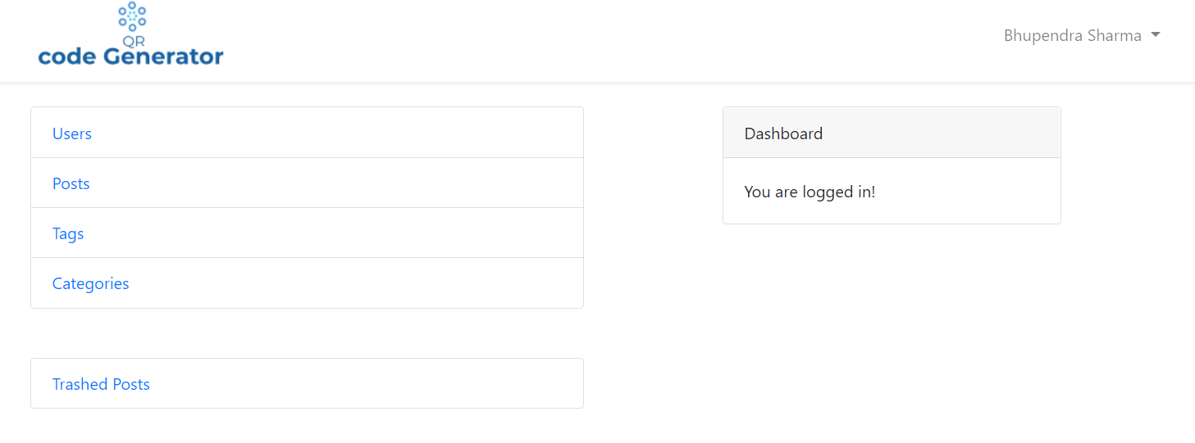

Registration:

|  |  |  |  |  |  |  |
| --- | --- | --- | --- | --- | --- | --- |
| **Test case ID** | **Test Scenario** | **Test Description** | **Test Data** | **Expected Result** | **Actual Result** | **Status** |
| T05registration | Registration validation | Without name, email, password | Name=””  Email=””  Password=”” | Failed display validation required details | Message displayed | Pass |
| T06registration | Registration validation | Providing name, email and leaving password field empty | Name=Bhupendra Sharma  [Email=bhupendrasharma98123@gmail.com](mailto:Email=bhupendrasharma98123@gmail.com)  Password=”” | Registration failed message password require | Message displayed password required | Pass |
| T07registration | Registration validation | Providing name, email and password and wrong confirm password | Name=Bhupendra Sharma  [Email=bhupendrasharma98123@gmail.com](mailto:Email=bhupendrasharma98123@gmail.com)  Password=”sharma77”  Confirm password=”sharma78” | Display Message the password you entered does not match | Message displayed password does not match | Pass |
| T08registration | registration | Providing valid name, email and password | Name=Bhupendra Sharma  [Email=bhupendrasharma98123@gmail.com](mailto:Email=bhupendrasharma98123@gmail.com)  Password=”sharma77”  Confirm password=”sharma77” | Registration should success and show user dashboard | Registration succeed and it shows user dashboard | Pass |
| T09registration | Registration | Email validation providing email without @ | Email=”bhupendrasharma98123 gmail.com” | Display the message showing email need to have @ in | Message displayed successfully | pass |

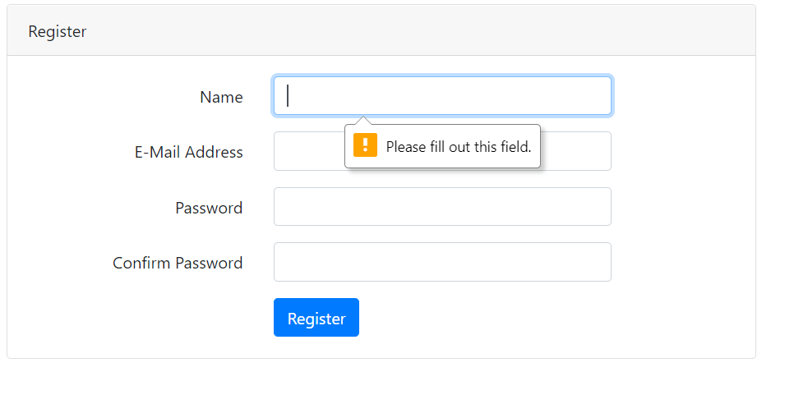

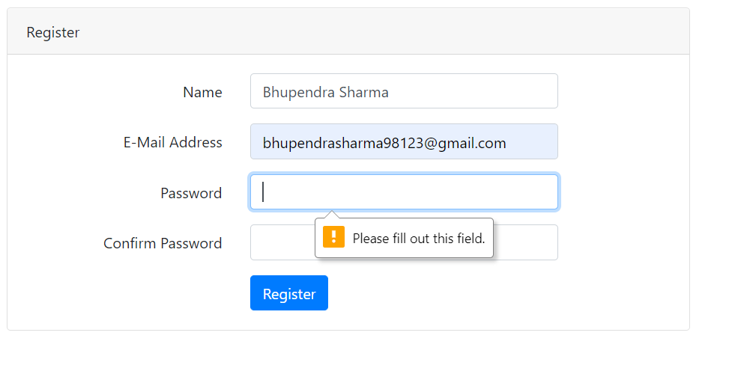

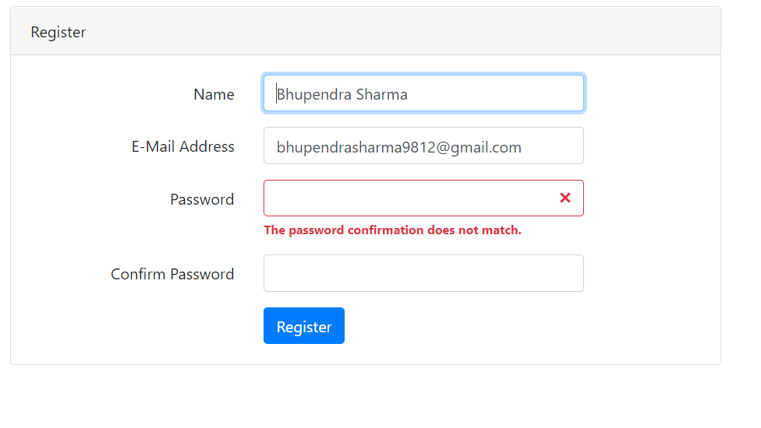



Create post:

|  |  |  |  |  |  |  |
| --- | --- | --- | --- | --- | --- | --- |
| **Test case ID** | **Test Scenario** | **Test Description** | **Test Data** | **Expected Result** | **Actual Result** | **Status** |
| T010create post | Validation fields required | Submit form without providing details | Title=””  Description=””  Contents=””  Published at=””  Image=””  Category=””  Tags=”” | Failed display validation required details | Message displayed | Pass |
| T011create post | Validation fields required | Submit form providing details and leaving other | Title=”QR code”  Description=”this is the testing”  Contents=””  Published at=””  Image=””  Category=”programming”  Tags=”” | Should show the message about required fields with validation | Message displayed requesting the required field | Pass |
| T012create post | Creating post | Providing all details to the form post | Title=”QR code”  Description=”this is the testing”  Contents=”are you searching content”  Published at=”2020-1-29”  Image=”code.png”  Category=”programming”  Tags=”learn-code” | Message should display post created successfully and return to post index page | Message displayed and return to index page | Pass |
| T013create post | Creating post | Creating post without having category | Click on Add post | Return back to the add category page displaying message that “add some category first” | Message displayed and show add category page | Pass |

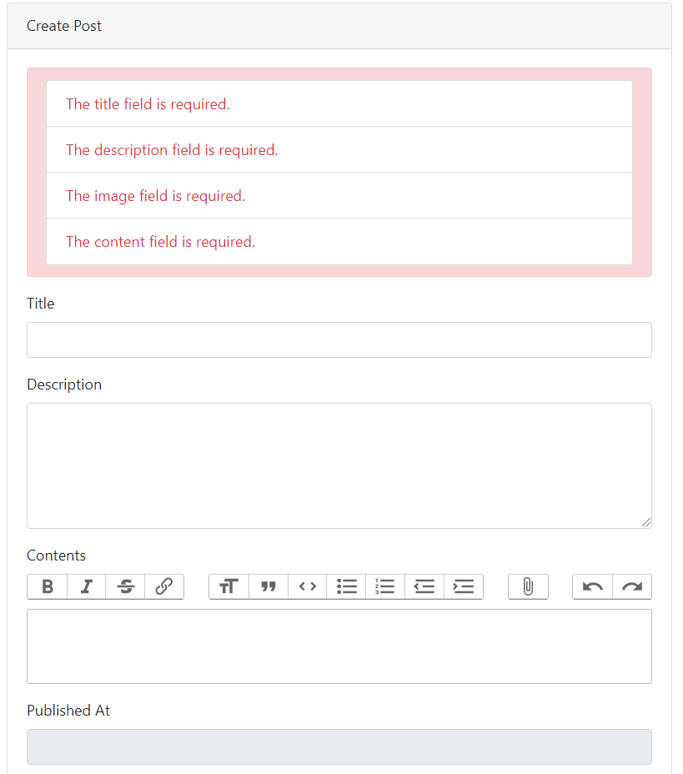

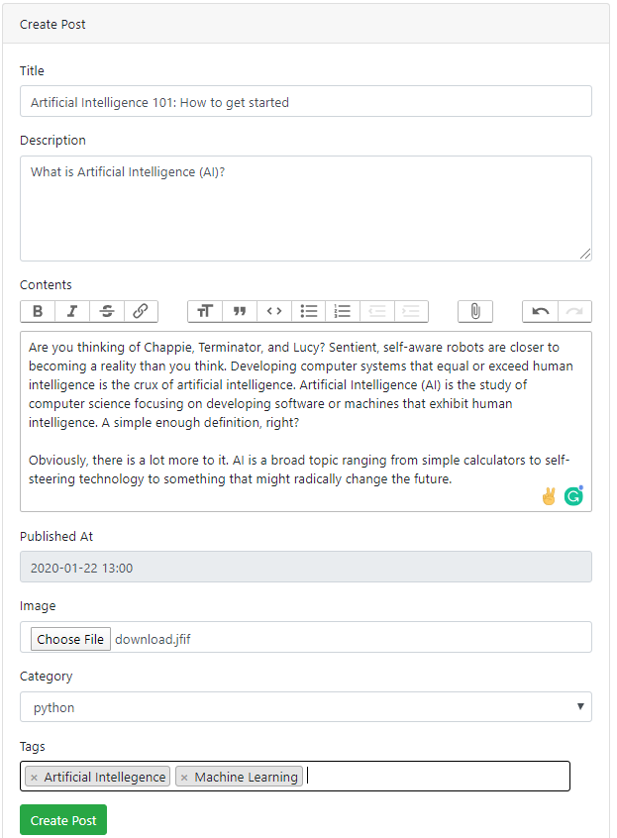

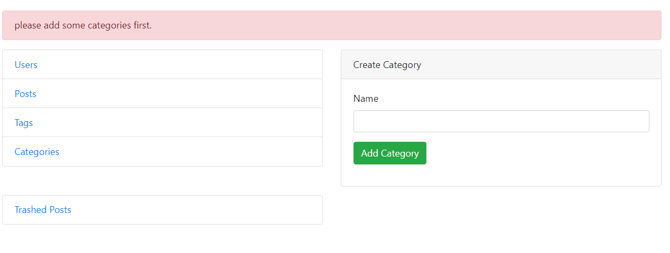

Category:

|  |  |  |  |  |  |  |
| --- | --- | --- | --- | --- | --- | --- |
| **Test case id** | **Test scenario** | **Test description** | **Test data** | **Expected result** | **Actual result** | **Status** |
| T019category | Add category validation | Providing empty category name and submit | Name=”” | Validation Message should display of required field | Message displayed to enter name first | pass |
| T020category | Add category | Provide category name and submit | Name=” Laravel” | Category should insert in database and display message and return back to category index | Category created success and return back to category index | pass |
| T021category | Adding category that already existed in database | Providing existing details of category | Name=” Laravel” | Error message should be displayed that name has already been taken | Message displayed and return back to add category page | pass |

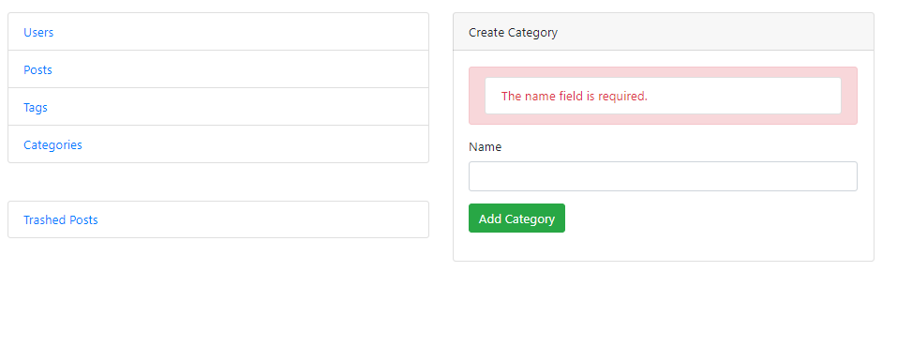

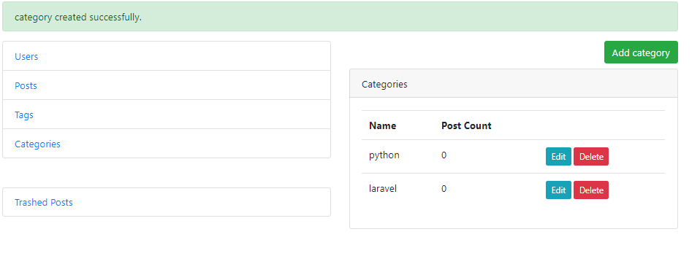

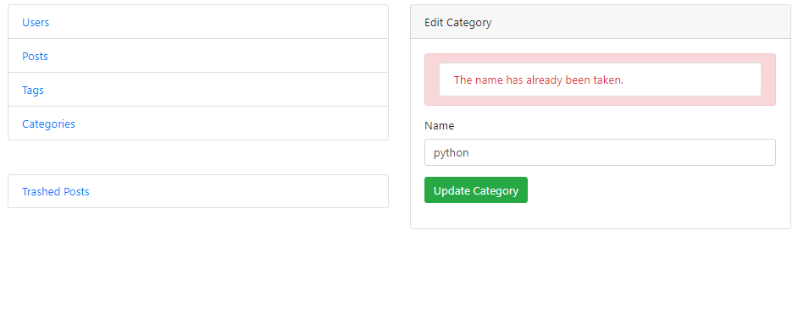

Update Category:

|  |  |  |  |  |  |  |
| --- | --- | --- | --- | --- | --- | --- |
| **Test case id** | **Test scenario** | **Test description** | **Test data** | **Expected result** | **Actual result** | **Status** |
| T022 update category | Update category | Providing empty category name and submit | Name=”” | Validation Message should display of required field | Message displayed to enter name first | Pass |
| T023 update category | Update category with new name | Provide category new name and submit | Old Name=” Laravel”  New name=” Laravel5.8” | Category should be update and return back to category index | Updated category and success message and return back to category index with new category name | Pass |



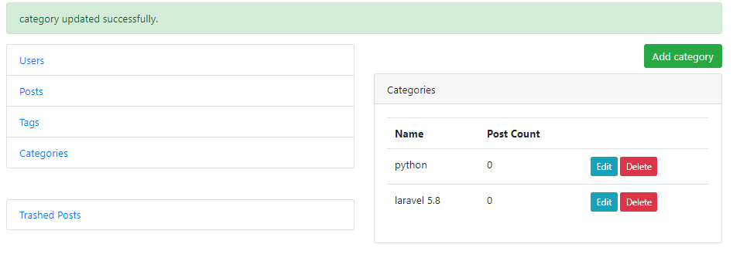

Generate QR code of URL:

|  |  |  |  |  |  |  |
| --- | --- | --- | --- | --- | --- | --- |
| **Test case id** | **Test scenario** | **Test description** | **Test data** | **Expected result** | **Actual result** | **Status** |
| T026 URL QRCODE | Create QR code of URL | Providing empty details | URL= NULL | Validation error showing please enter URL first | Validation error showing message | Pass |
| T027 URL QRCODE | Create QR code of URL | Providing URL | URL= “<http://localhost/qrcodesystem/generatecode>” | QR code should be generated and displayed | QR code generated successfully | Pass |

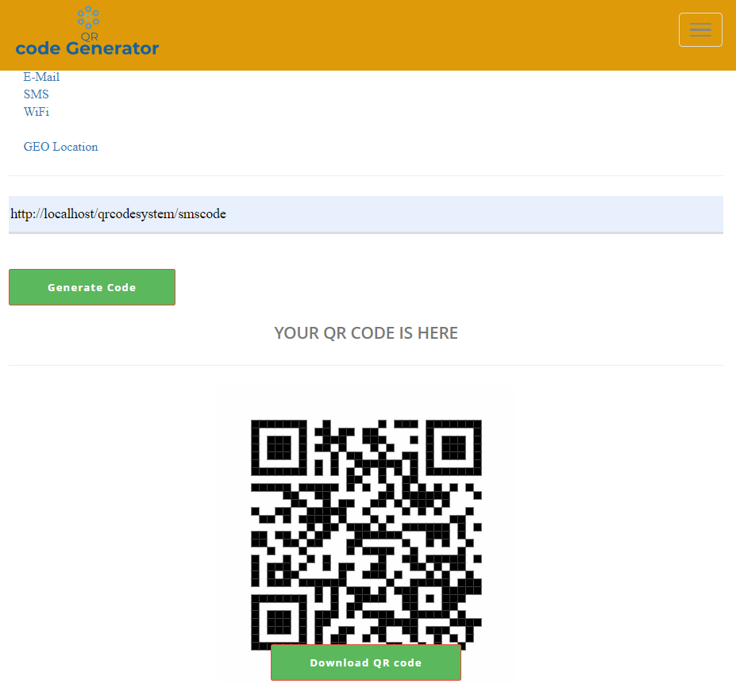

Generate QR code of Email:

|  |  |  |  |  |  |  |
| --- | --- | --- | --- | --- | --- | --- |
| **Test case id** | **Test scenario** | **Test description** | **Test data** | **Expected result** | **Actual result** | **Status** |
| T028 Email QRCODE | Create QR code of Email | Providing all valid details | Email= “bhupendrasharma98123@gmail.com”  Email subject= “QR code packages”  Message= “Hi I am trying to generate QR code in my project how could it be wanna help me” | QR code should generate for the provided details of email | QR code generated successfully for email and displayed | Pass |

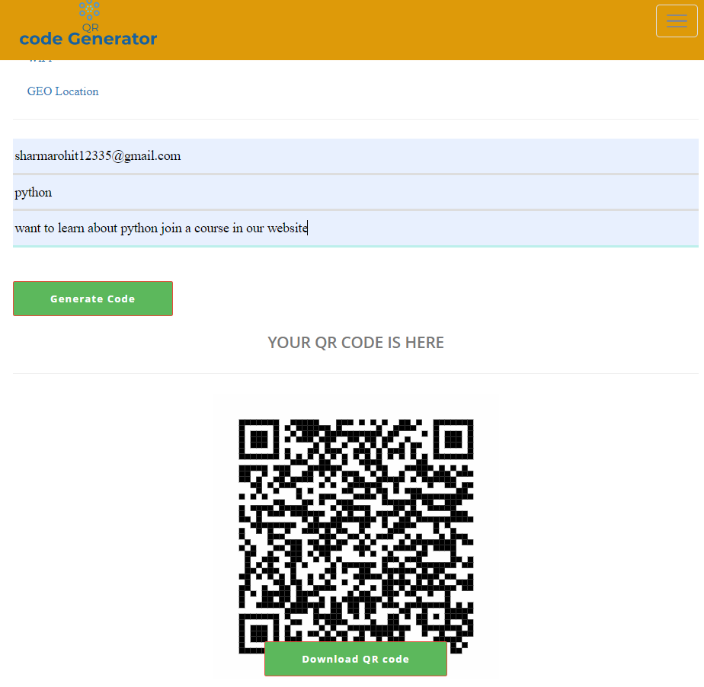

Generate QR code of SMS:

|  |  |  |  |  |  |  |
| --- | --- | --- | --- | --- | --- | --- |
| **Test case id** | **Test scenario** | **Test description** | **Test data** | **Expected result** | **Actual result** | **Status** |
| T029 SMS QRCODE | Create QR code of SMS | Providing all valid details | Mobile=9812396654  Message= “what am I doing here” | QR code should generate for the provided details of SMS | QR code generated successfully for SMS and displayed | Pass |

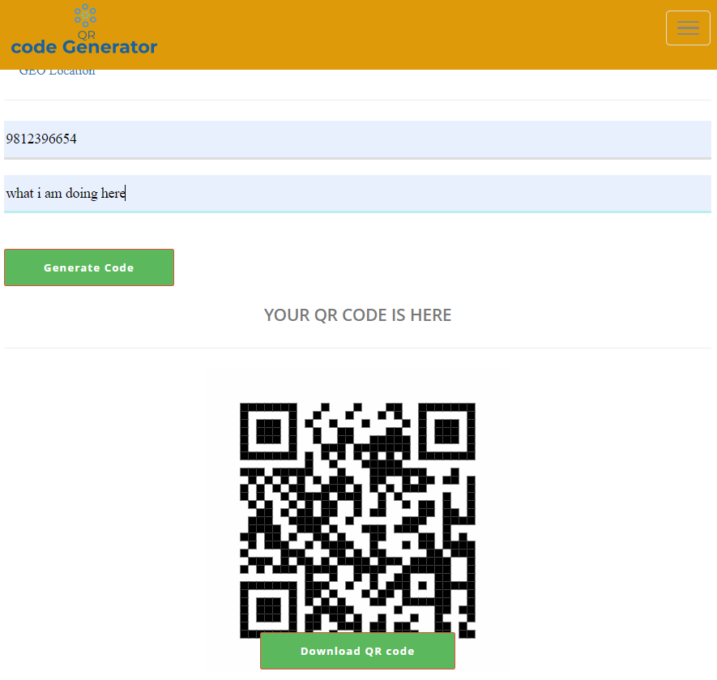

Generate QR code of WIFI:

|  |  |  |  |  |  |  |
| --- | --- | --- | --- | --- | --- | --- |
| **Test case id** | **Test scenario** | **Test description** | **Test data** | **Expected result** | **Actual result** | **Status** |
| T030 WIFI QRCODE | Create QR code of WIFI | Providing all valid details | WIFI SSID= TOTOLINK_N150RT  Encryption= WPA  Password= 9812396654 | QR code should generate for the provided details of WIFI | QR code generated successfully for WIFI and displayed | Pass |

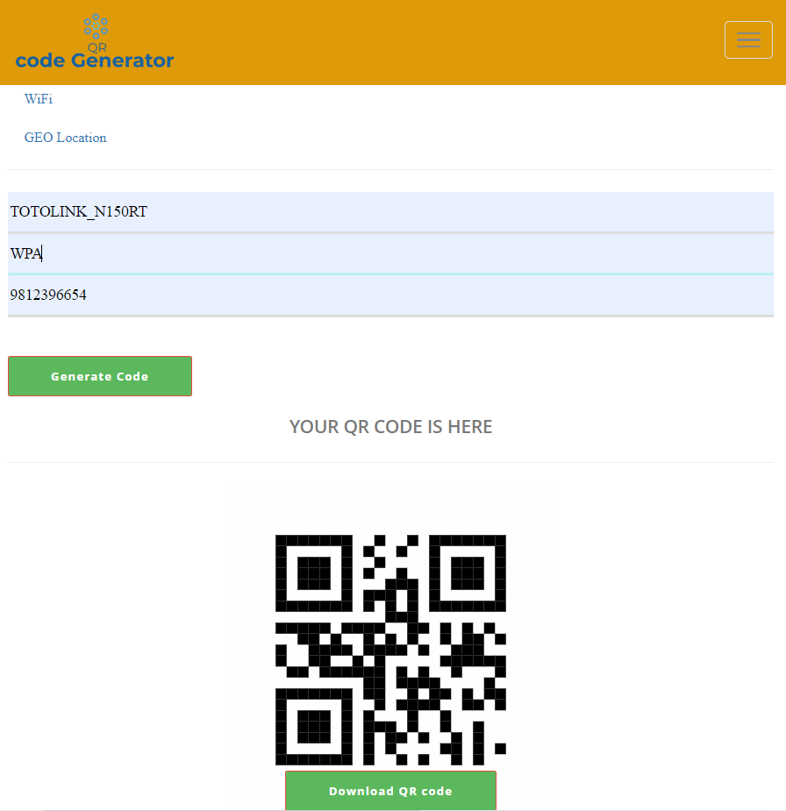

Scan QR code:

|  |  |  |  |  |  |  |
| --- | --- | --- | --- | --- | --- | --- |
| **Test case id** | **Test scenario** | **Test description** | **Test data** | **Expected result** | **Actual result** | **Status** |
| T032 scan QR code QRCODE | scan QR code | Scan code with camera showing QR code image | Open camera and scan code | QR code should be decode and show the details over localhost server | Code scanned successfully and showed result | Pass |
| T033 scan QR code QRCODE | scan QR code | Scan code uploading image | Upload QR image | After uploading image, it should display the inside information of QR code to us | It shows the details over the encoded QR code image | Pass |

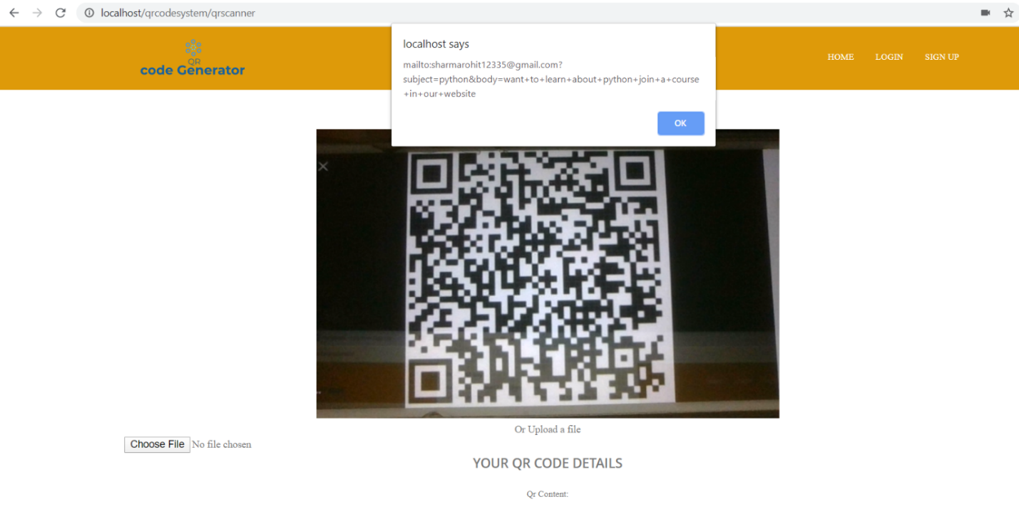

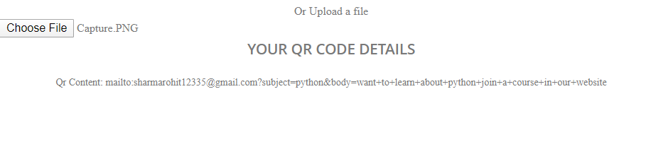

## White Box Testing

White-box research is a design development technique that measures rather than its functionality within an application's systems or operations. For white-box research, an internal image of the system is used as well as programming resources for design studies

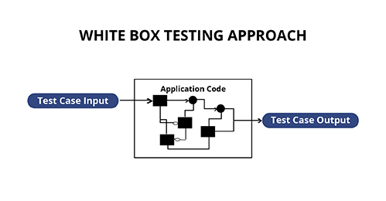

Figure: White Box Testing

### Unit Testing

UNIT TESTING is a test stage for applications, in which specific device units / components are tested. The aim of this is to verify that every unit of software performs as expected. A unit is the tiniest component of any testable tool. This generally has one or more inputs, and normally one output.

It is carried out using the form White Box Analysis.

# Chapter 6- Other project issues

**6.1 Limitations**

Some of the features that’s need to be implemented but cannot be completed are refer to be the limitation of the project and there are some of the things that I cannot complete and they are listed below:

* We were unable to perform some of the unit testing of the program
* We would have performed the Agile methodology but unable due some insufficient knowledge
* Some of the additional features such as tracking campaign with dynamic code was unable to implement

**6.2 Futures works**

With the limitation period I was unable to add some features and function to the system which I had mentioned in proposal. And those incomplete features would be implemented in future works.

The listed below incomplete features would be completed in future work and they are:

* Dynamic code to track the campaign management
* Reviewing and comments
* Login system using QR code

## 6.3 Risk management

Project risk management is the practice of recognizing, assessing and then reacting to any threats that occur over a project's life cycle to ensure the project stay on track and achieve its objective Managing risk is not only proactive; it should be part of the production process to determine the danger that may arise in the project and how to mitigate the risk if it actually happens.

Risk faced during the project development are:

* Choosing the right tool for the designing of different aspects
* Time management
* Internal testing of the program or software that is with Unit Testing
* Overtaking server failure
* Setting up site not be attacked by DOS or DDOS attack

Some of the risk that might occur are listed below with impact and solution to it:

|  |  |
| --- | --- |
| **Likelihood (L)** | **Value** |
| Low | 1 |
| Medium | 2 |
| High | 3 |

|  |  |
| --- | --- |
| **Consequences (C)** | **Value** |
| Very Low | 1 |
| Low | 2 |
| Medium | 3 |
| High | 4 |
| Very High | 5 |

|  |  |  |  |  |  |
| --- | --- | --- | --- | --- | --- |
| **SN** | **Risks** | **Likelihood** | **Consequence** | **Impact** | **Actions** |
| 1 | Natural disaster | 1 | 5 | 5[1*5] | Backup plan |
| 2 | Hardware or software crash | 2 | 3 | 6[2*3] | Maintenance |
| 3 | System may get infected with virus | 2 | 4 | 8[2*4] | Antivirus Software |
| 4 | Theft | 3 | 2 | 6[3*2] | Backup |
| 5 | Insufficient time | 3 | 3 | 9[3*3] | Must keep milestone on mind |
| 6 | Requirements may not be found easily | 3 | 1 | 3[3*1] | Should take an example of similar type of web application |

**Gantt Chart**

Grant chart showing a sequence of horizontal lines representing the amount of output or produced over certain time periods in comparison to the amount expected for those years.

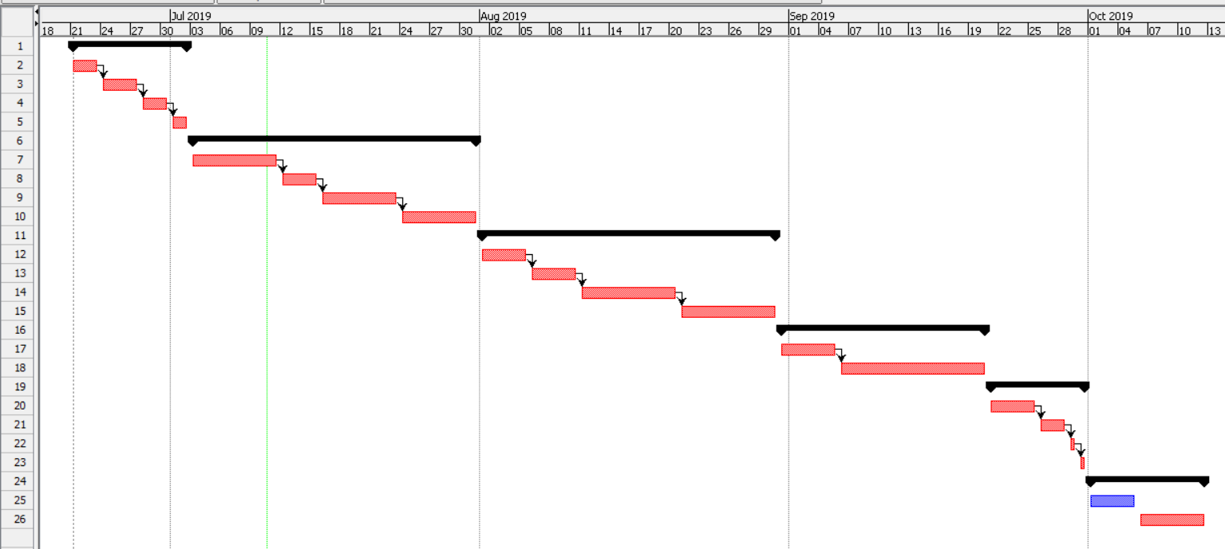

**6.4 Configuration Management**

Configuration management can be described as identification process, individual configuration object, functional capability documentation, and interdependence monitoring. Simply put, configuration management is a method of demonstrating how the files and folder are interrelated, and what will happen when any changes are made. It is file and folder management.

**6.5 User Manual**

Since this product is introduced onto the market, the technology is fresh so users are unable to learn how to use the application properly. And make sure the consumer makes it simple to use, I need to include a user documentation page that shows users how to build account and password, and how to produce code and search the accessible data.

Every steps to follow while using this system is defined below with all label in figures, following those step helps the user interacting easier to system:

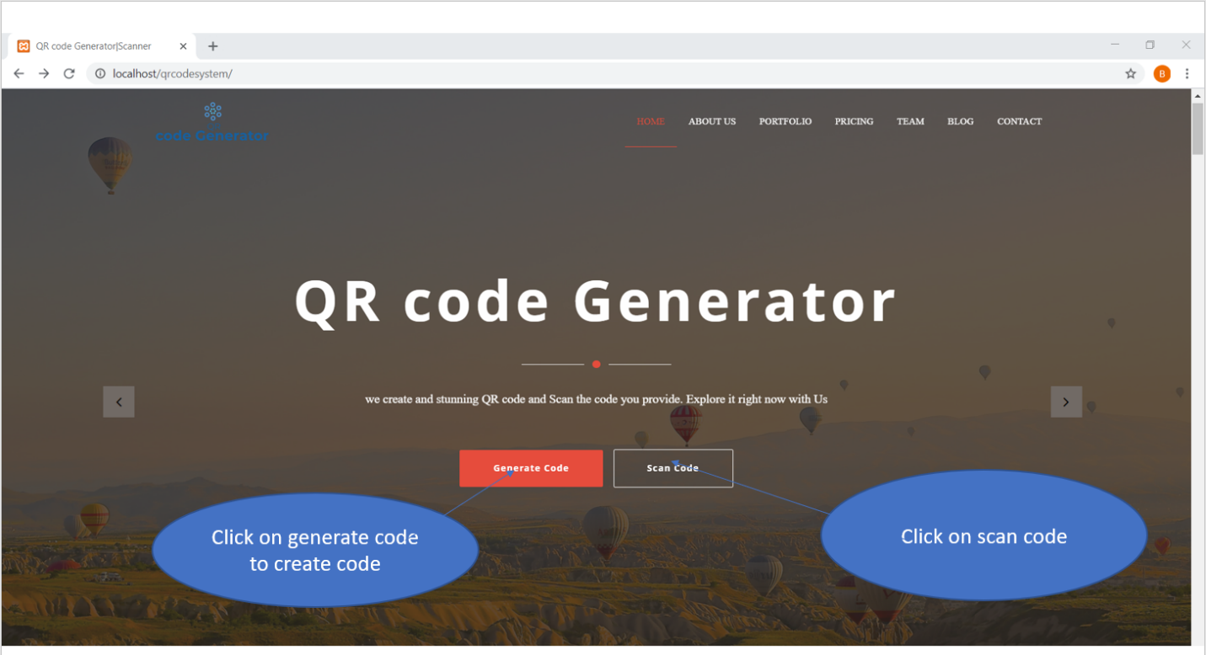

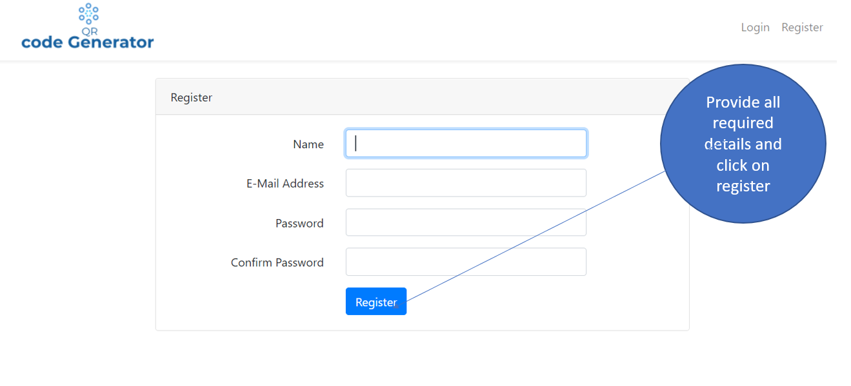

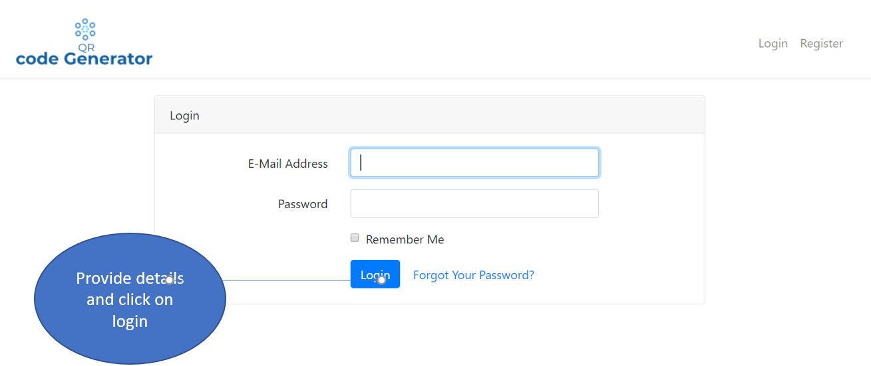

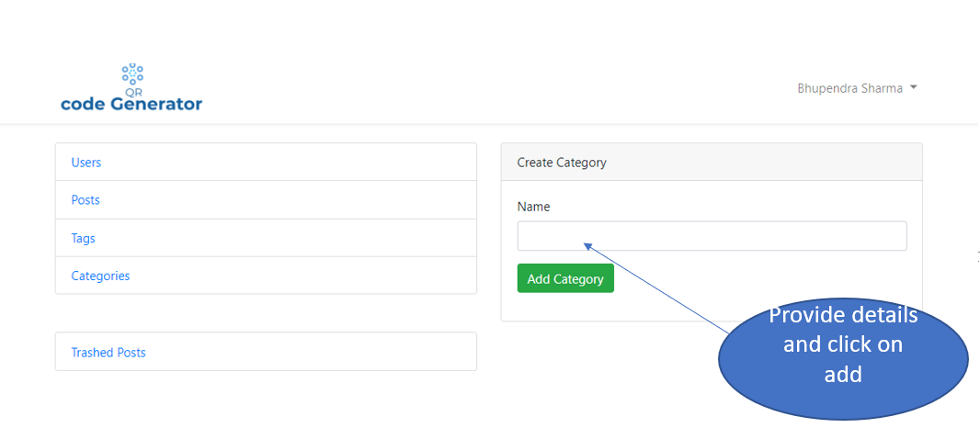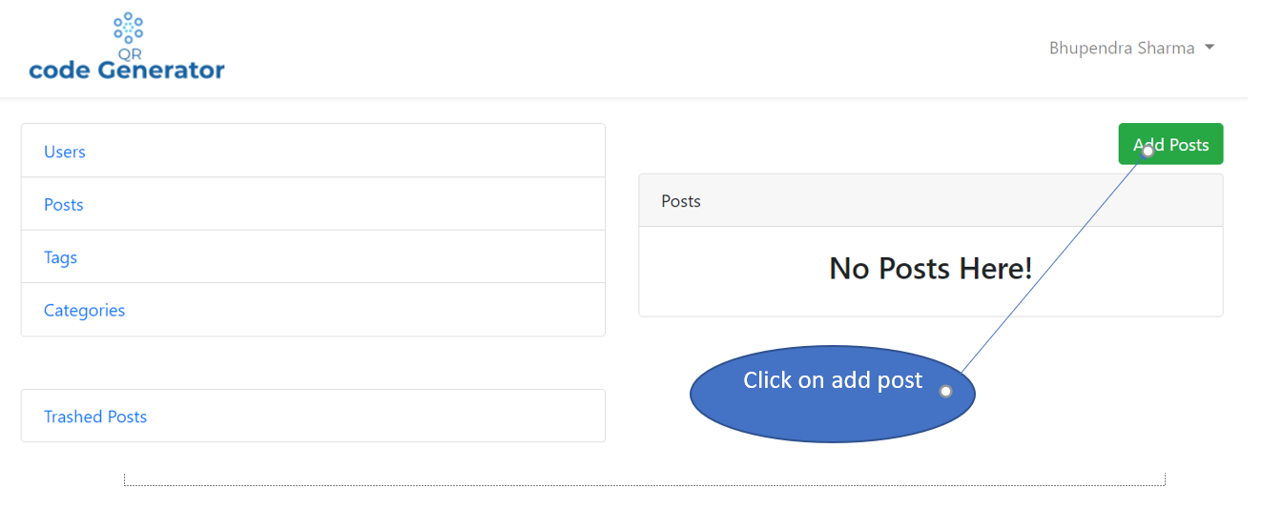

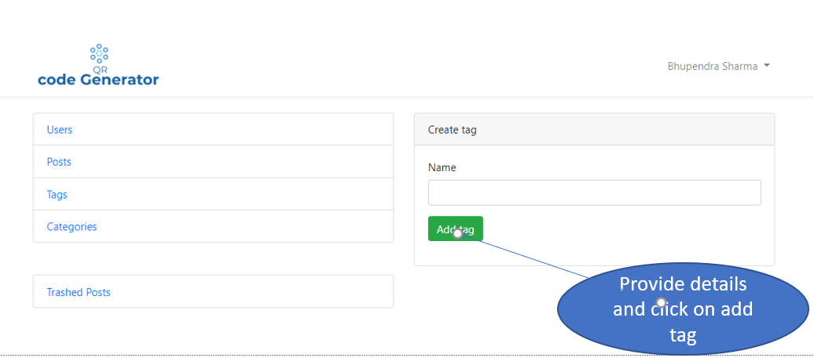

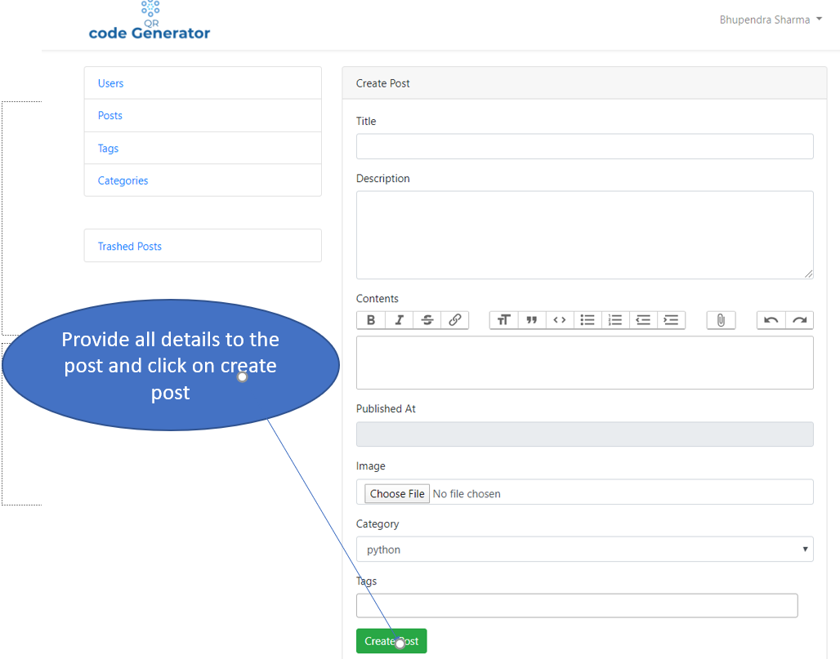

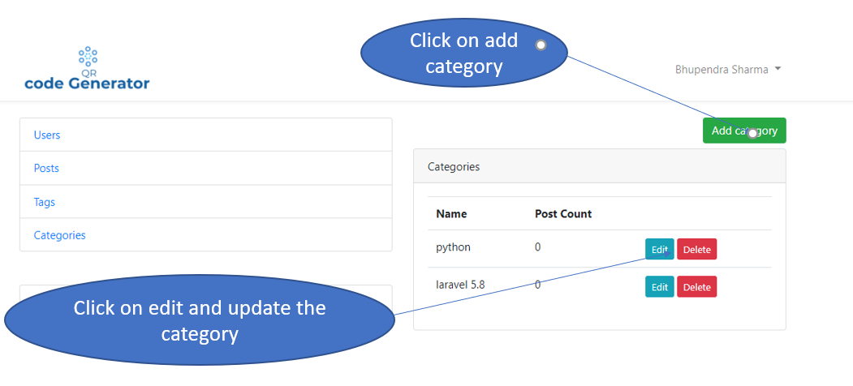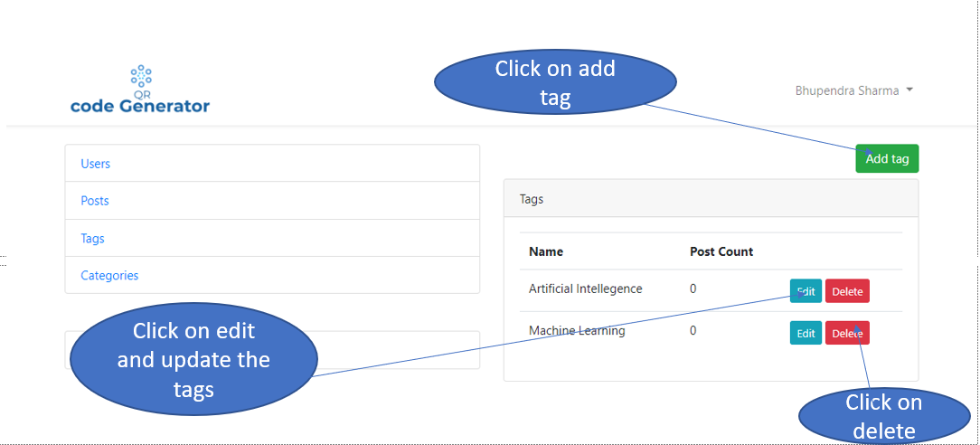

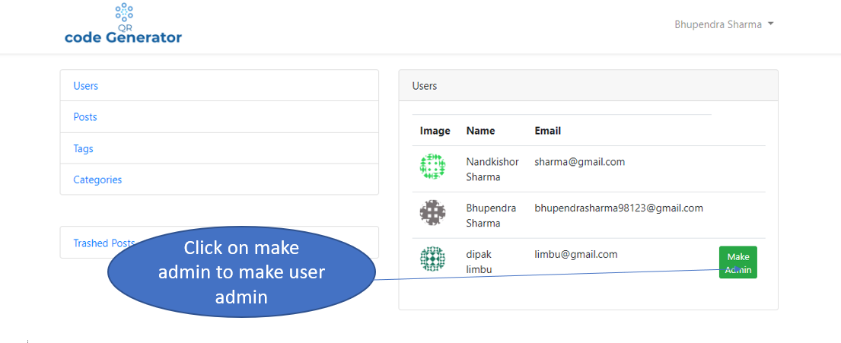

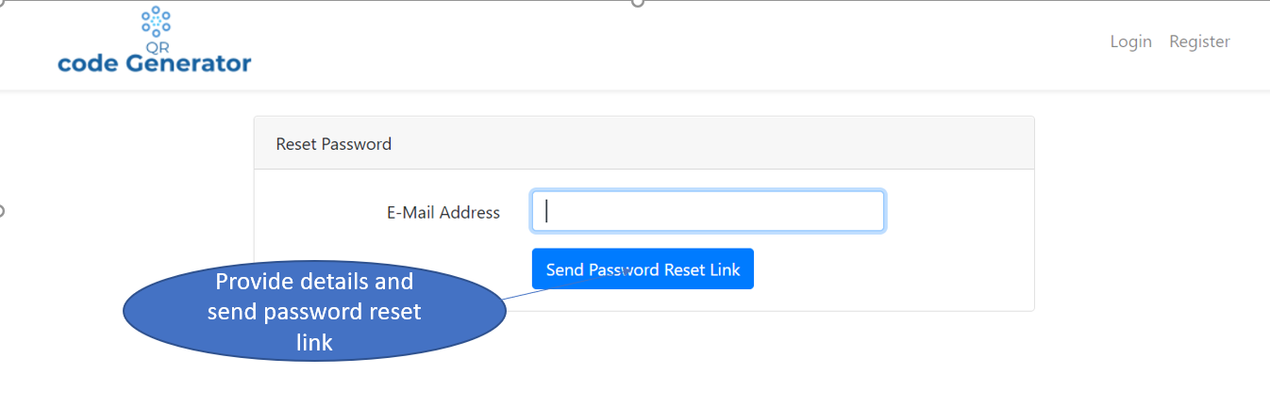

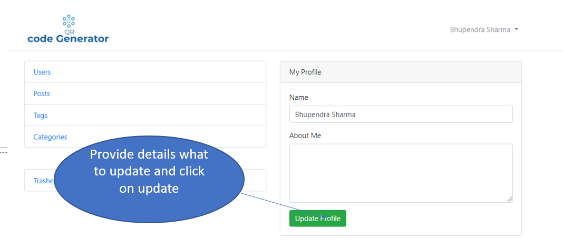

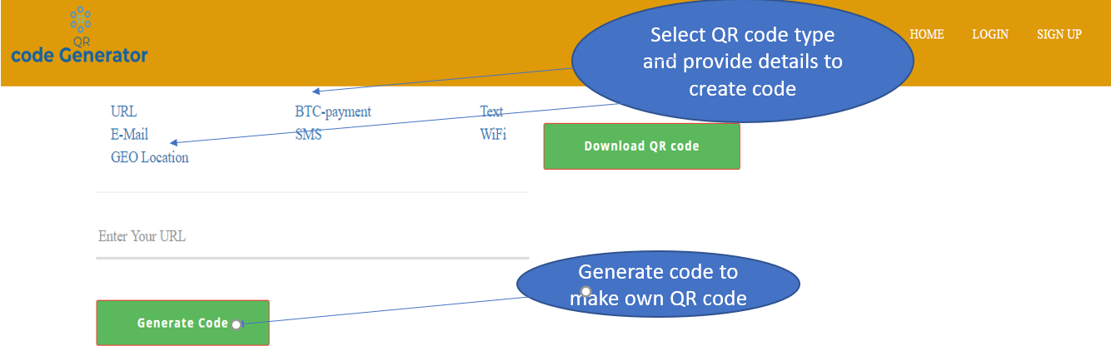

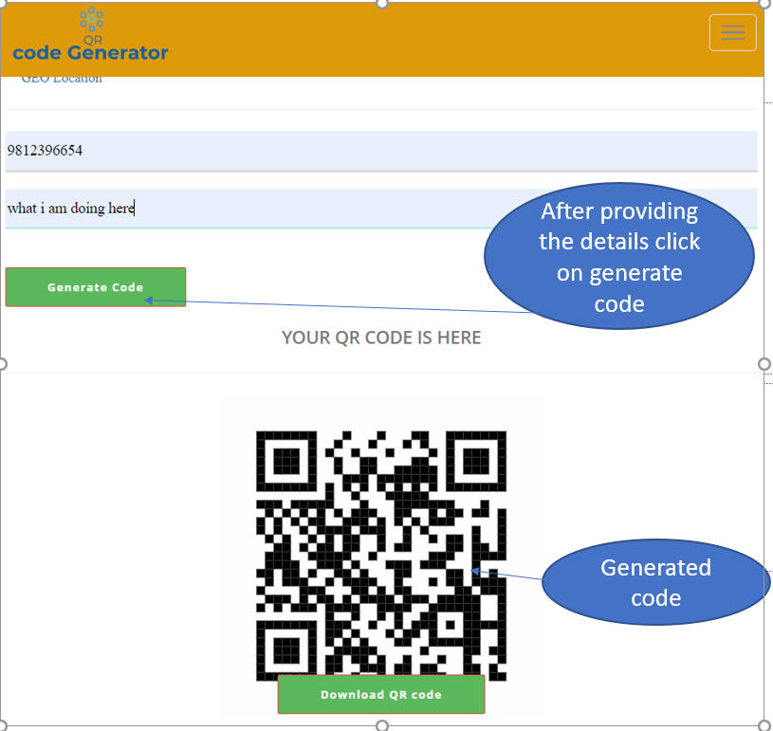

**Chapter 7- Conclusion**

After all the development process has been finished, after all the functions are reviewed, the QR code generator is ready to launch. This program is powerful, easy and user-friendly, with device users easily created generate code form the place where they are. The system design is responsive and admin is provided with the CMS authority where he can manage all the post and related item with the database and site settings.

All users should register as regular user and their function can only be modified by admin. Admin and customer have varied authority. Users may have their profile updated. I have completed nearly all the pieces of this project's documentation as well as the section of implementation.

# Chapter9 – Appendix

Implementation part of the design pattern MVC

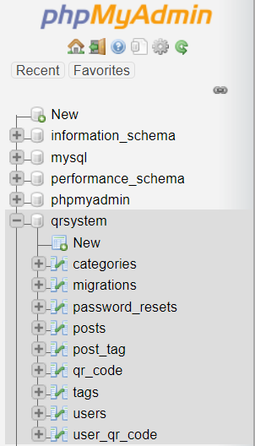

Fig: database tables

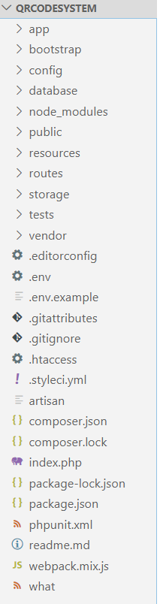

Fig: MVC pattern code structure in laravel

**Route page:**

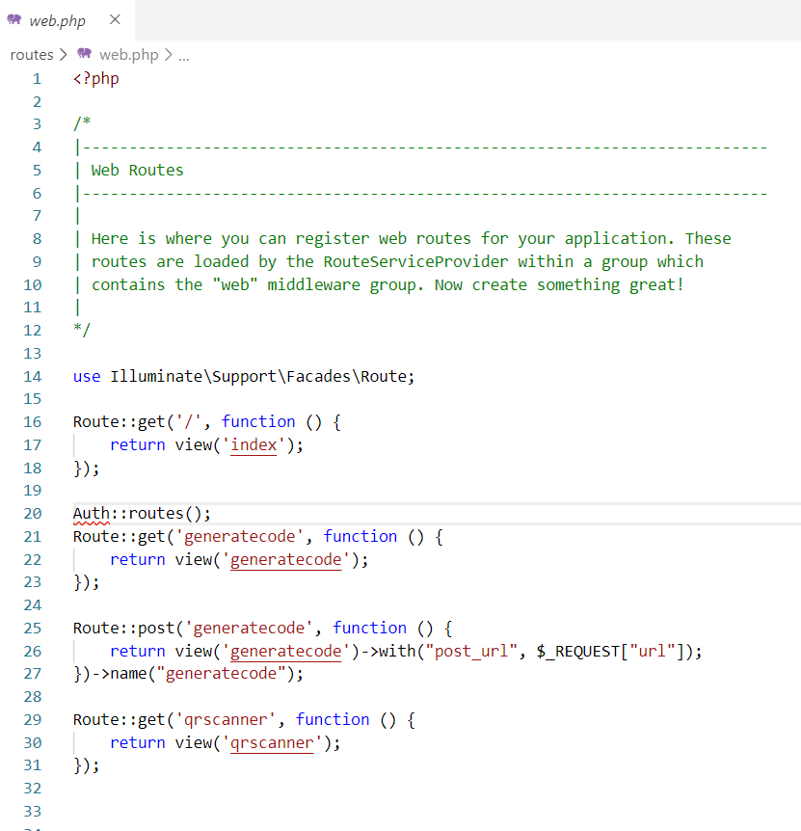

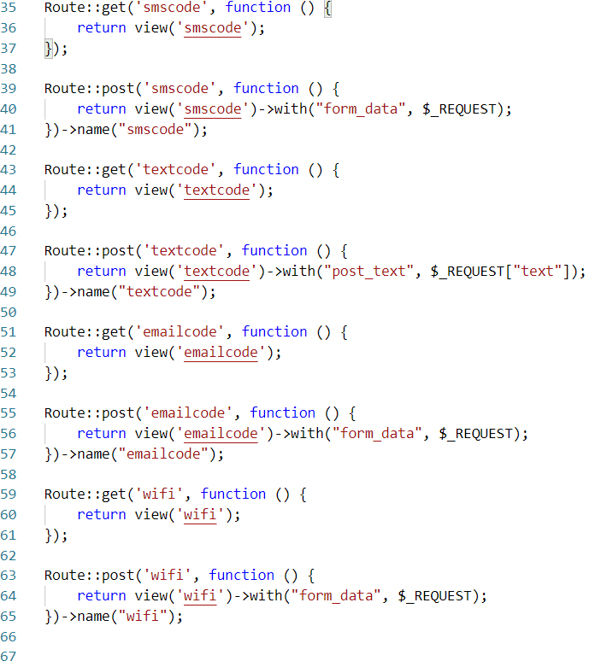

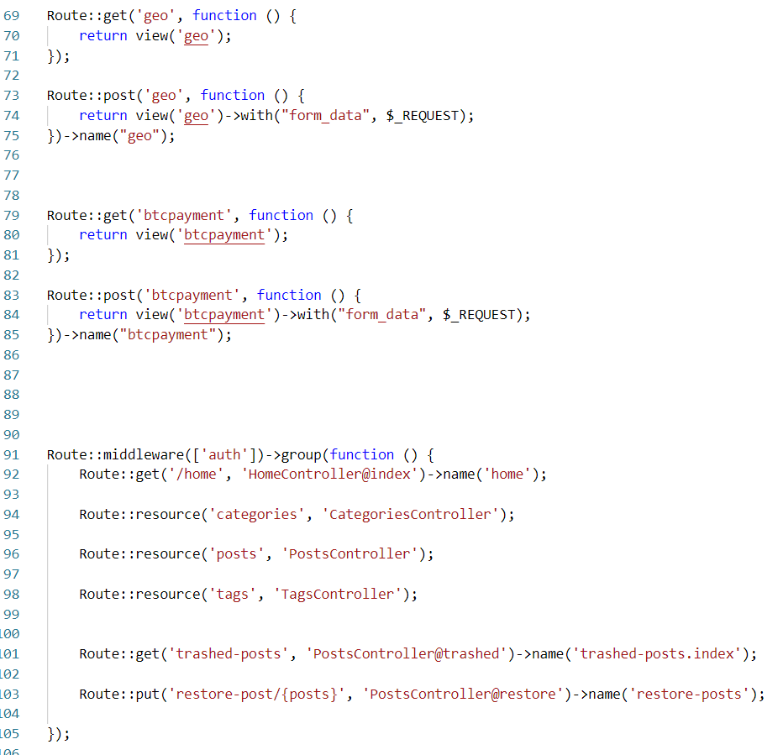

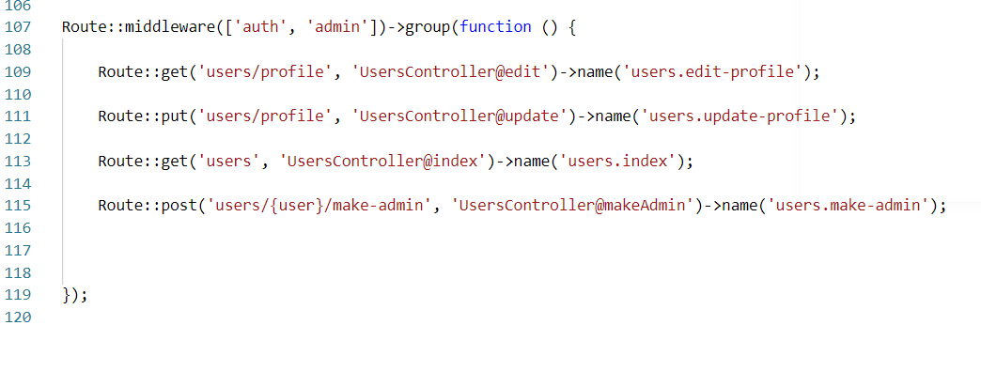

Fig: Route web

**Login controller**

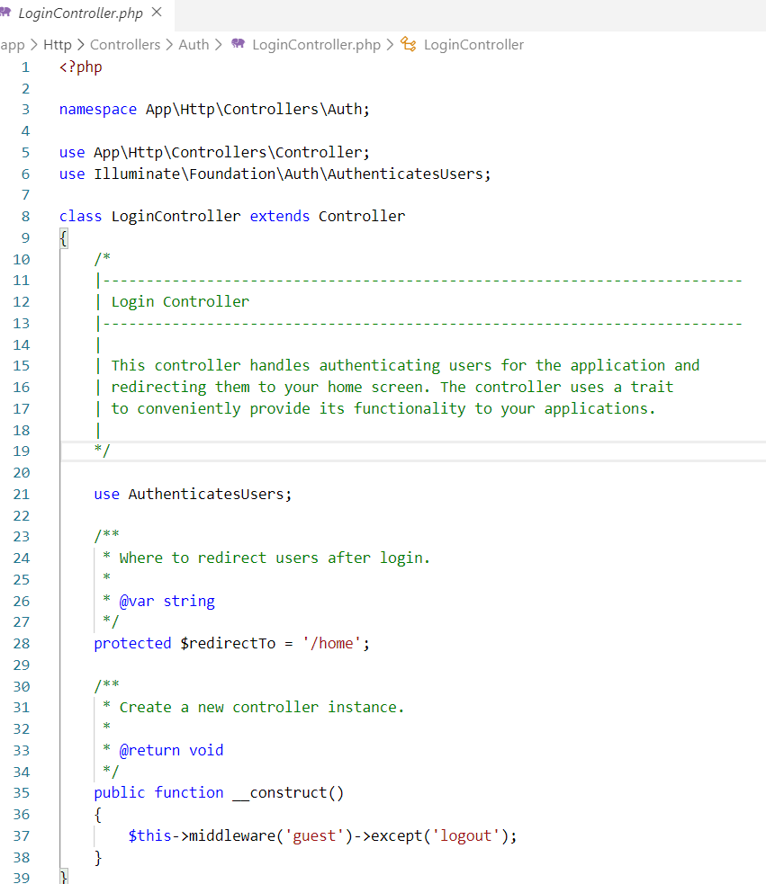

**Login index page:**

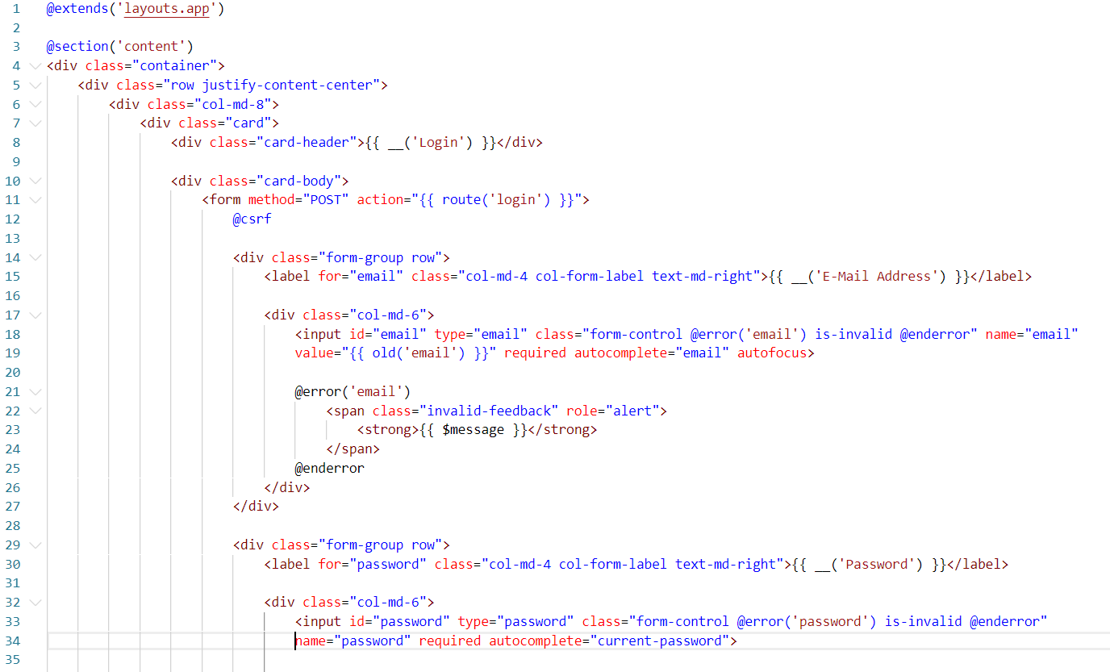

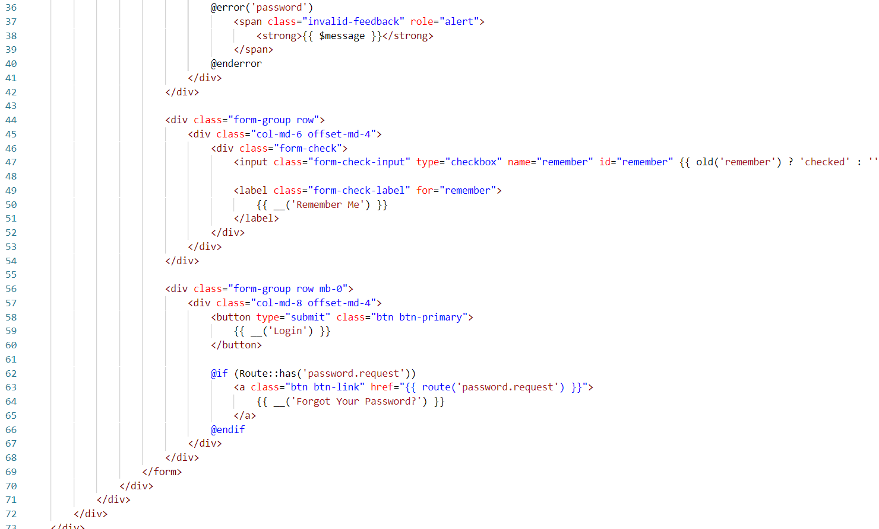

**Register controller**

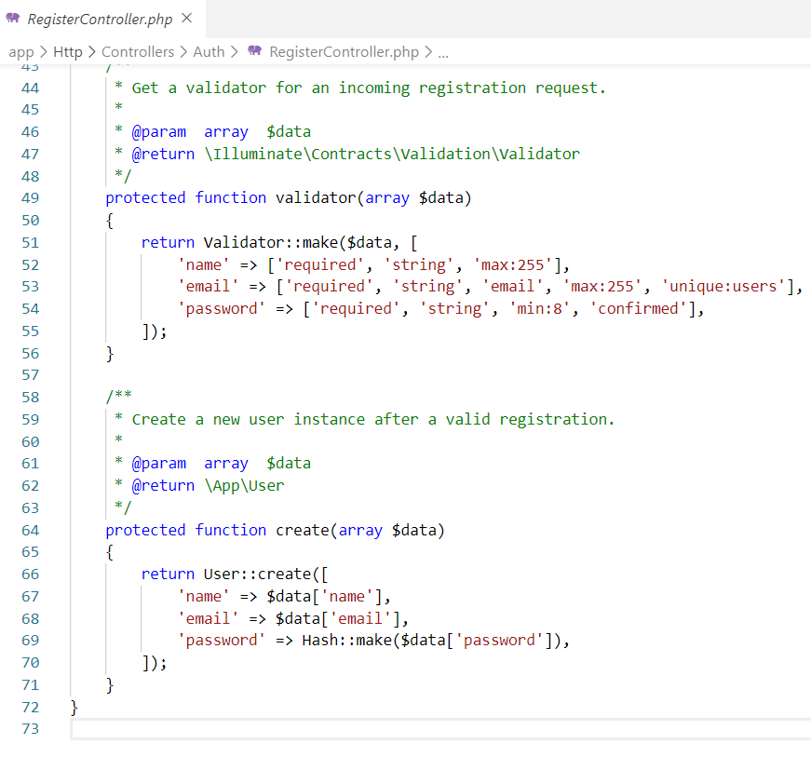

**Register view page**

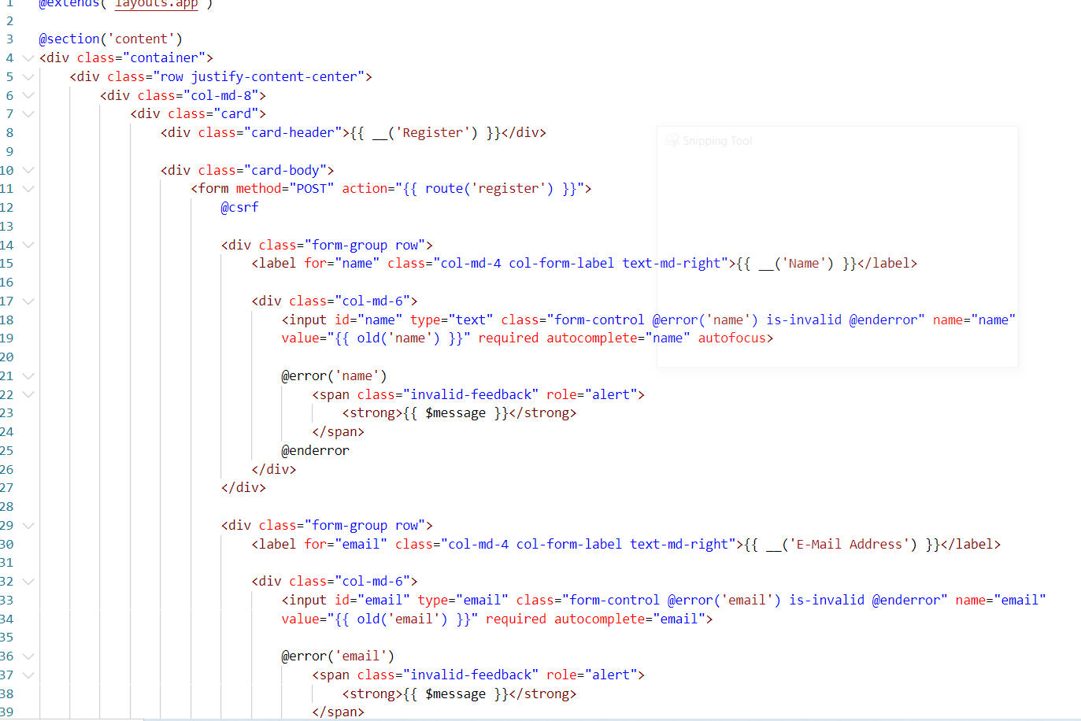

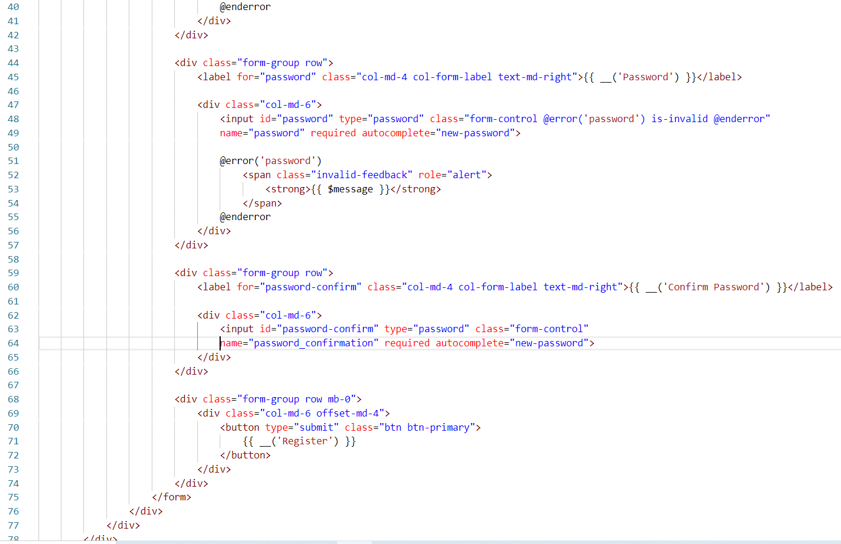

**Reset password controller**

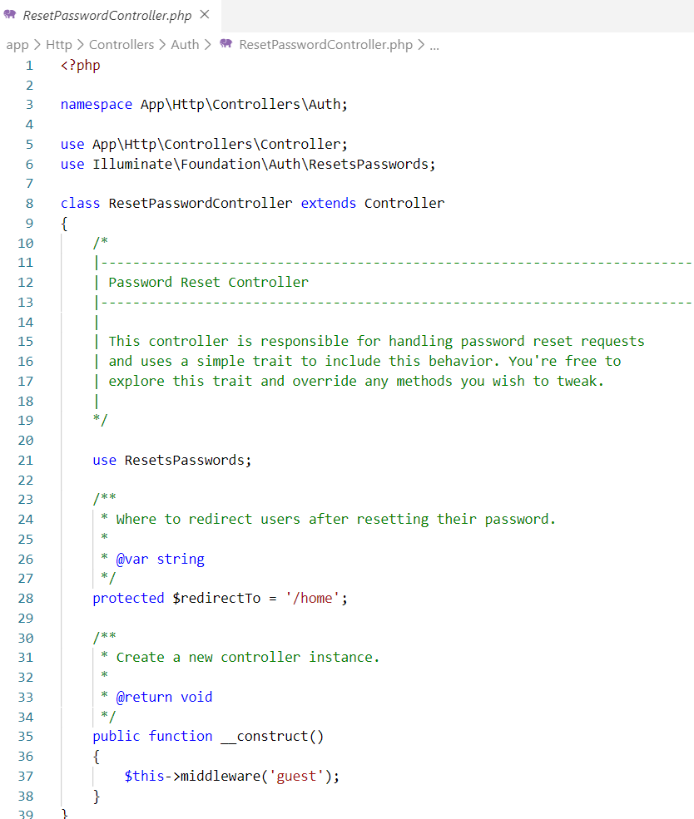

**Forget password controller**

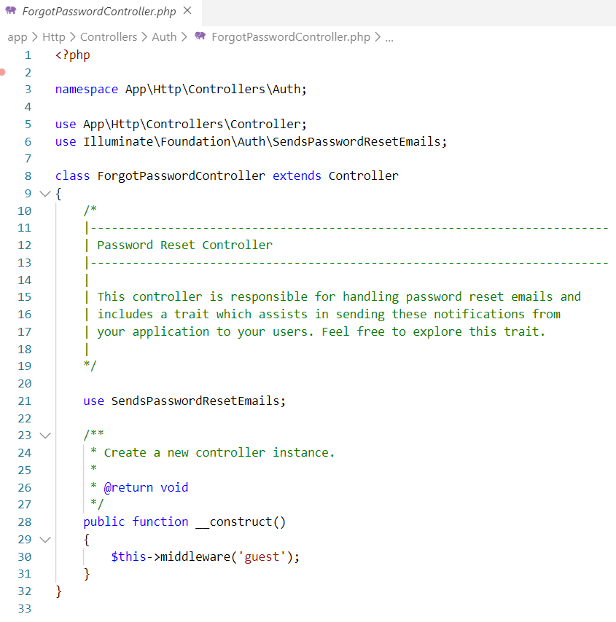

**Verification controller**

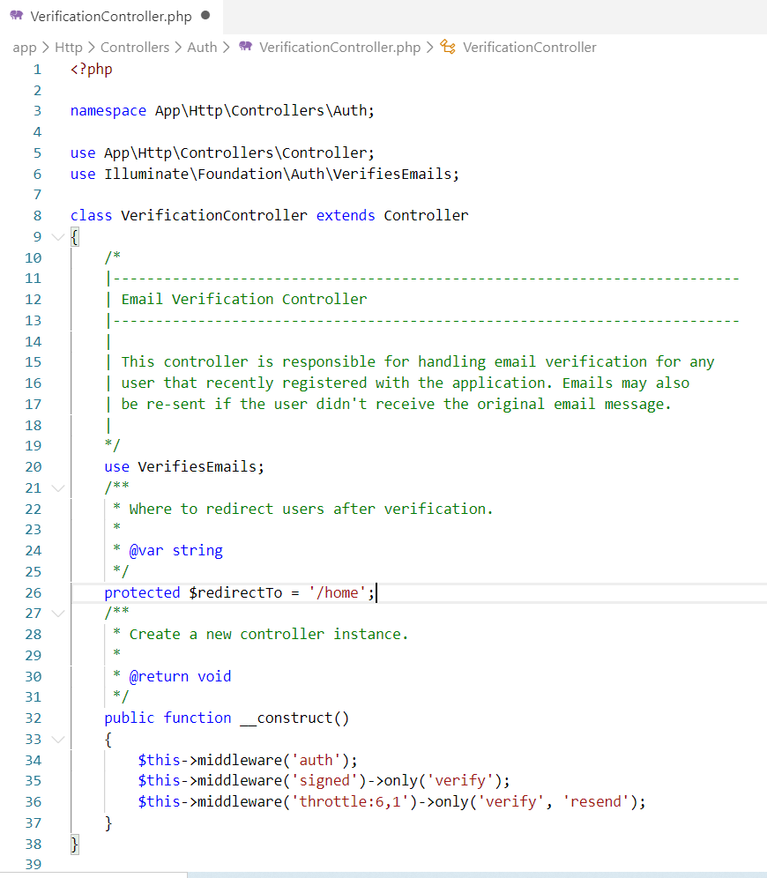

**Category controller**

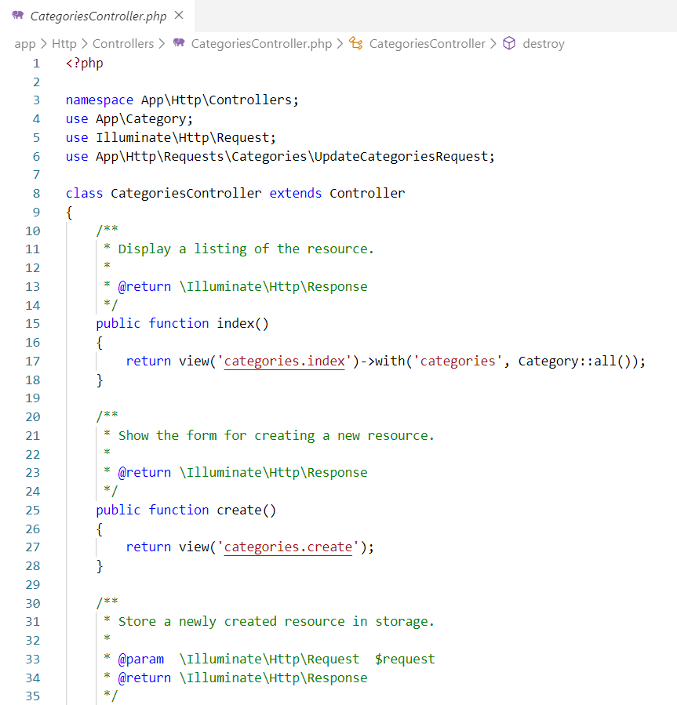

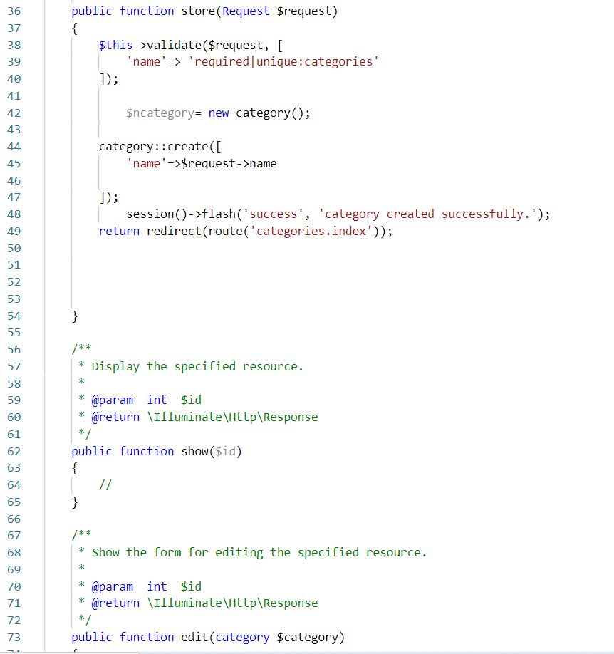

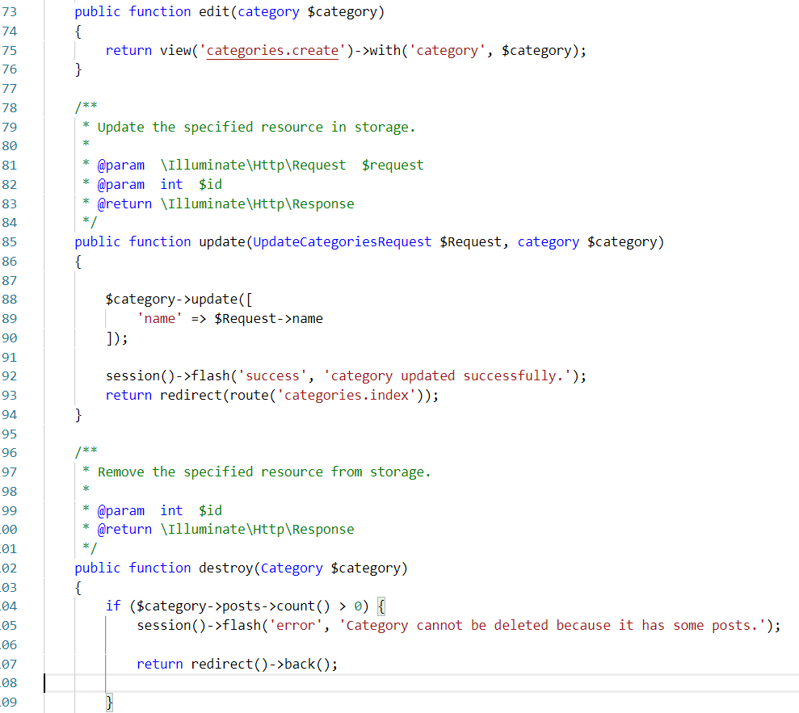

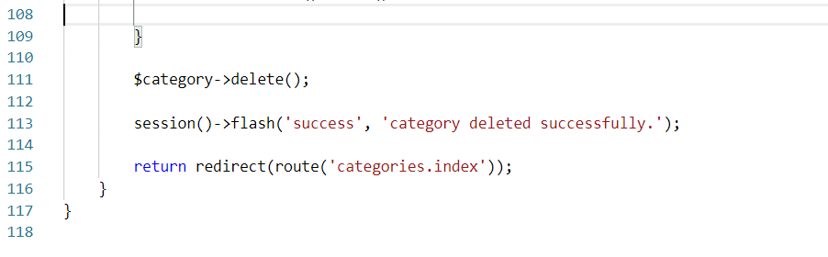

**Model for category**

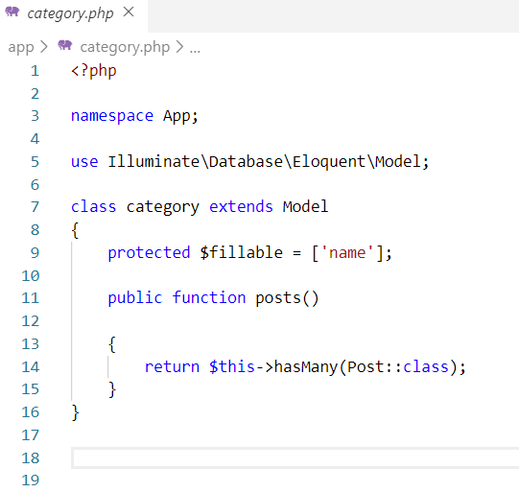

**Request verify category**

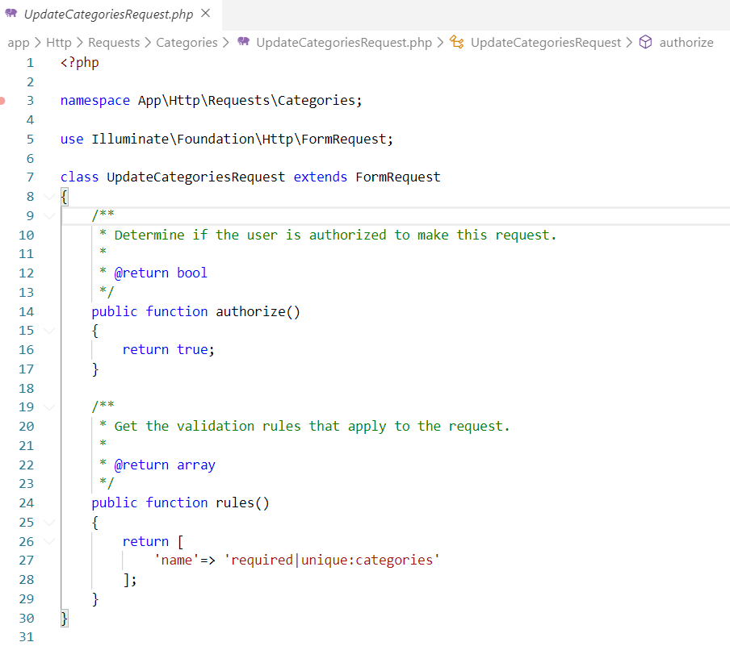

**Middleware verify category count**

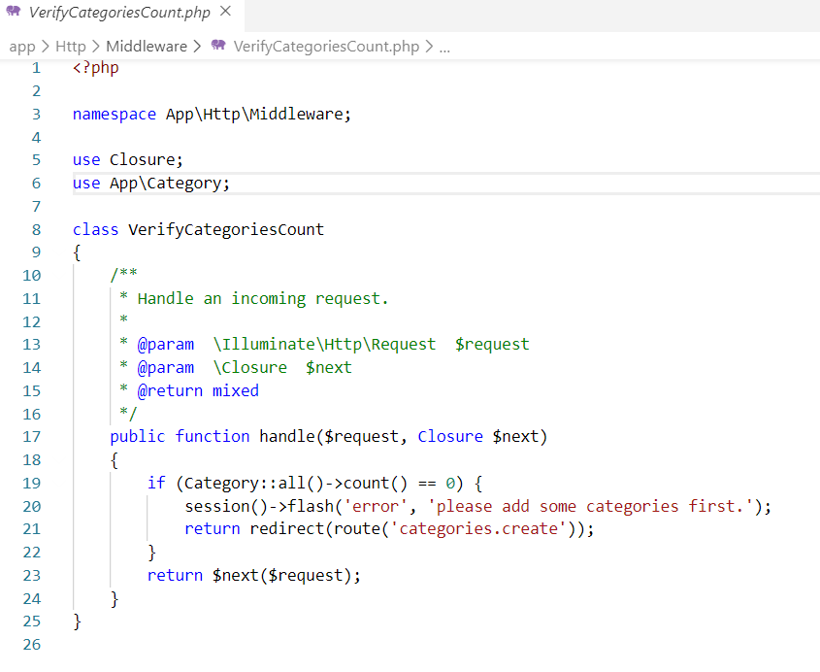

**View for category**

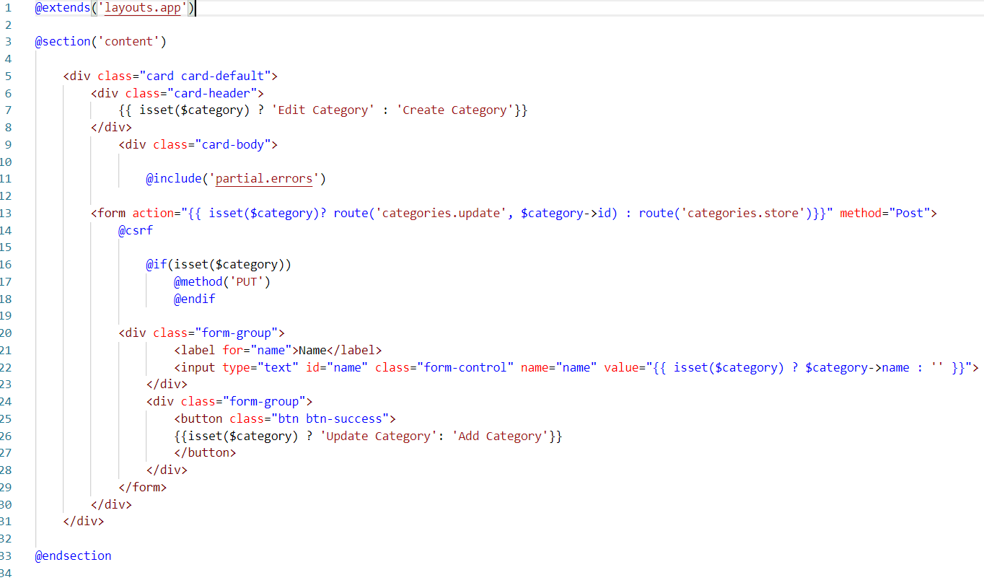

**Index for category**

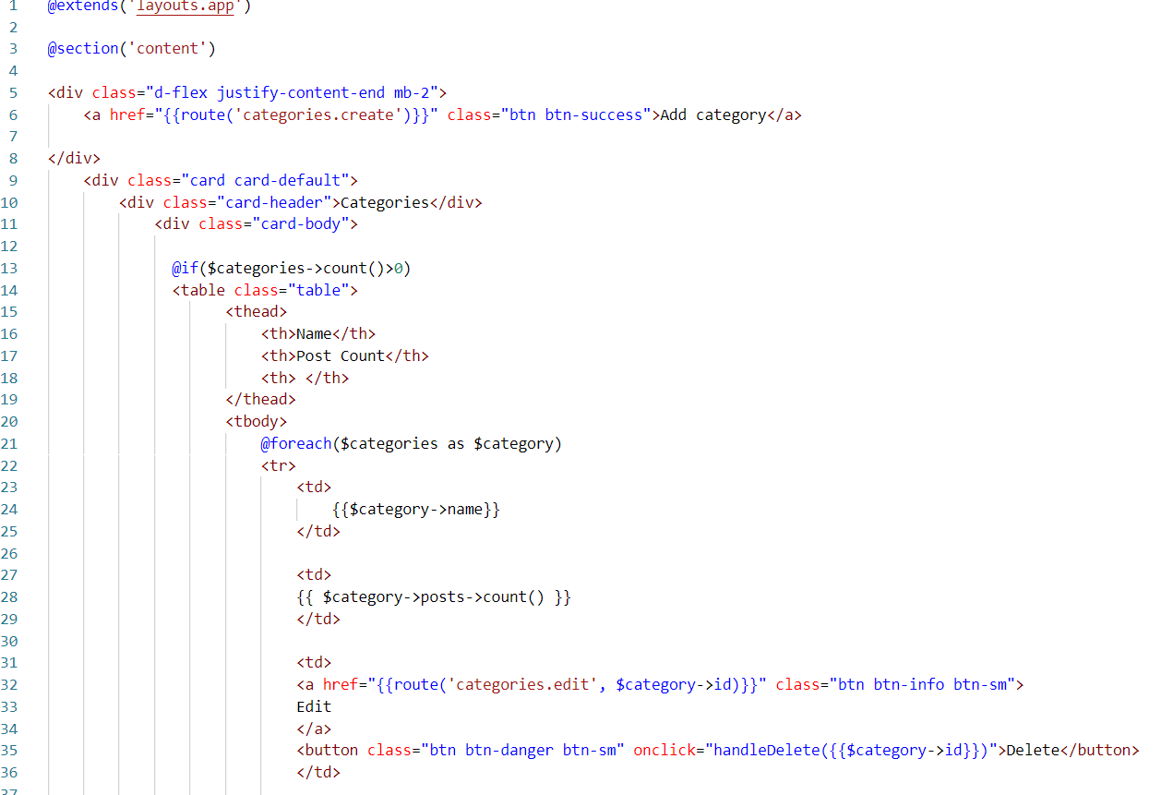

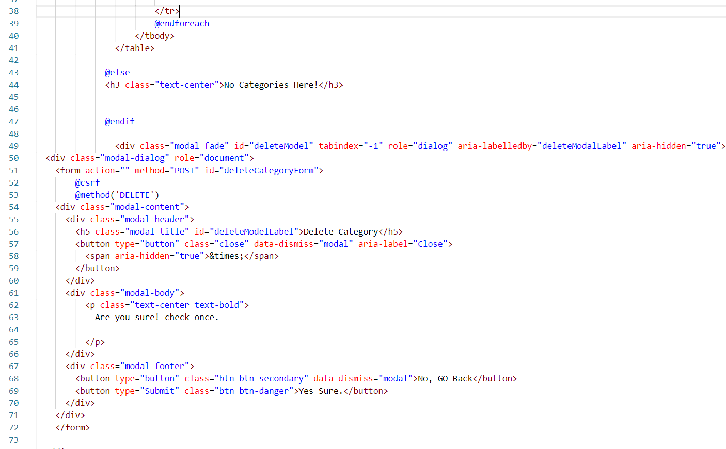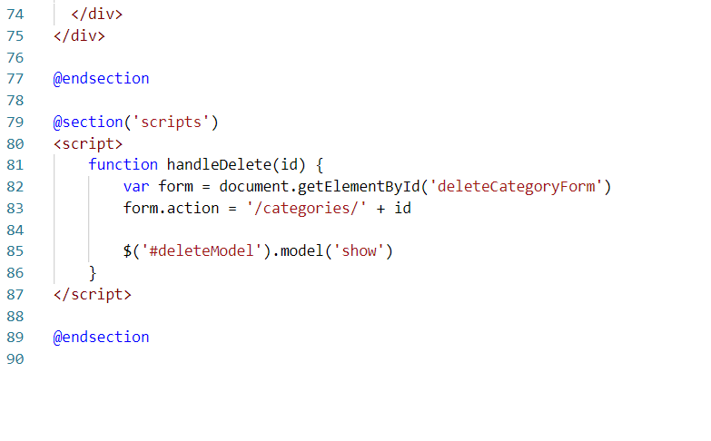

**Migration of tables**

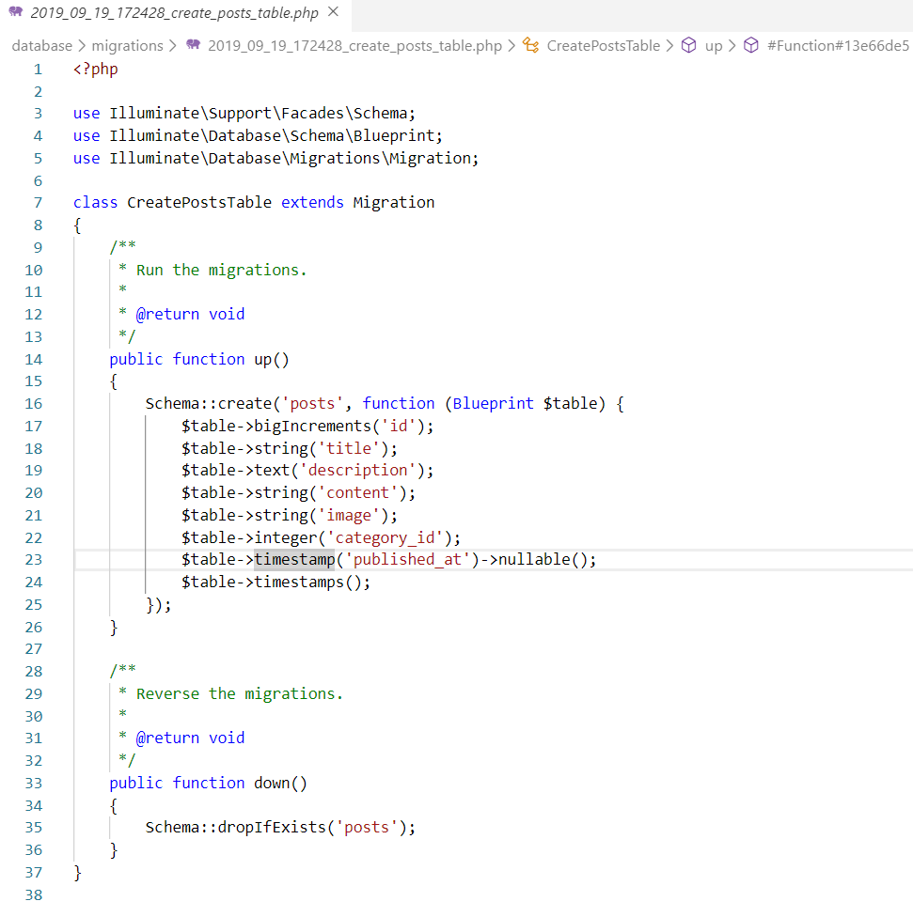

Fig: Migration create post table

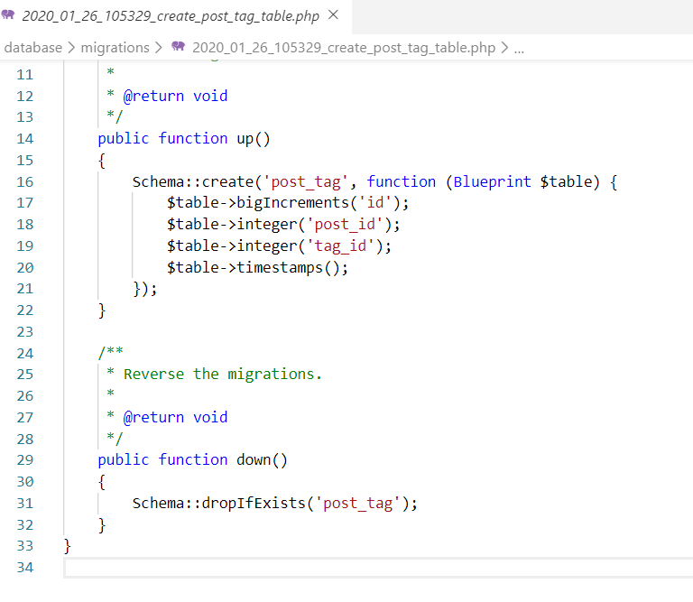

Fig: migration Create post tag table

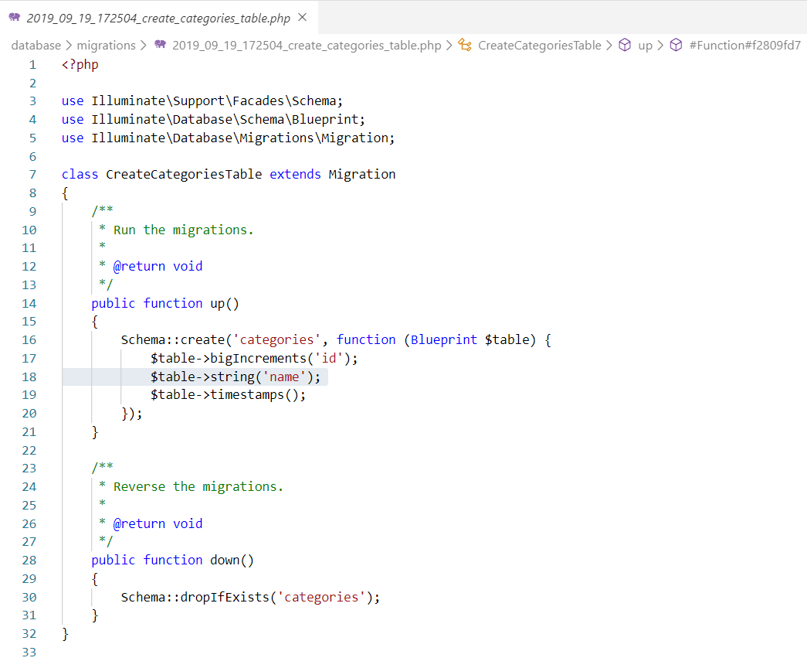

Fig: migration Create table category

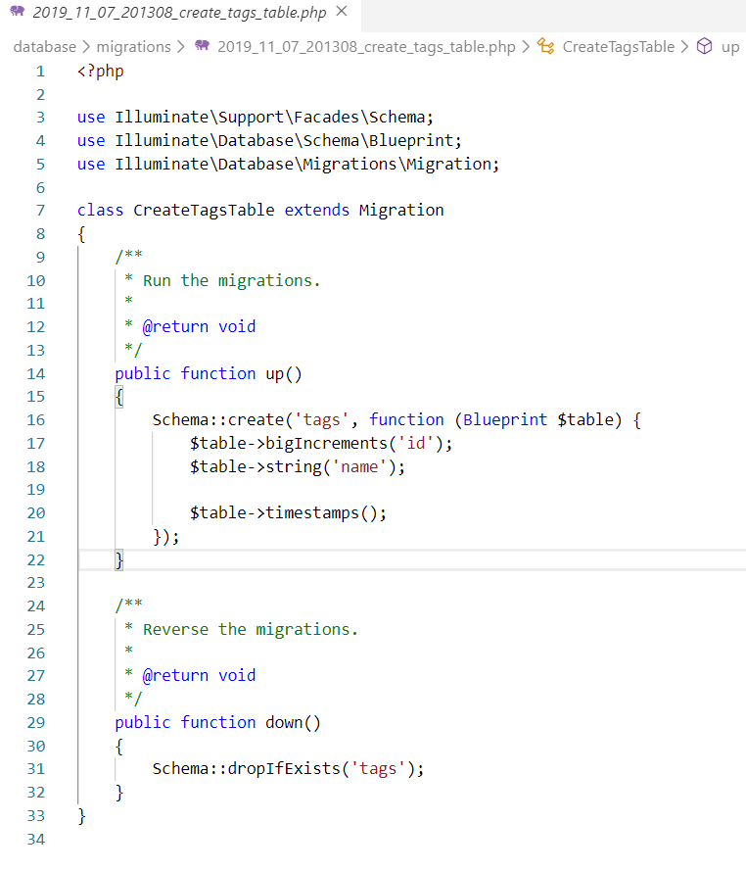fig: migration create table tag

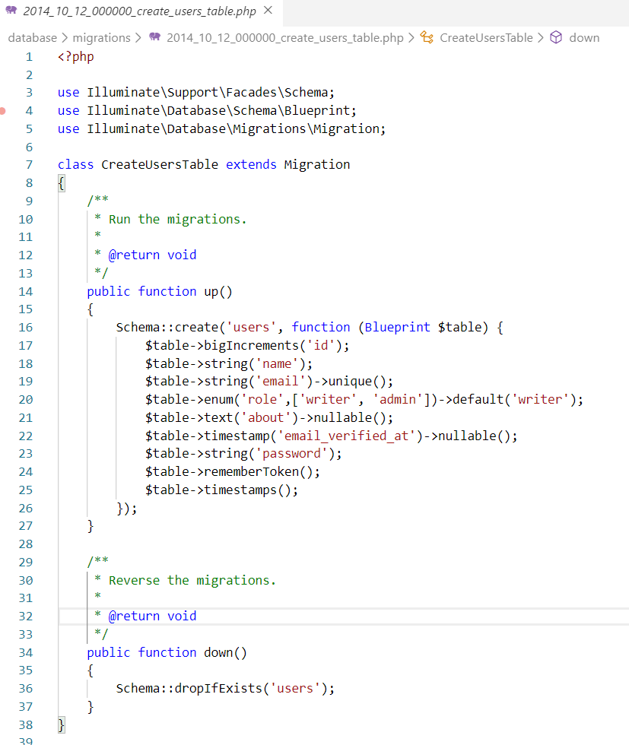

Fig: migration Create table user

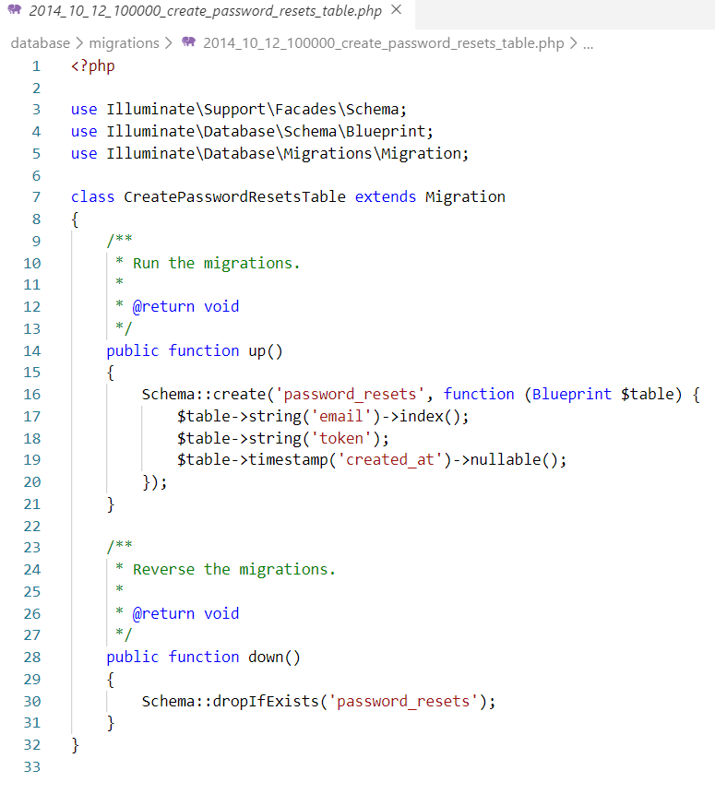

Fig: migration Create password reset table

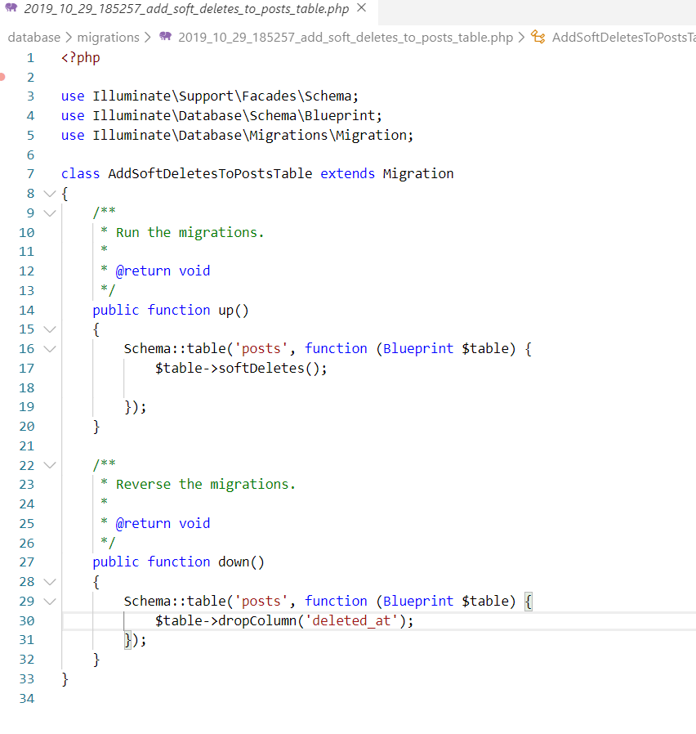

Fig: migration add soft delete to the post table

**Controller for post**

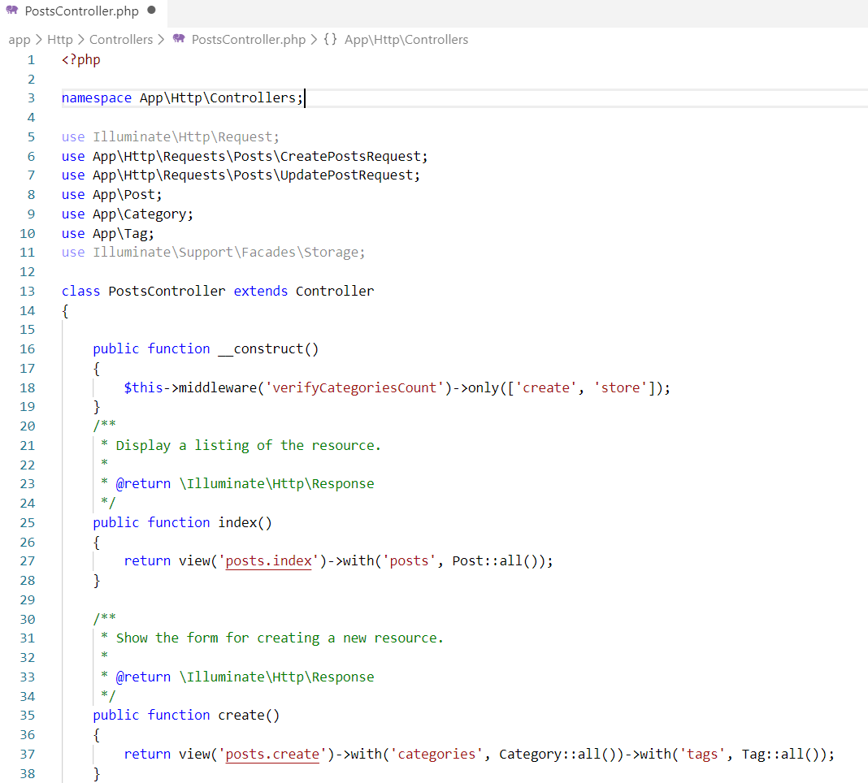

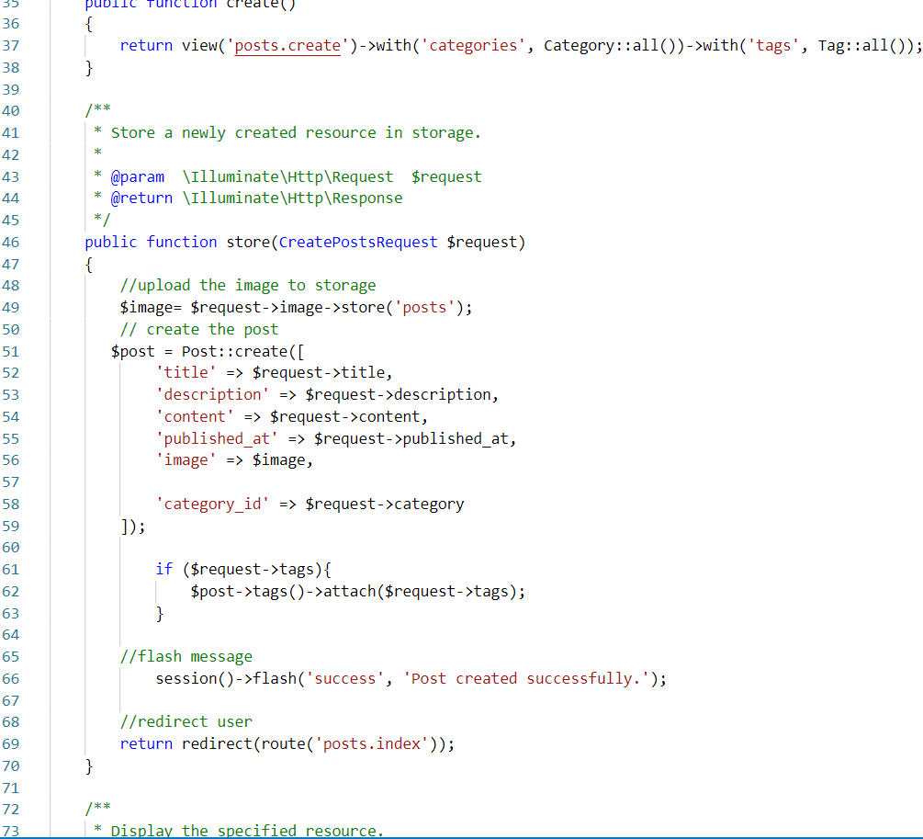

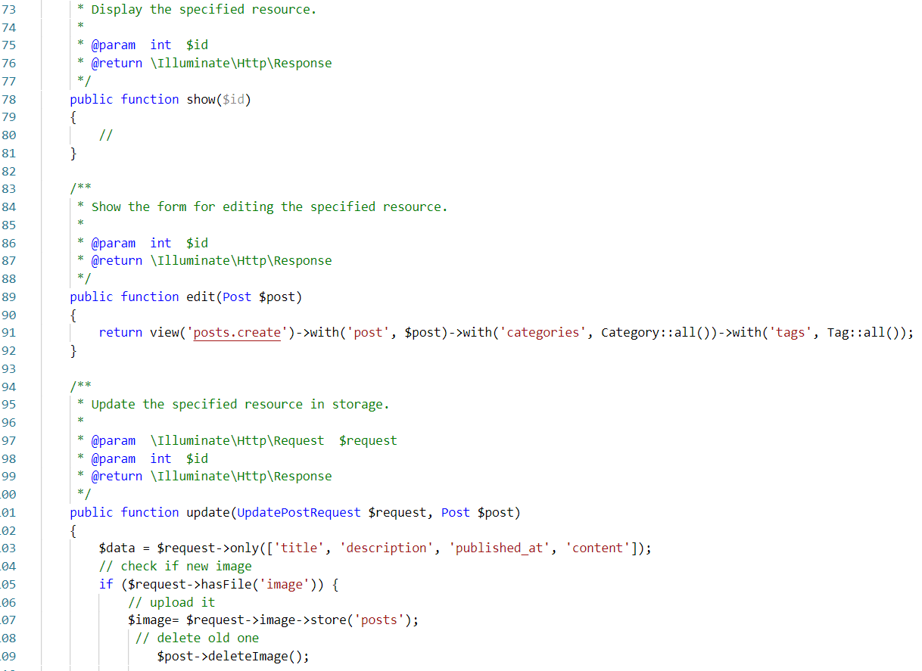

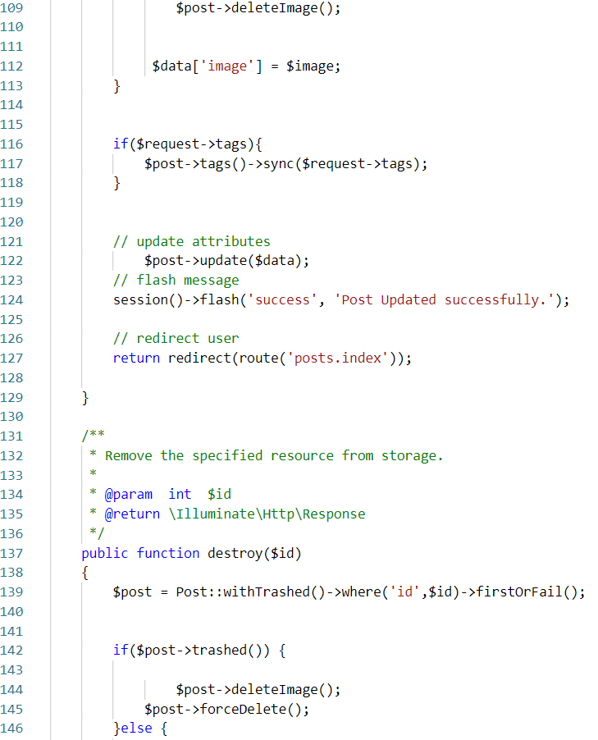

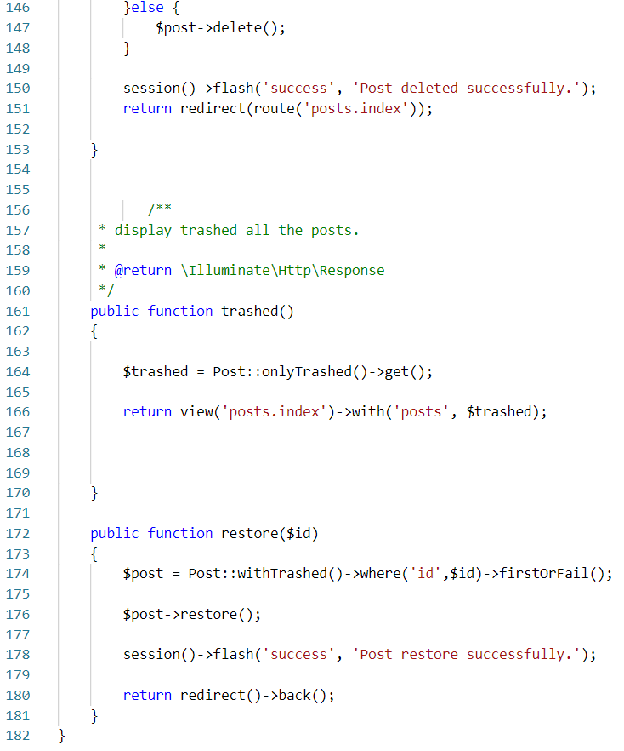

**Model for post**

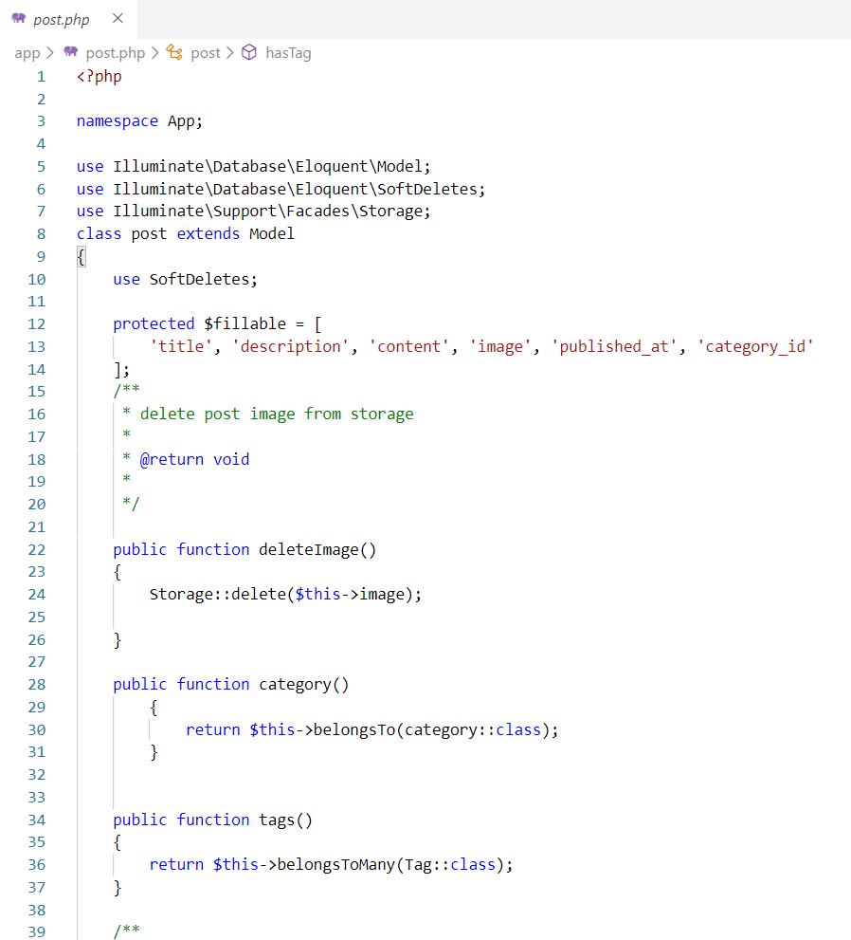

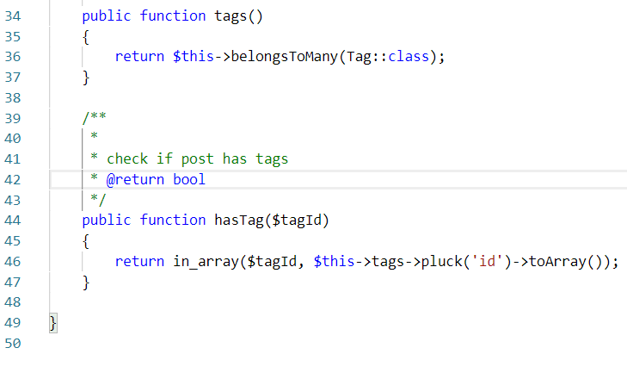

**View for post**

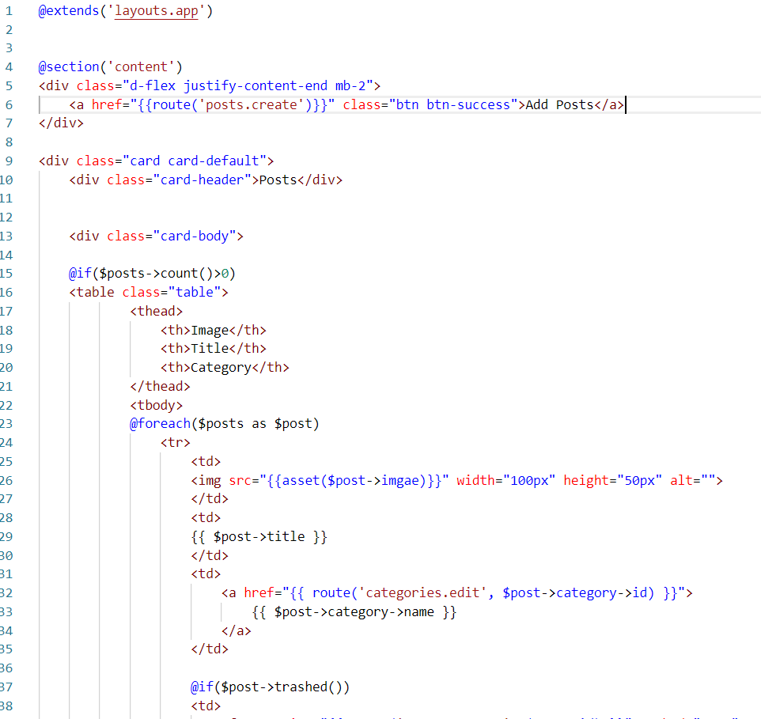

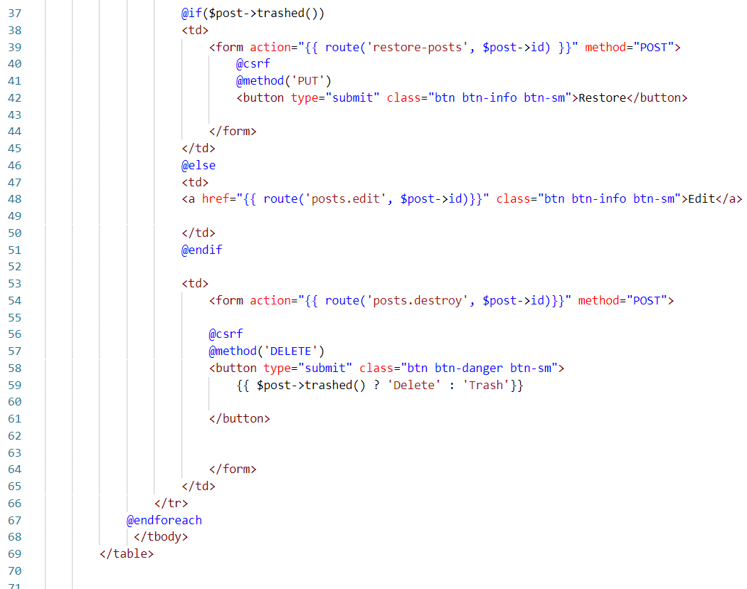

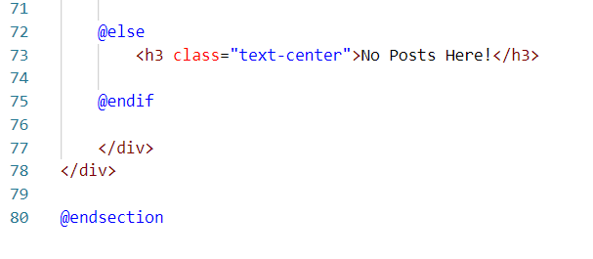

**Create post view**

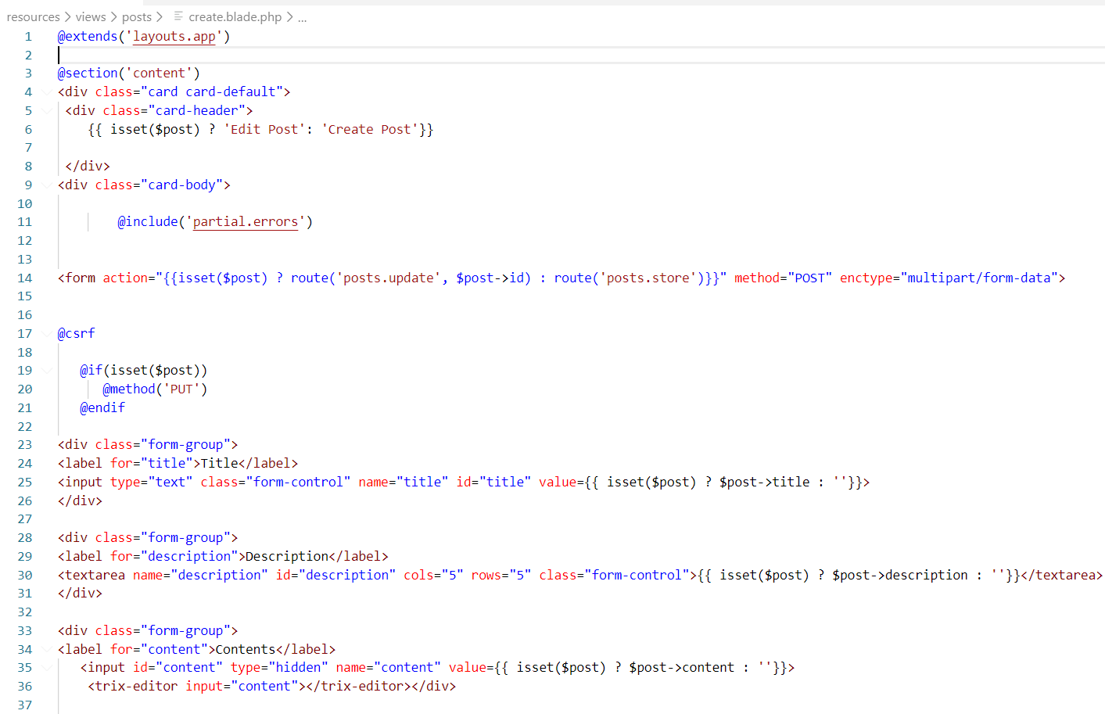

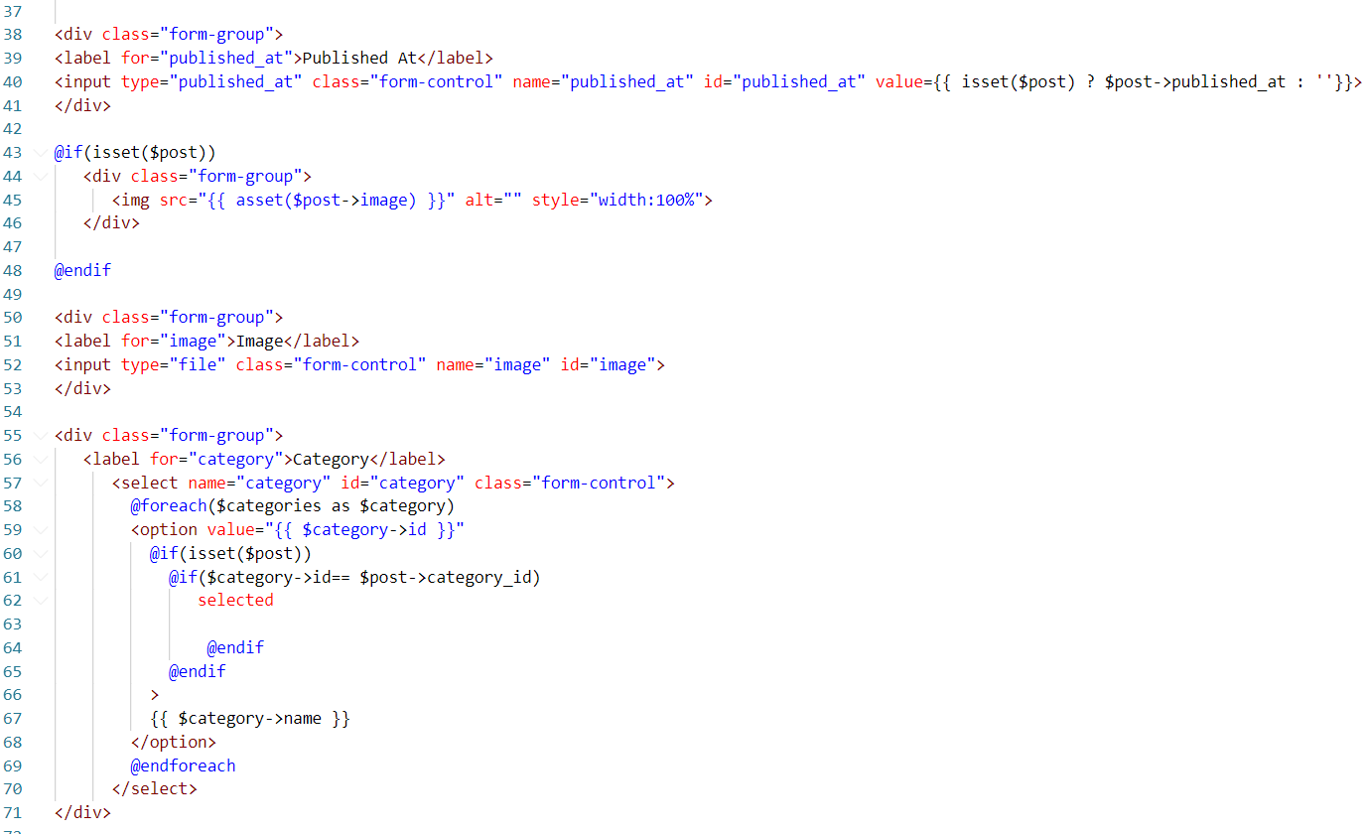

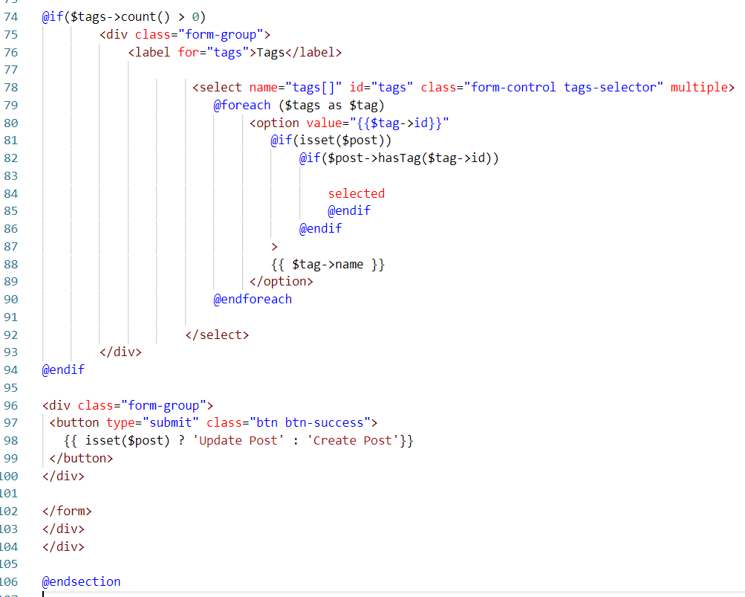

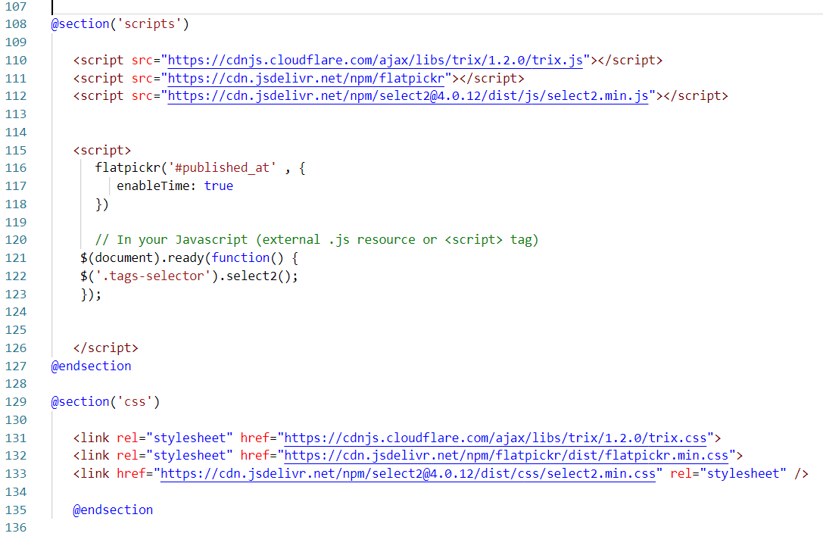

**Request for the posts**

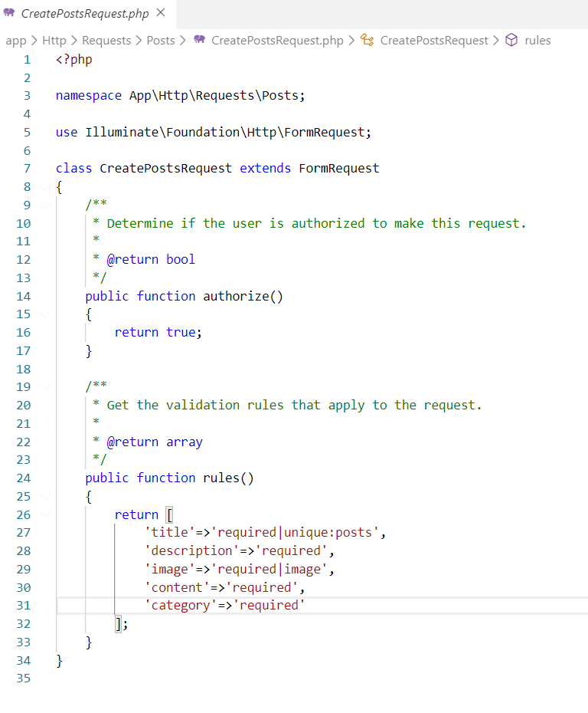

Fig: Create post request

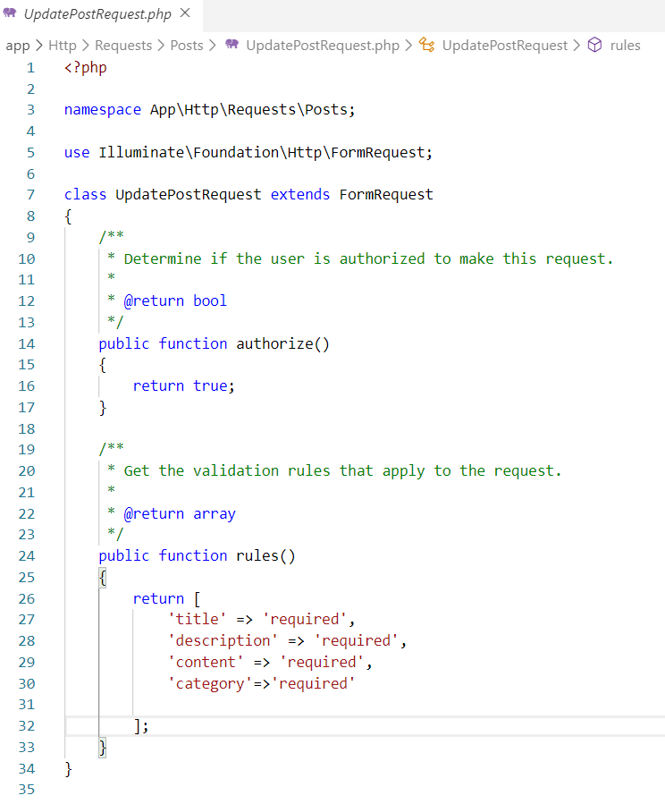

Fig: Update post request

**Controller for tags**

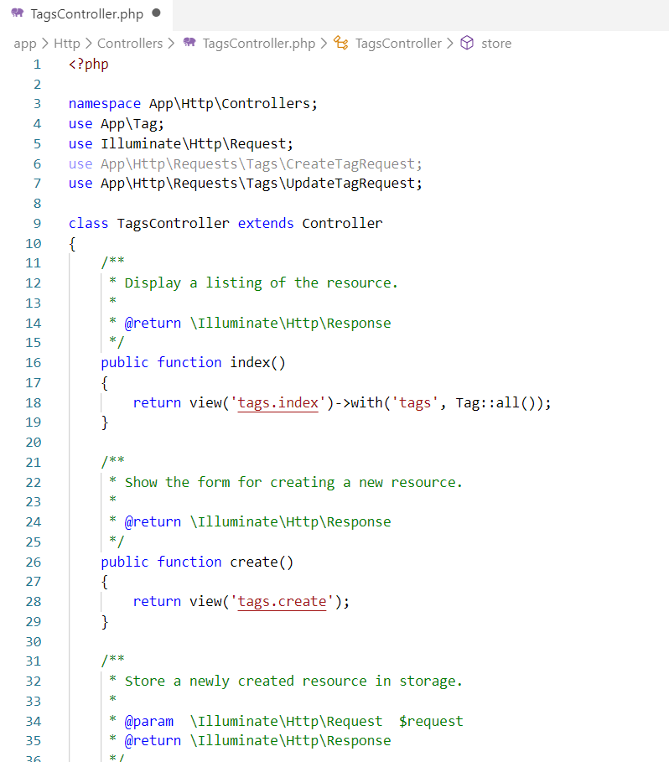

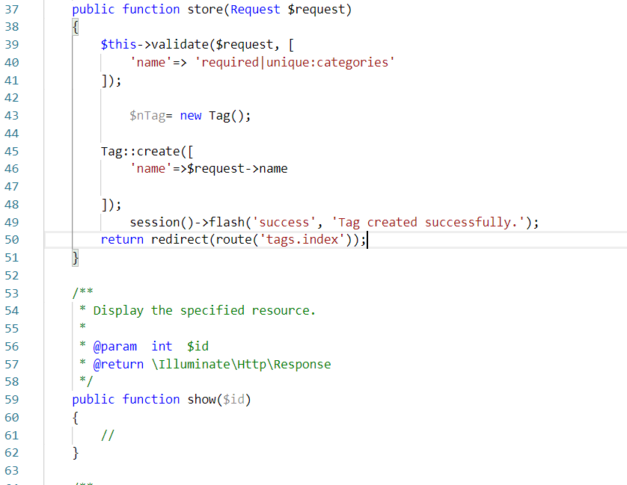

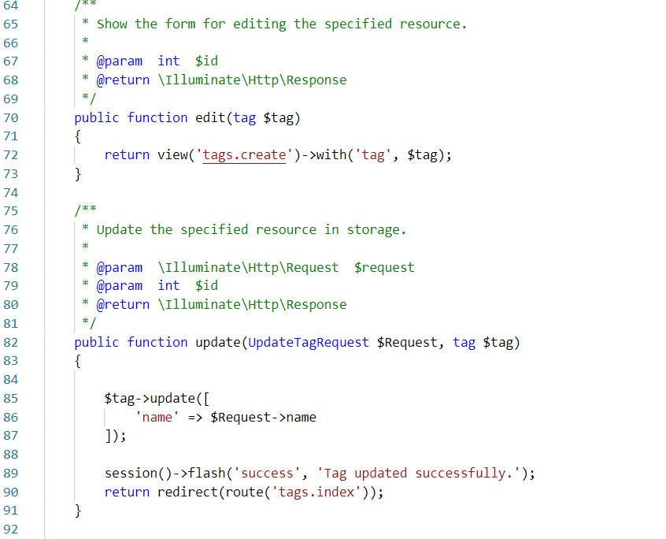

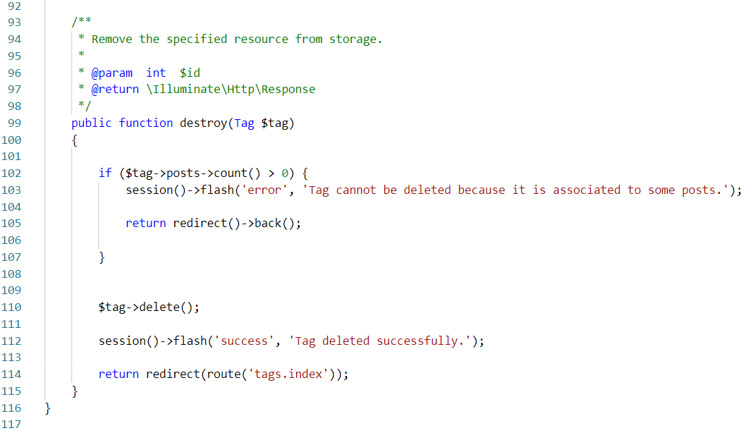

**Model for tag**

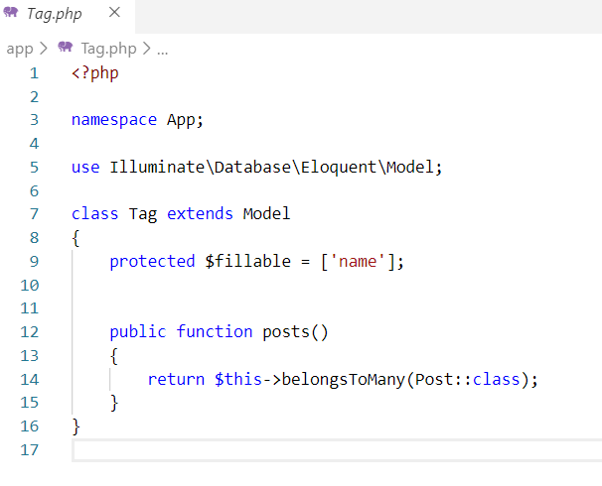

**View for tags**

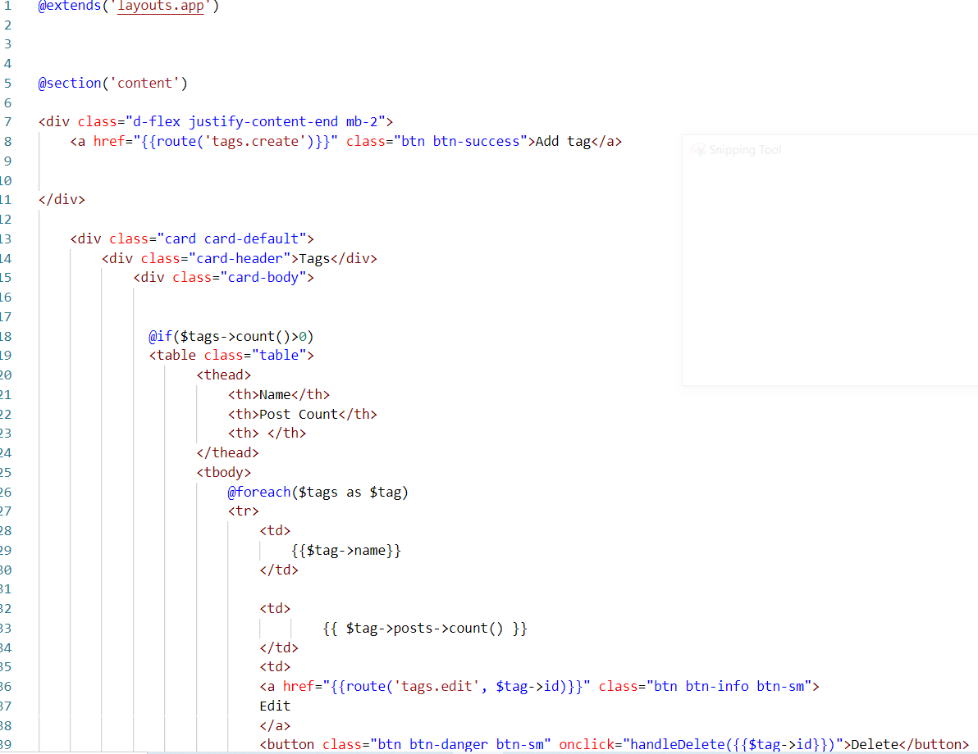

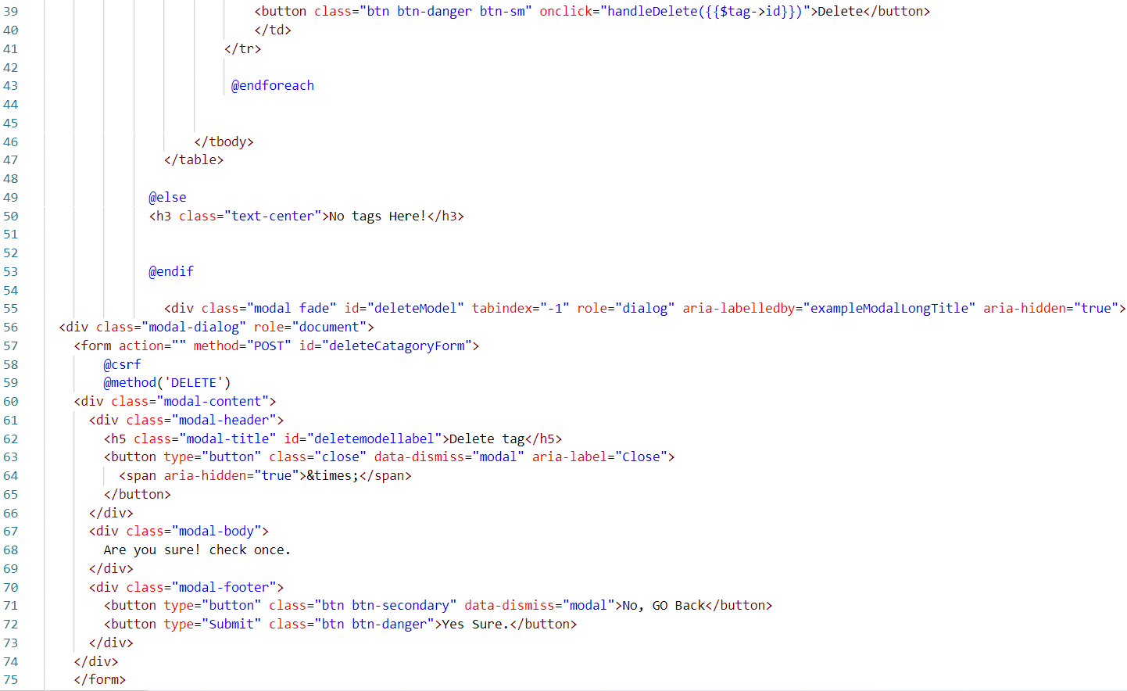

Fig: Tag index

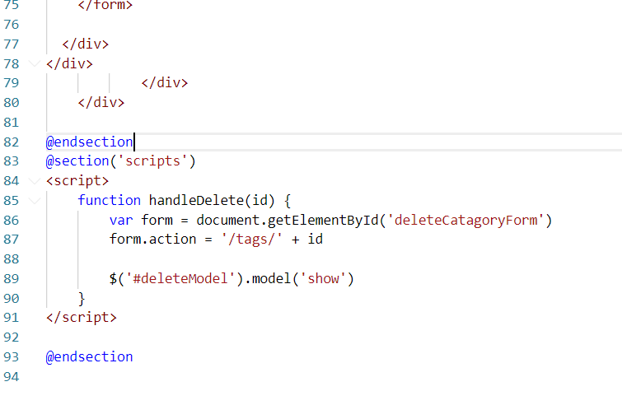

Fig: Tag index

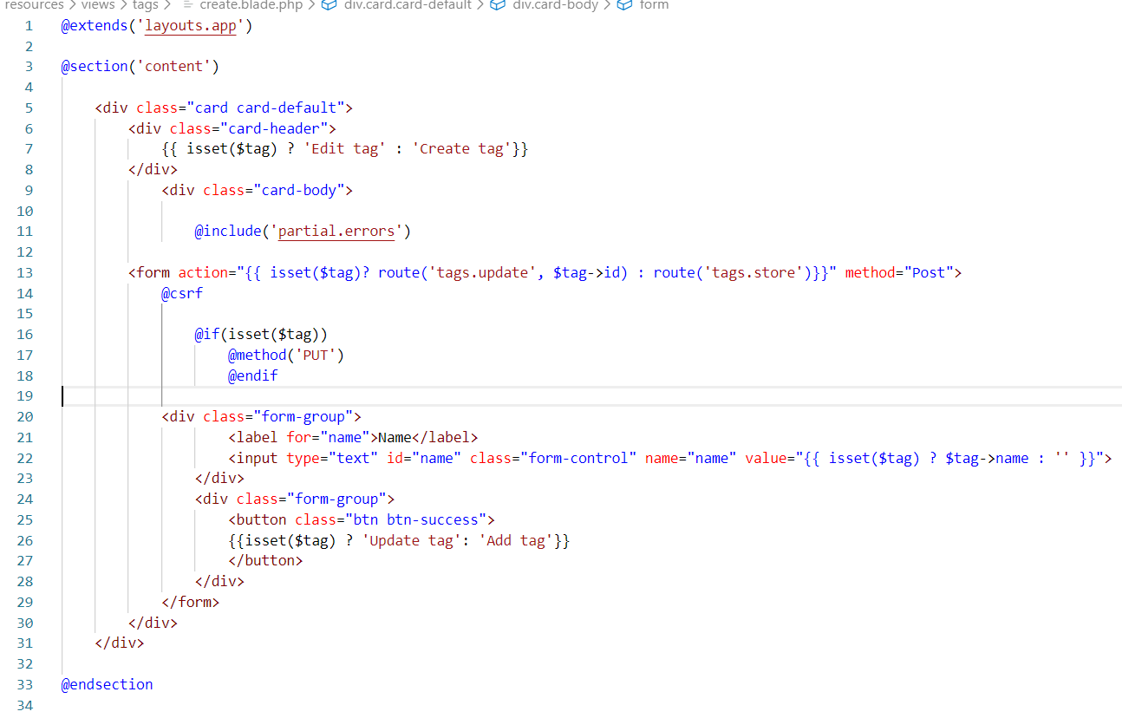

Fig: Create tag view

**Tags request**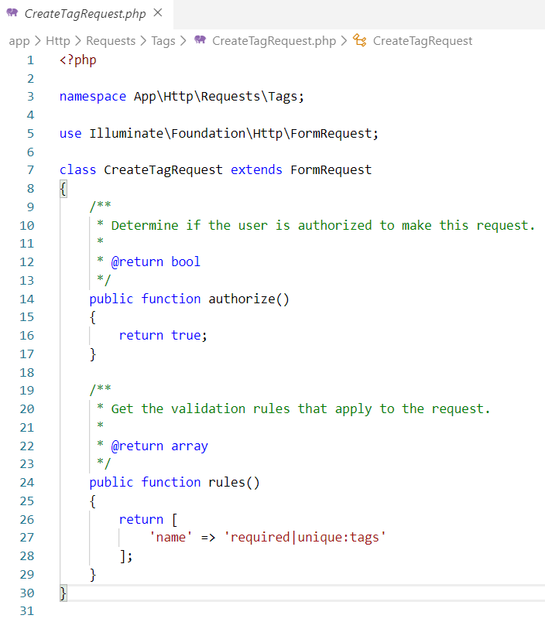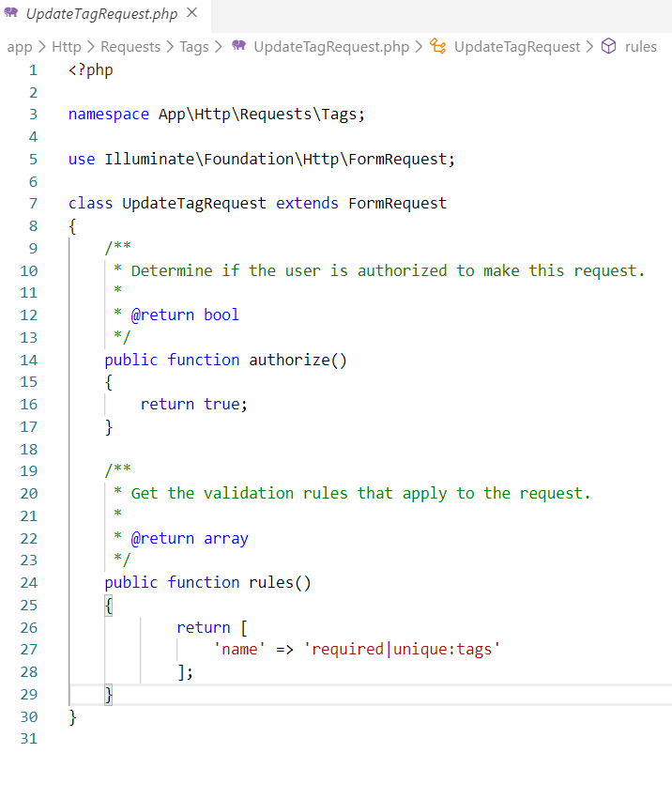

Fig: Update tag request

**User controller**

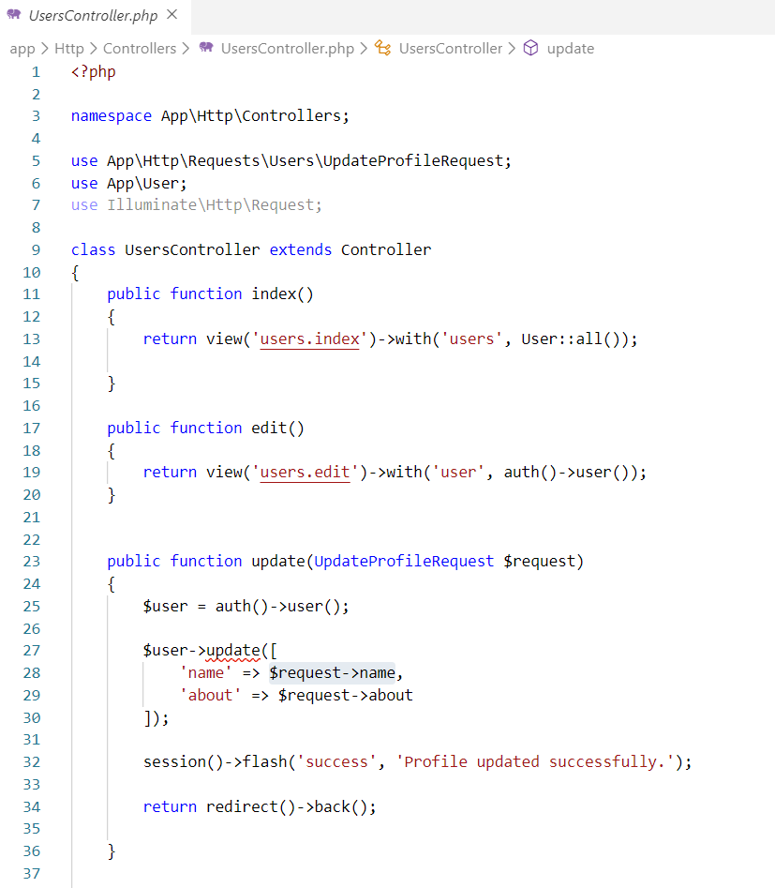

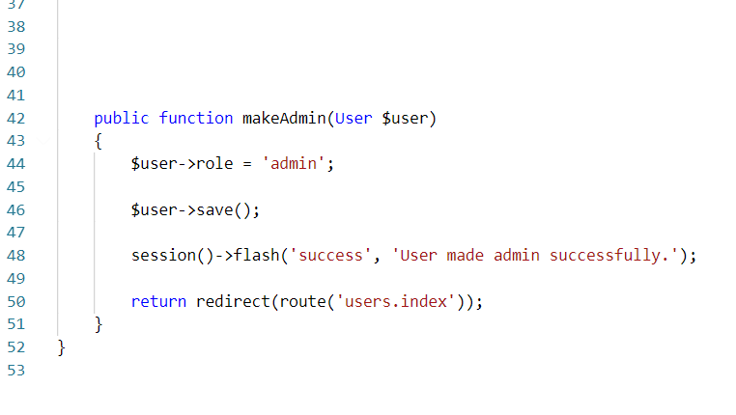

**Model user**

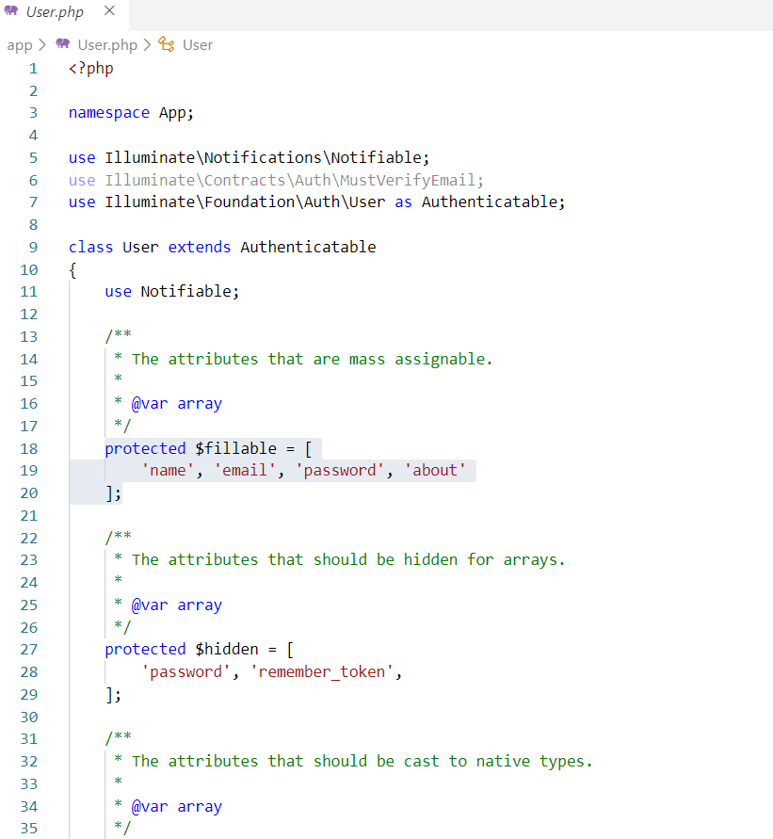

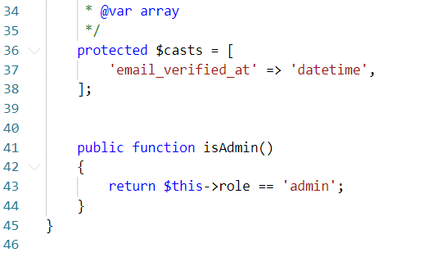

**Update profile request**

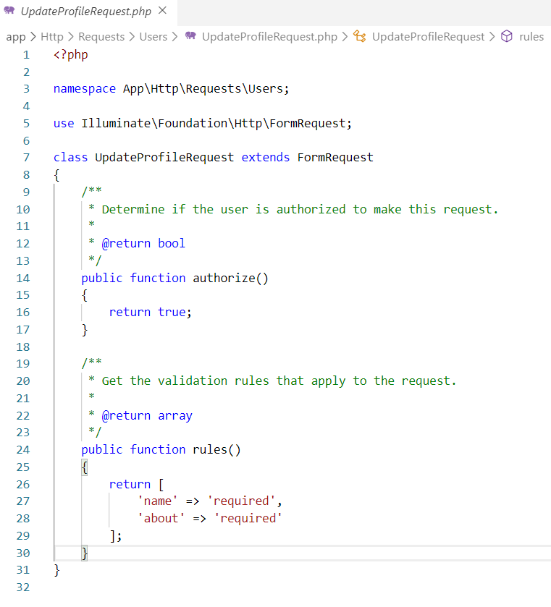

**View for users**

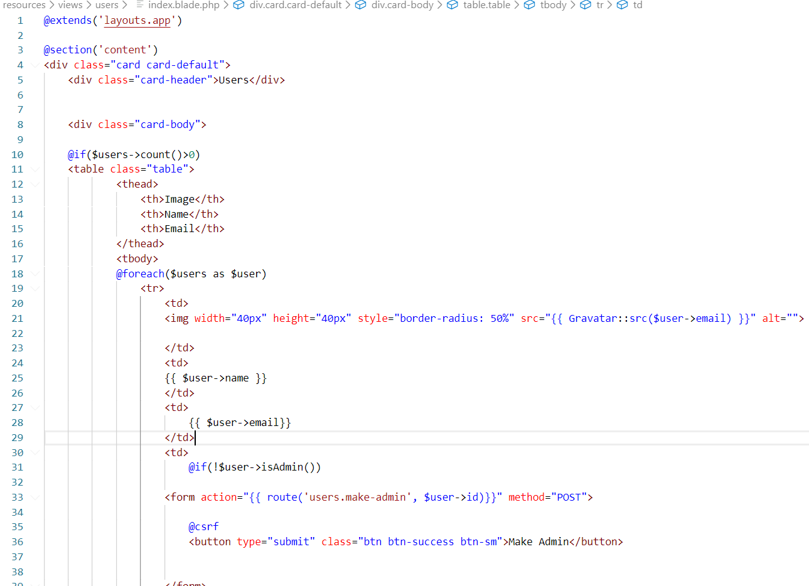

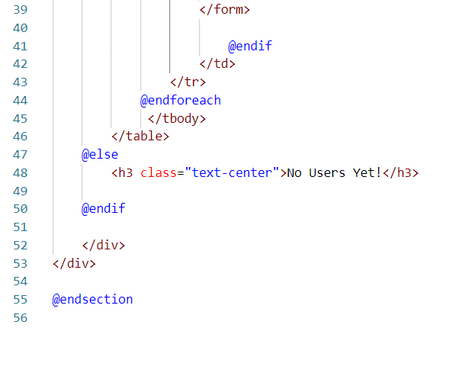

Fig: User index

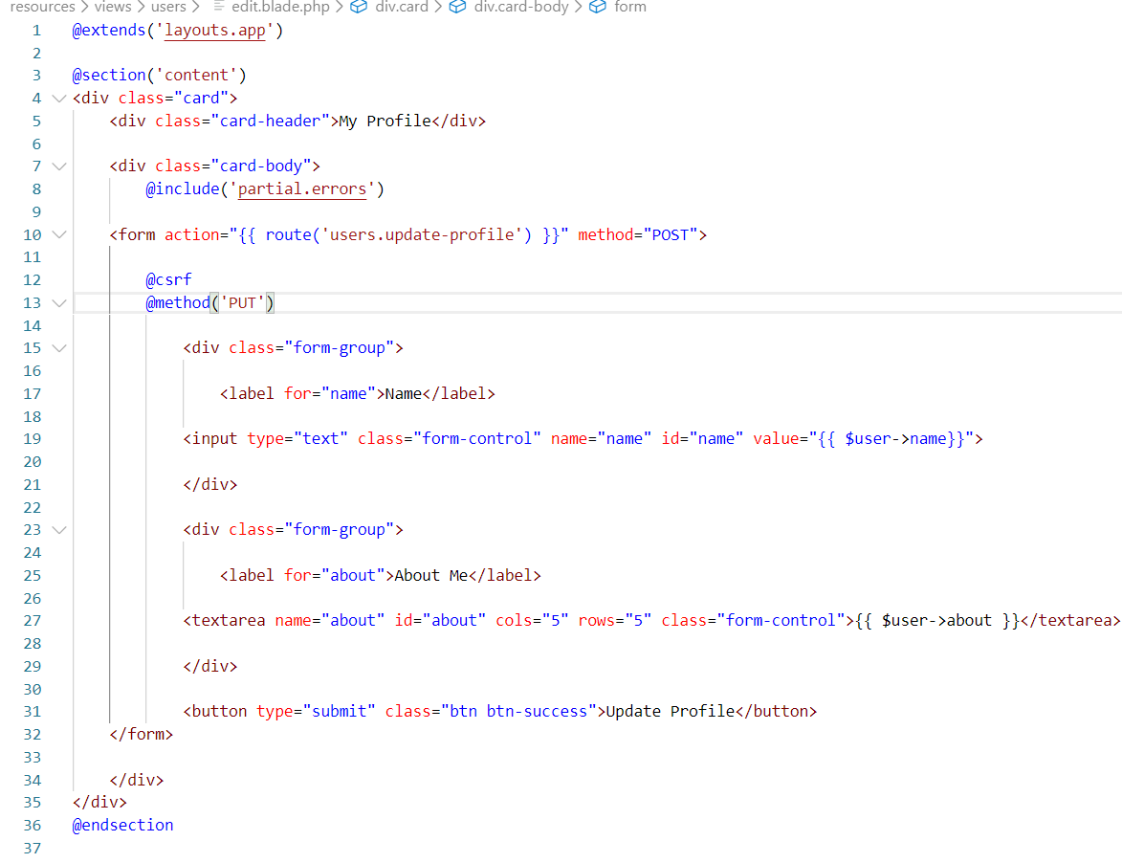

Fig: User edit

**Middleware verify admin**

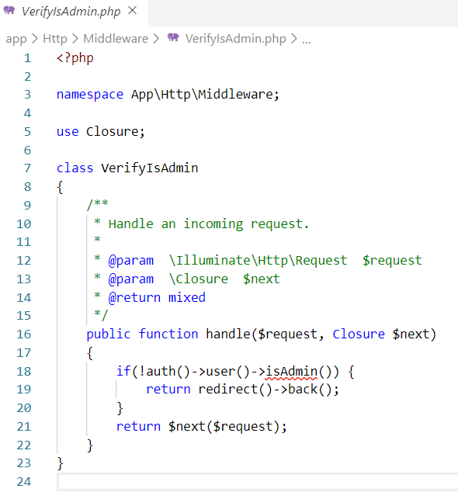

**QR code generator view with codes**

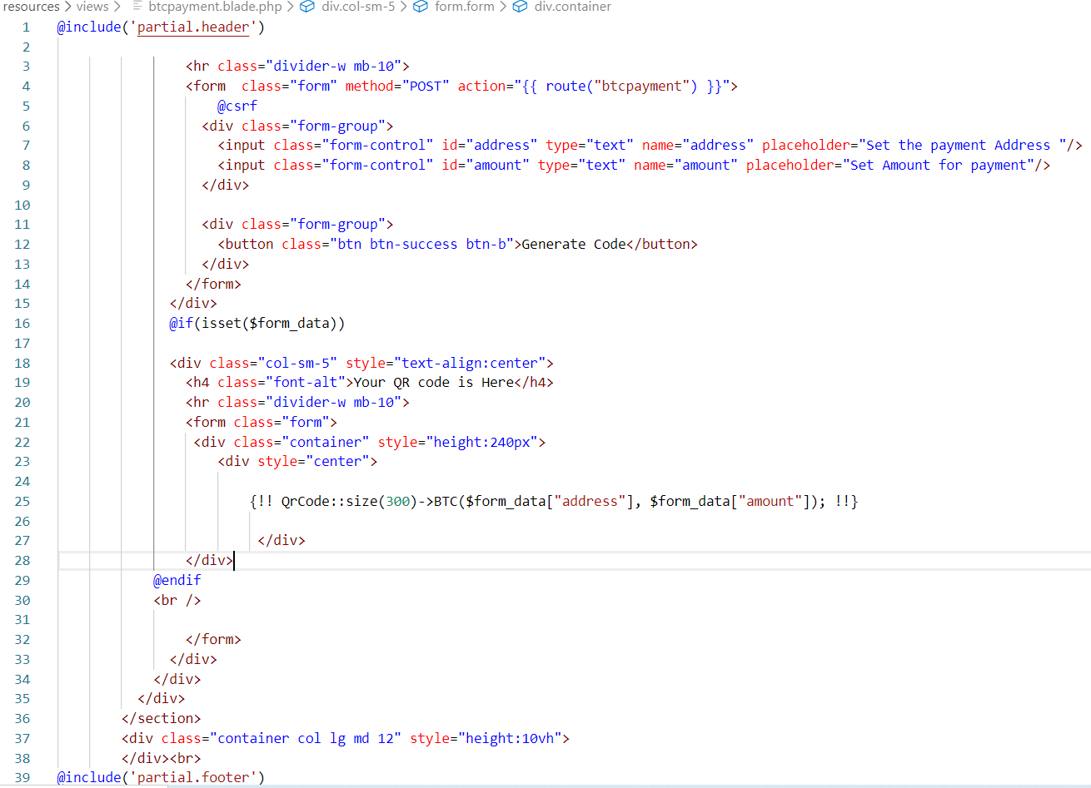

Fig: BTC payment code

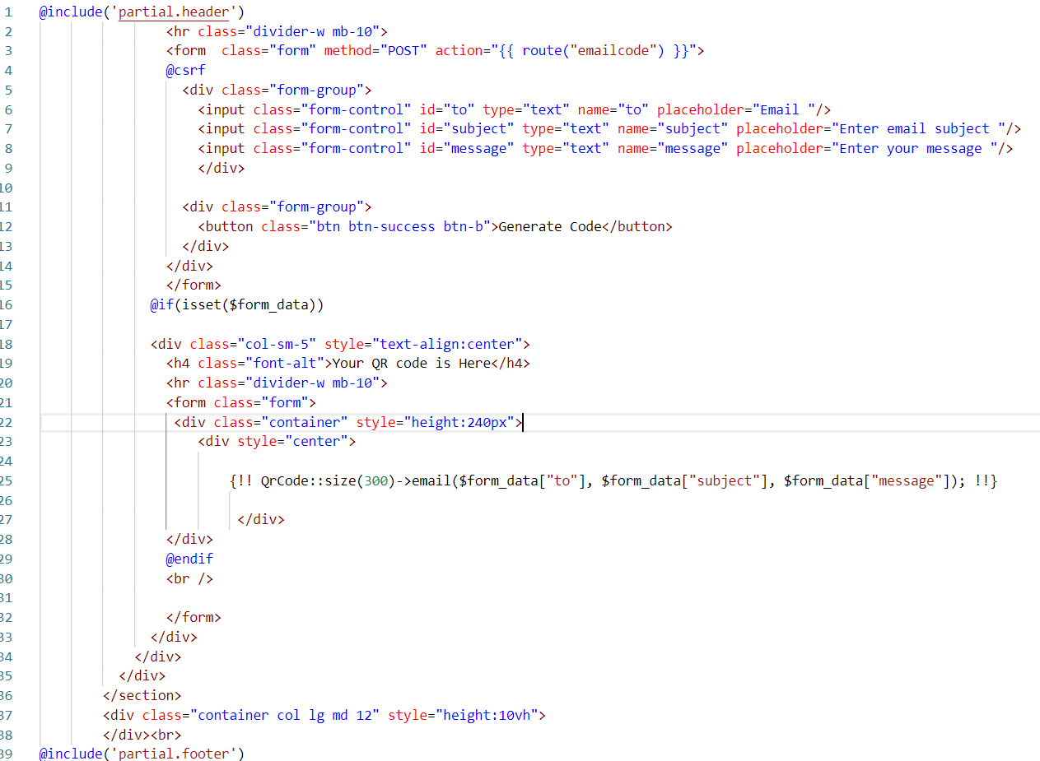

Fig: Email code

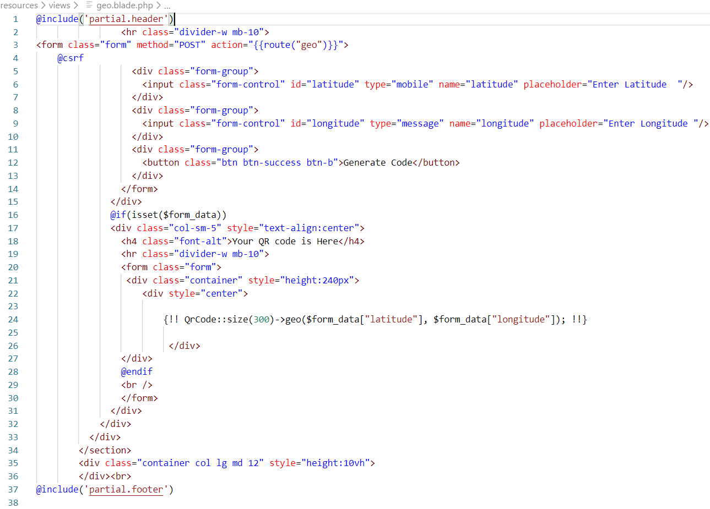

Fig: Geo location code

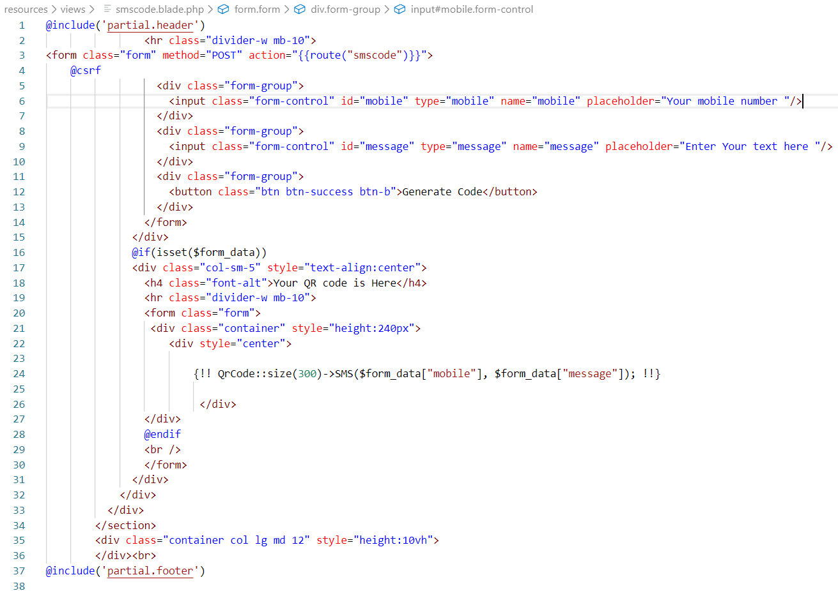

Fig: SMS code

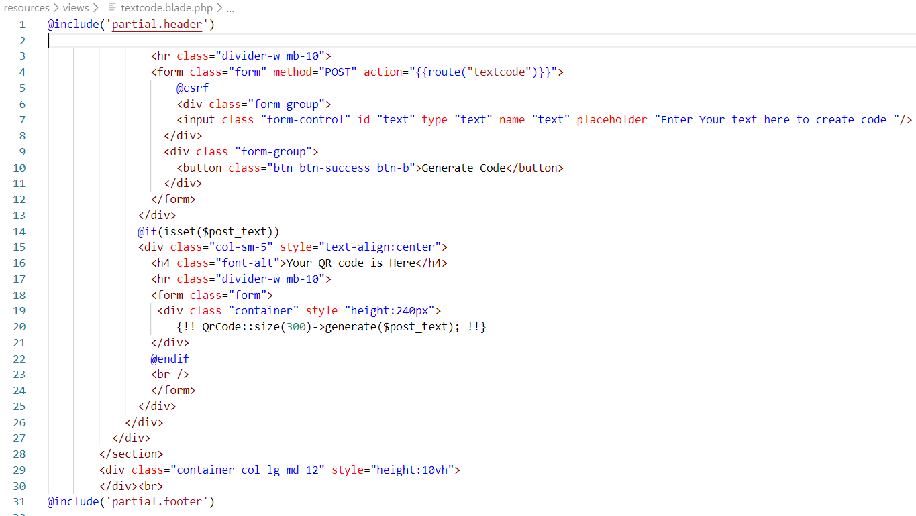

Fig: Text code

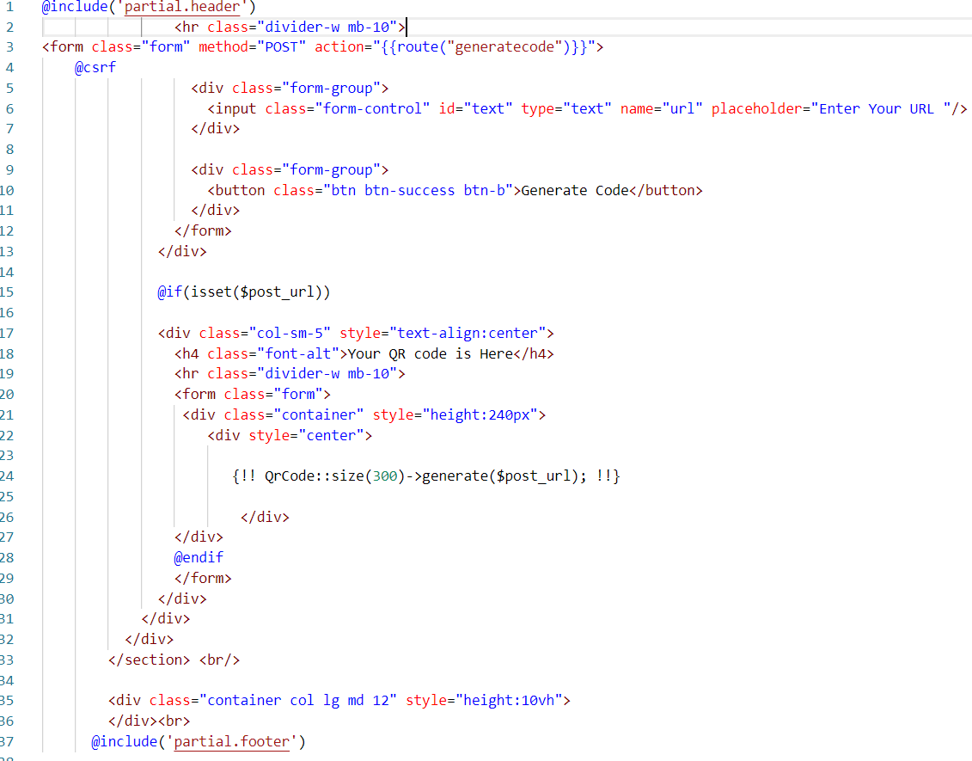

Fig: URL code

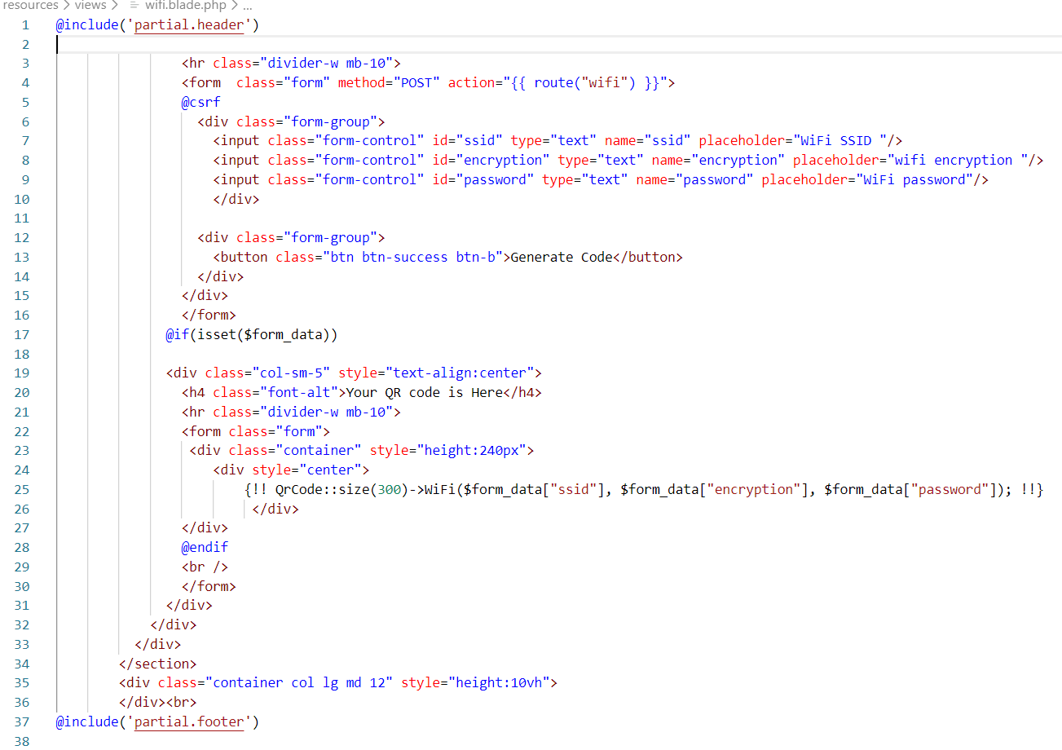

Fig: WIFI code

**QR code scanner**

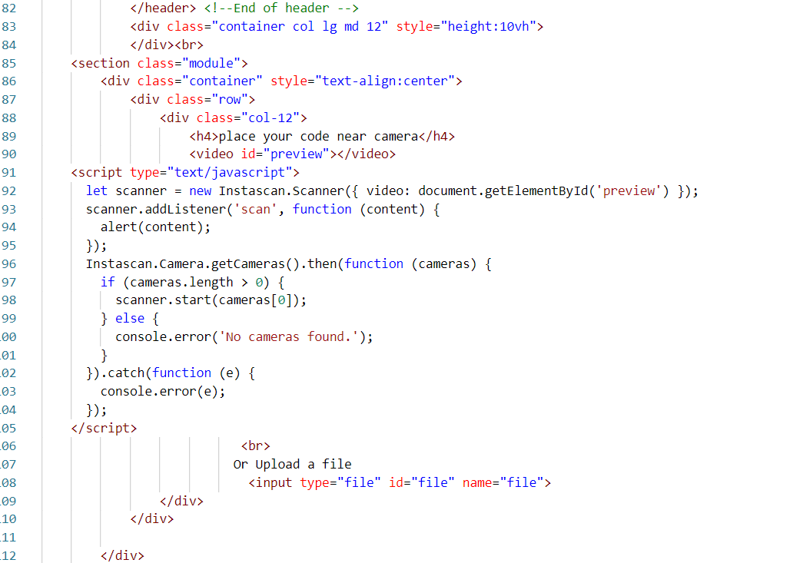

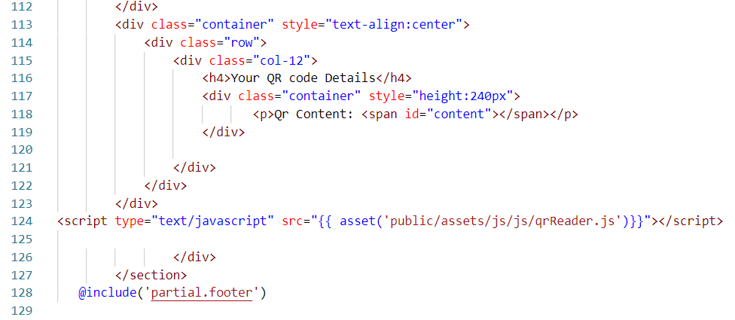

Fig: QR code scanner